

**UiPath Training Document**

**Version 1.0**

**Table of Contents**

**Chapter 1 Introduction**4 - 6

* 1. Introduction to RPA 5
  2. Introduction to UiPath 5
  3. Modules of UiPath 5
  4. Installation of UiPath 5 - 6

**Chapter 2 Overview**7 - 18

2.1Overview of UiPath Studio8 - 12

2.2 Overview of UiPath Robot13

2.3 Overview of UiPath Orchestrator 14 - 18

**Chapter 3 Internal PoC**19 - 36

3.1 Product Compliance Automation using UiPath 20 - 25

* + 1. Description20
    2. Business case20
    3. Solution20
    4. Scope20
    5. Demo21 - 24
    6. Benefits25
    7. PoC Challenges and Workaround/Resolution25
  1. SDFC Automation using UiPath25 - 32
     1. Description25
     2. Business case25
     3. Solution25
     4. Scope25 - 26
     5. Demo26 - 31
     6. Benefits32
     7. PoC Challenges and Workaround/Resolution32
  2. SAP Automation using UiPath32 - 36
     1. Description32
     2. Business case32
     3. Solution32
     4. Scope32 - 33
     5. Demo33 - 35
     6. Benefits36
     7. PoC Challenges and Workaround/Resolution 36

**Chapter 4 Client PoC**37 - 66

* 1. PoC on SAP Automation on Citrix machine with IPG38 - 41
     1. Description38
     2. PoC Objective38
     3. Automation tool details 38
     4. Applications under test 38
     5. Scope38 - 39
     6. Estimates39
     7. What Worked Well39 - 40
     8. What did not Work Well? 40 – 41
     9. Demo 41
     10. Conclusion41
  2. PoC on E2E Automation with T-Mobile41 - 66
     1. Description41
     2. PoC Objective42
     3. Automation tool details 42
     4. Applications under test 42
     5. Scope42 - 43
     6. Estimates43
     7. RPA Design approach43
     8. What Worked Well44
     9. What did not Work Well? 44 - 45
     10. Demo45 - 66
     11. Conclusion66
  3. PoC on AS400 automation with Manheim 67 - 86
     1. Description67
     2. PoC Objective67
     3. Automation tool details 67
     4. Applications under test 67
     5. Scope67 - 68
     6. Estimates68
     7. What Worked Well68 - 69
     8. What did not Work Well? 69
     9. Demo69 – 86
     10. Benefits ………………………………………………………………………………………………………………………… 86
     11. Conclusion86

**Chapter 5 References**87 - 88

5.1 References88

**Chapter 1**

**Introduction**

* 1. **Introduction to RPA**

Robots are here to stay. The faster you harvest their potential, the faster you create a competitive edge for your business. Robotic Process Automation delivers direct profitability while improving accuracy across organizations and industries. Designed to perform on a vast range of repetitive tasks, software robots interpret, trigger responses and communicate with other systems just like humans do. Only substantially better: a robot never sleeps, makes zero mistakes and costs a lot less than an employee.

* 1. **Introduction to UiPath**

UiPath platform delivers enterprise wide automation benefits, residing within an open, extensible architecture designed for truly smart, highly scalable automation.

* 1. **Modules of UiPath**

**UiPath Studio:**

The perfectly intuitive environment where anybody can model automation visually, without scripting, without code. A powerful recorder literally builds automation by watching you work, and a rich library of template activities will get you moving at exceptional speed and ease.

**UiPath Orchestrator:**

A highly scalable server platform, Orchestrator deploys and manages your entire workforce, handling like a virtuoso all the critical enterprise duties: release management, centralized logging, reporting, auditing and monitoring, remote control, scheduling, workload management and asset management.

**UiPath Robot:**

A highly scalable server platform, Orchestrator deploys and manages your entire workforce, handling like a virtuoso all the critical enterprise duties: release management, centralized logging, reporting, auditing and monitoring, remote control, scheduling, workload management and asset management.

* 1. **Installation of UiPath**

**Step 1**: First we need to download UiPath Setup from the official website.

1. Open Official UiPath Website [www.uipath.com](http://www.uipath.com/)
2. In home page click on “Download Studio” Button.
3. Next, hover down to the page. There you will see “Download Studio Trial” button, Click on it.
4. In the next page, you need to fill all the required information. And click on “Request Free Trial” button

Once you have requested for a free trial. UiPath team will send a mail to your registered email id. Which contains a download link.  
Note: Make sure to check your Spam folder if UiPath mail is not showing in your Inbox.

**Step 2:** Once you received the mail. Click on Download link, provided in the mail.

**Step 3**: Run the setup file once it is downloaded.

**Step 4:** Walkthrough for Installation wizard. Once the Installation wizard is open. Follow these steps to complete your installation.

1. Click on Accept License Agreement checkbox. Then click on Install.
2. If you are getting any permission alert from your OS. Click on Yes.
3. Once installation progress is completed. On the next window click on Finish

UiPath is installed on your machine.

After successfully installing the software. Next thing, you need to activate the software.

**Step 5:** Activating UiPath

1. Open UiPath Studio from your Start menu.
2. In the UiPath Activation wizard. You will see three options.
   * Start Trial
   * Activate License
   * Purchase License
3. Because we activating trial version. Click on “Start Trial”.
4. Enter your Email Address
5. Keep Device ID same. Then click on “Activate”

Once it is done. You will be redirecting to your browser and message showing like “UiPath has been successfully installed”.

**Chapter 2**

**Overview of UiPath**

* 1. **UiPath Studio Overview**

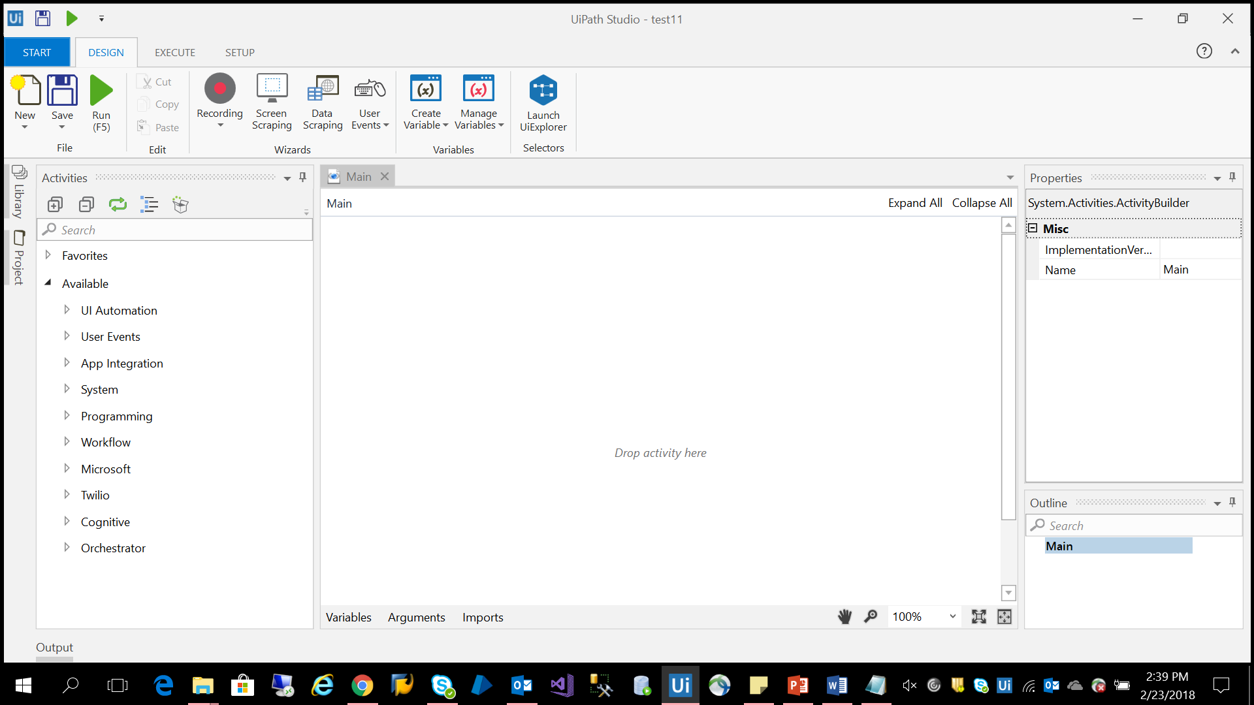

*“Open blank project”*

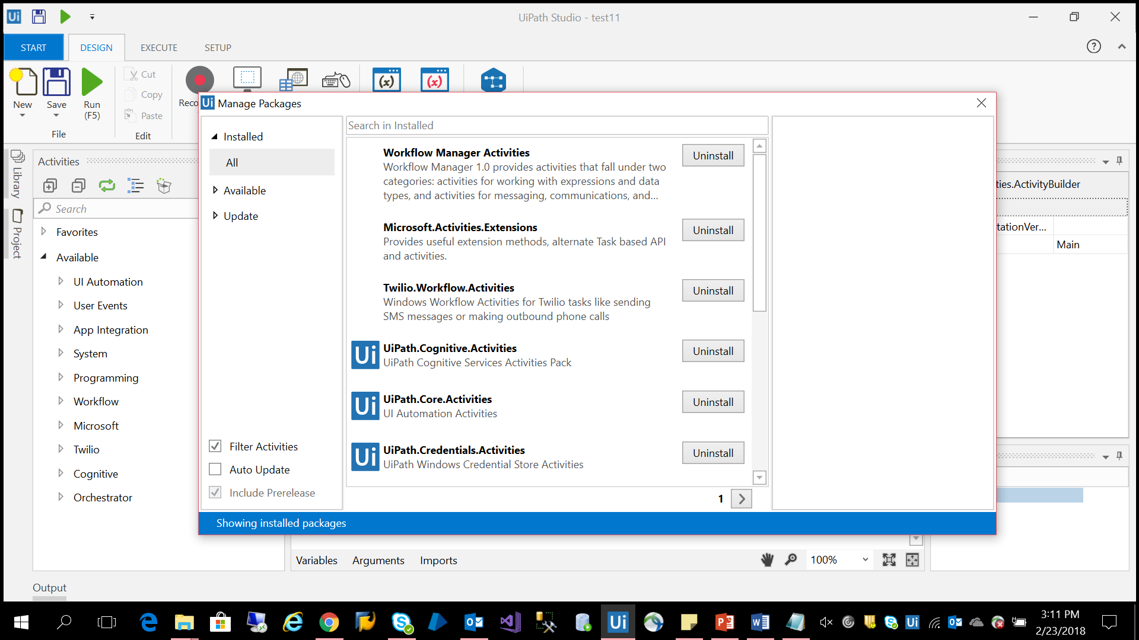

*“Click on Manage packages”* Install all the packages available.

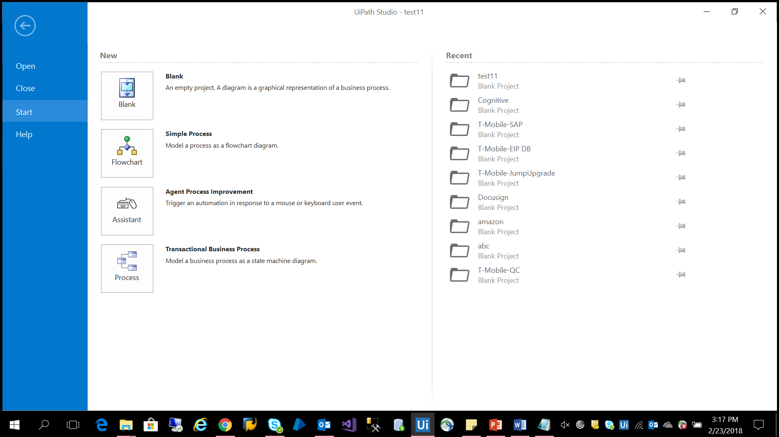

*“Click on Start Tab to create new project”*

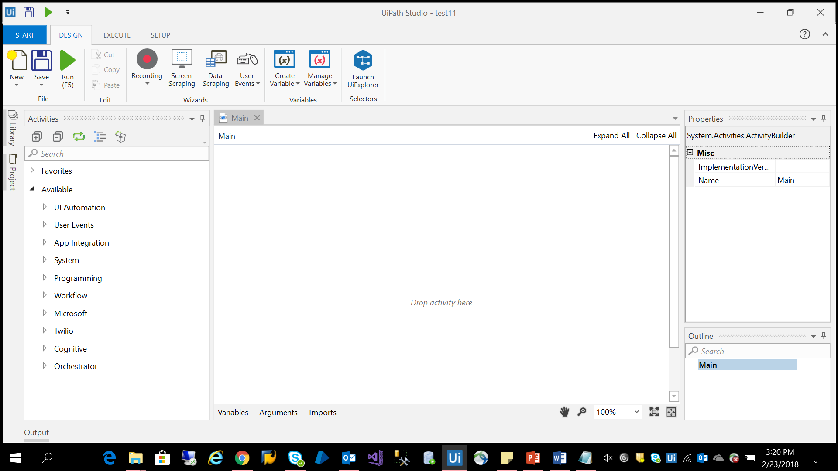

*“Click on Design tab”* To view the designer window and to create the workflow flow to meet the business requirements.

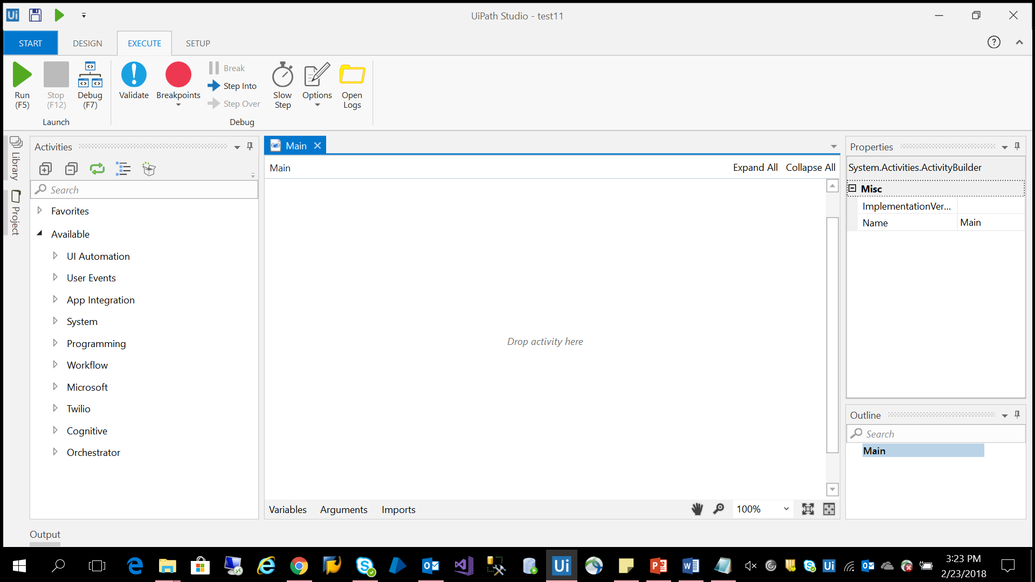

*“Click on Execute tab”* To view debug functions

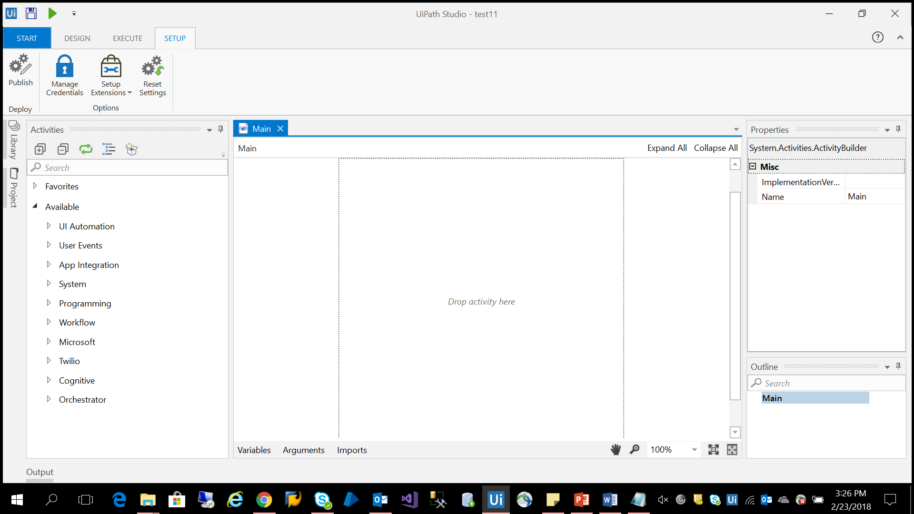

*“Click on Setup tab”* To view Extensions and project publish features.

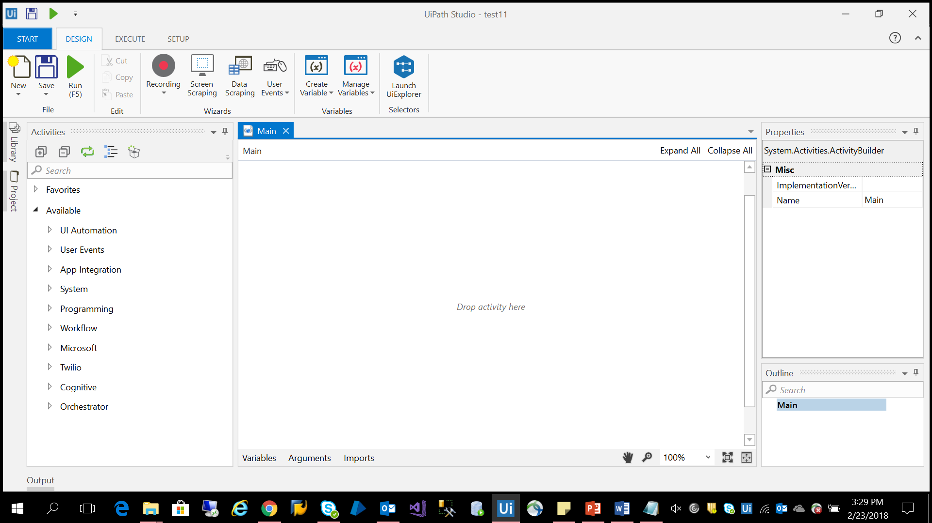

*“Activity Panel*” Container which has more than 500 built-in activities used to design the workflow.

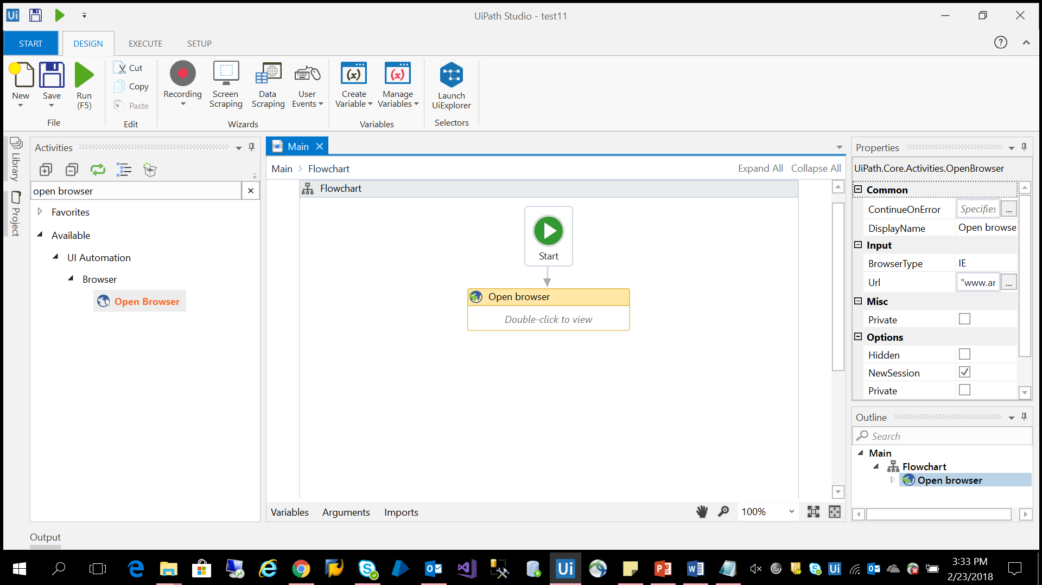

*“Properties Panel”* To set the properties for each activity.

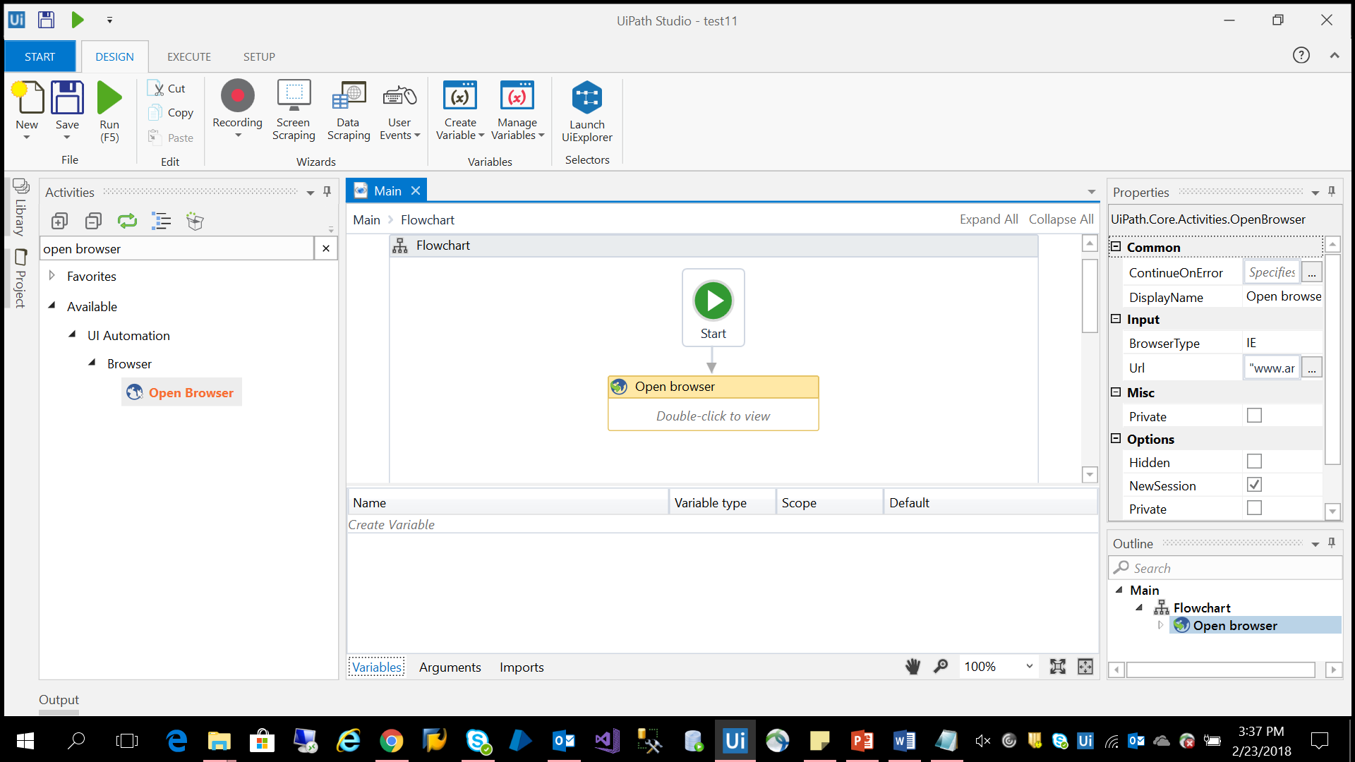

*“Variable Panel”* To create the Variables, Arguments and Import namespaces.

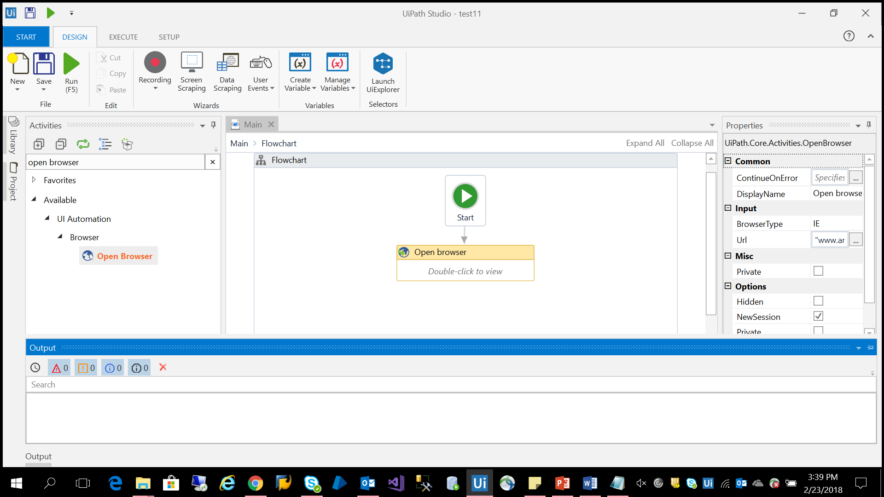

*“Output Panel”* To view output, error and warning messages.

* 1. **UiPath Robot Overview**

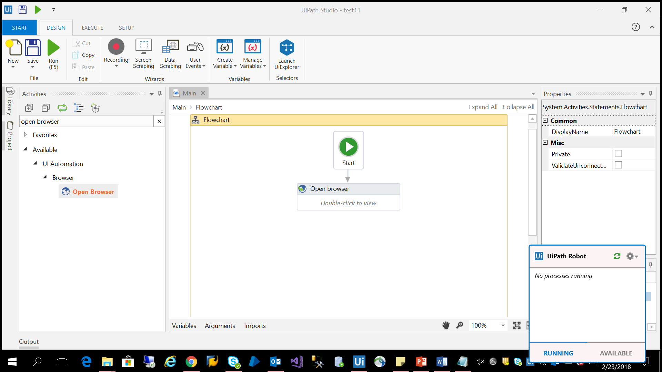

*“UiPath Robot”* An Execution environment to verify the behavior of the workflow and execute it.

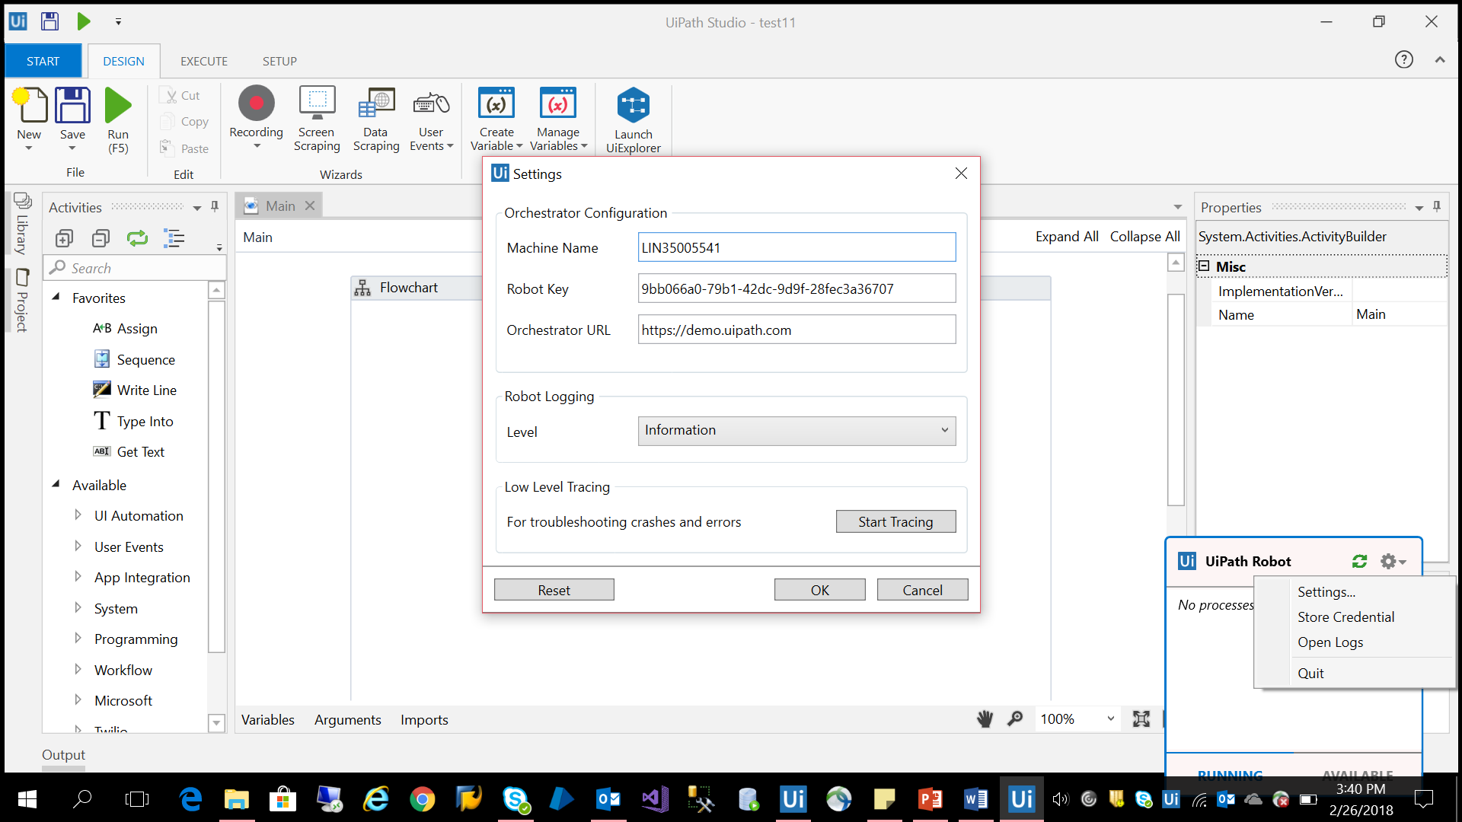

“Click on settings in Robot window” give the required credentials to connect with the orchestrator.

**2.3 UiPath Orchestrator Overview**

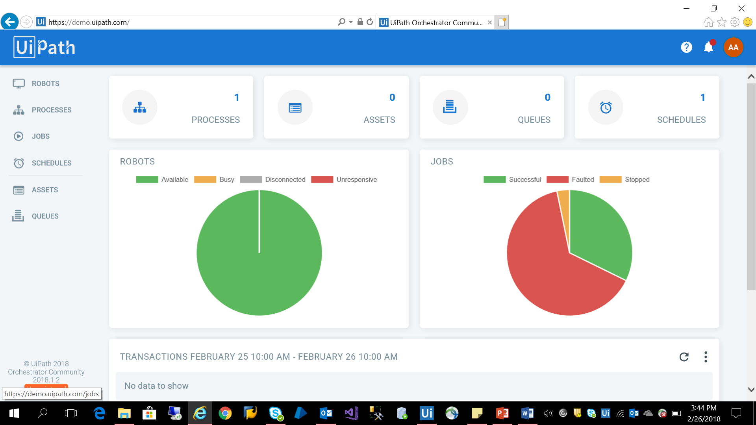

*“Orchestrator dashboard”*

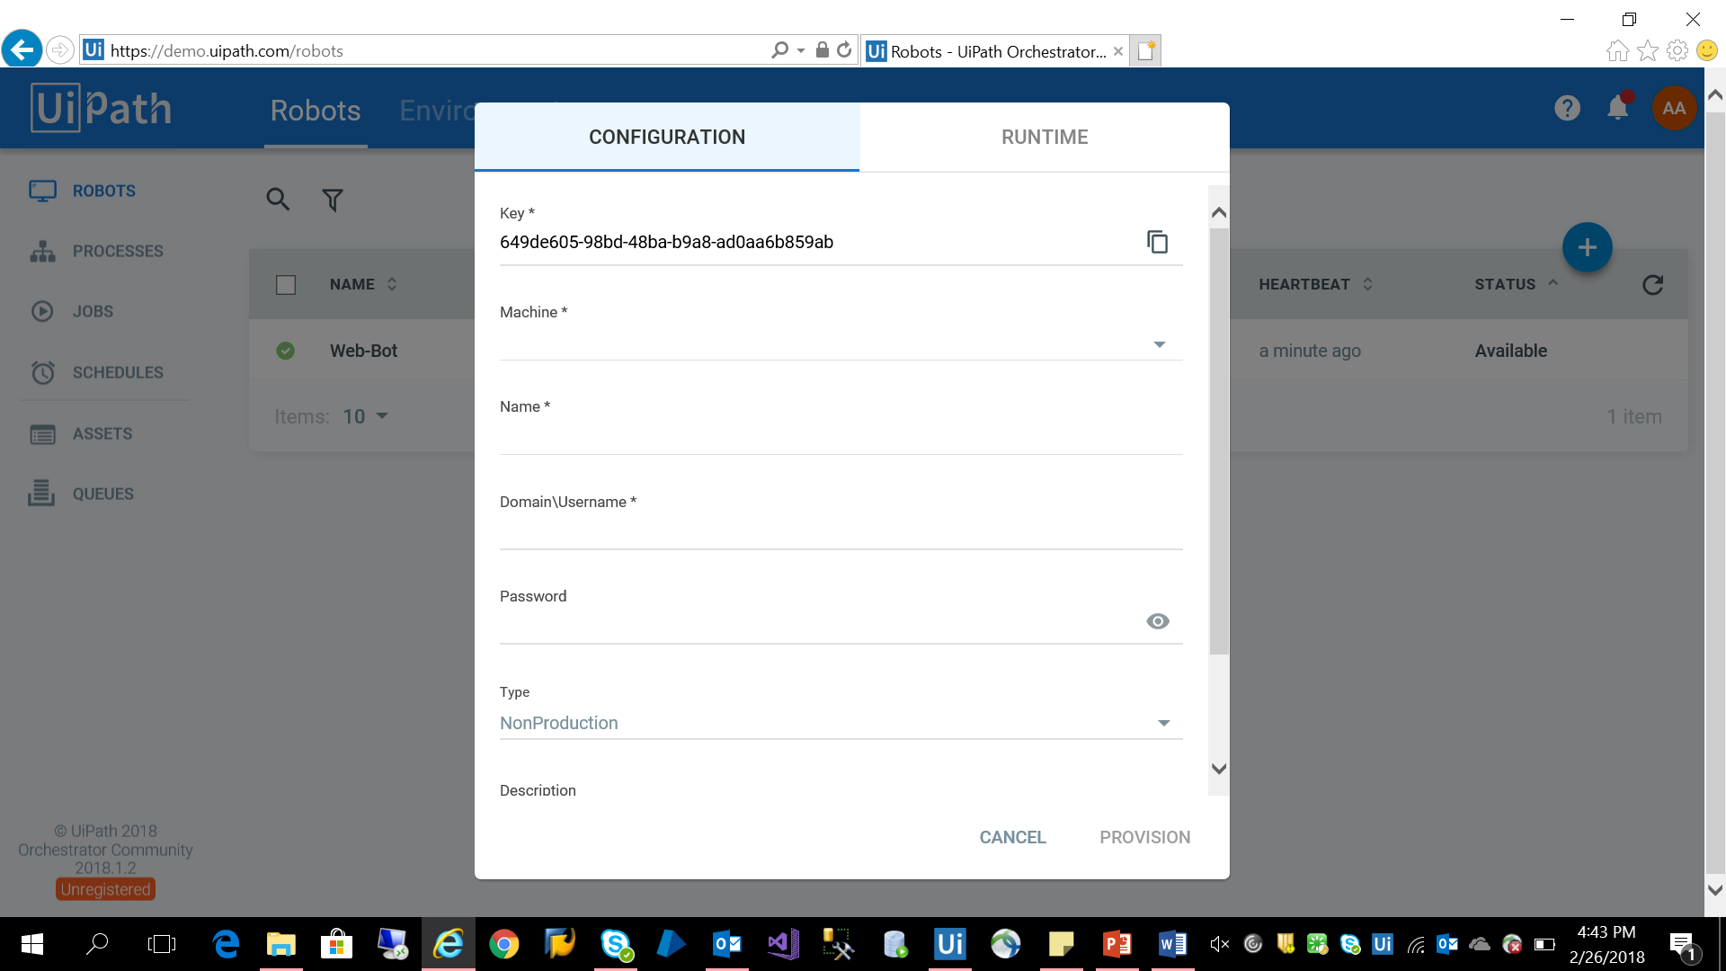

“Click on Robots tab and click on + icon” to configure your robot with your device/machine. Copy the key given and paste it in UiPath robot settings and fill the required details.

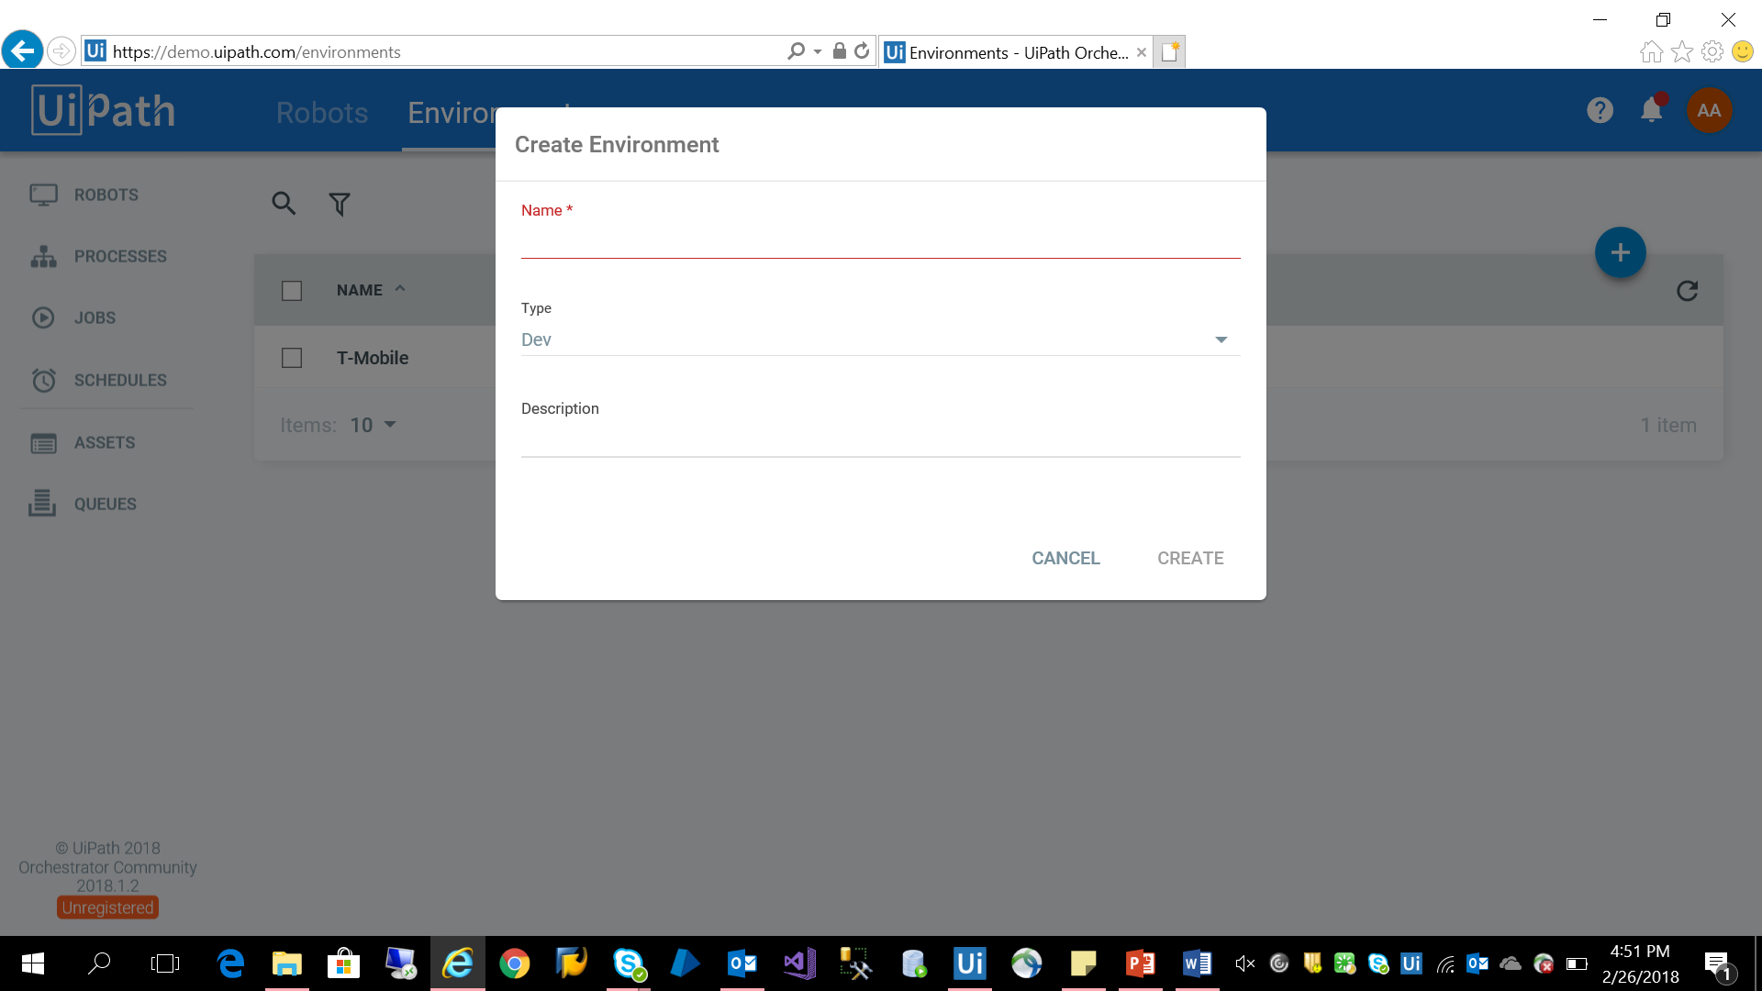

“Click on Environment tab and click on + icon” to create environment for your robot.

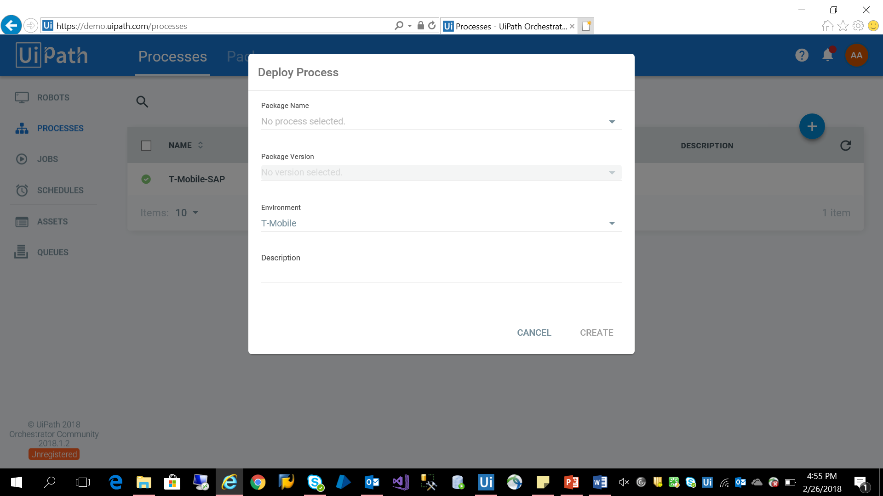

“Click on Processes tab and click on + icon” to deploy process. Select package name from dropdown box, Select version of the package, Environment and click on create.

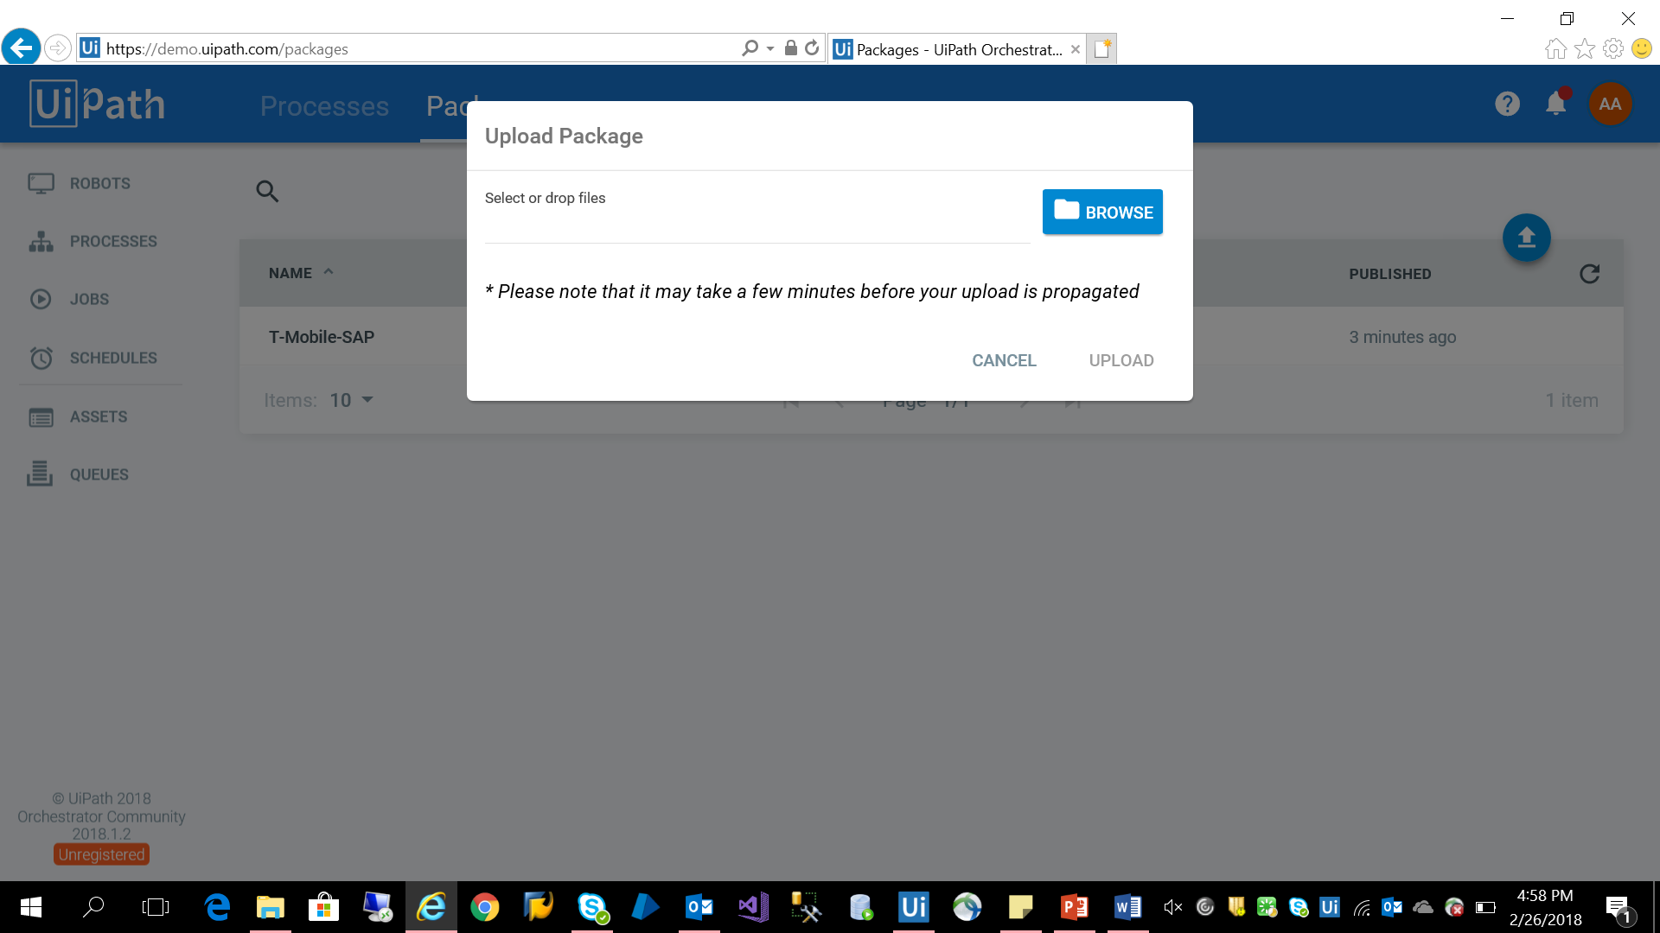

“Click on Packages tab and click on upload icon” to upload the package.

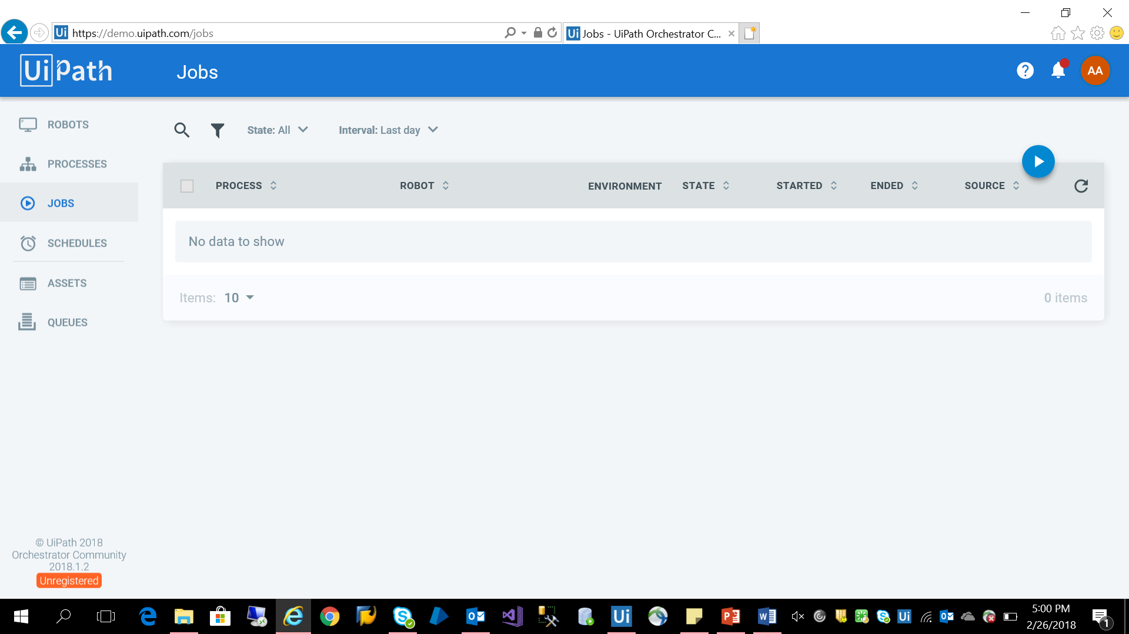

“Click on Jobs tab” to select the Job to be run.

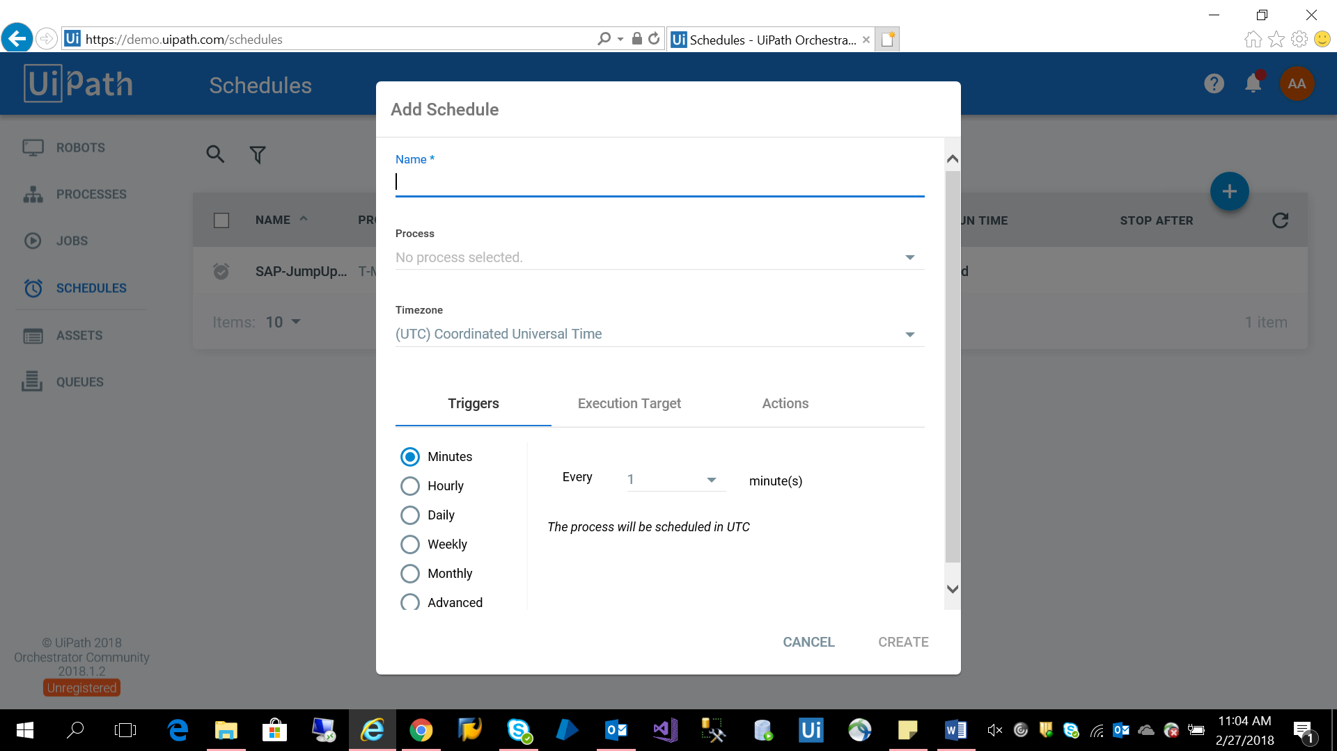

“Click on Schedules tab and click on + icon” to schedule the Job/Process. Enter the name and process which need to be scheduled and in which time zone. Then click on create.

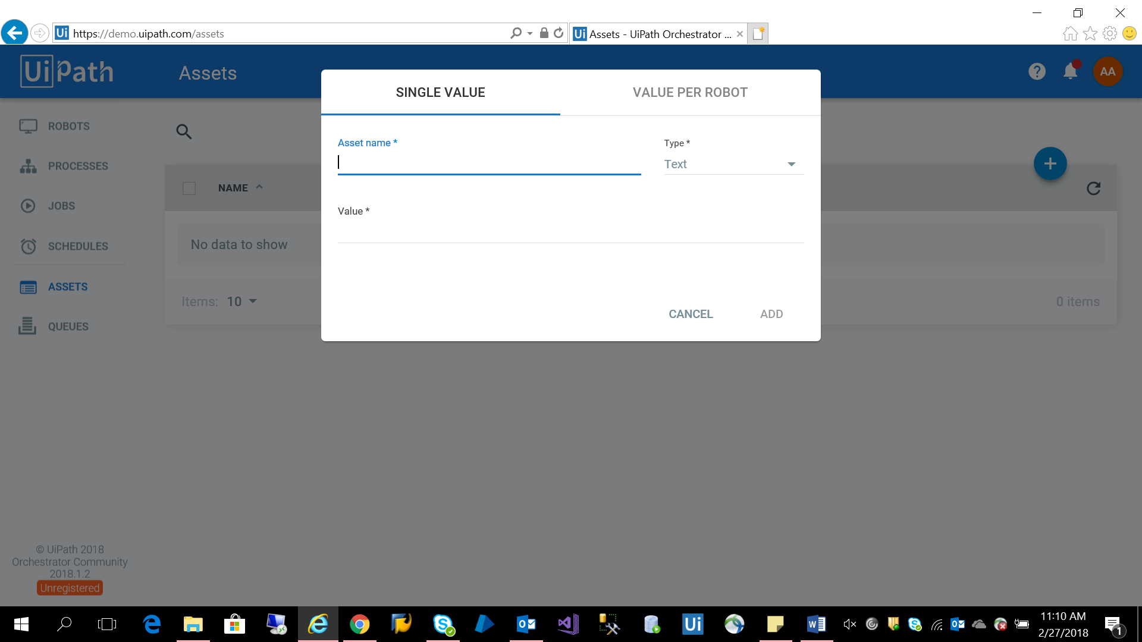

“Click on Assets tab and + icon” to add Asset name, value and type for robot.

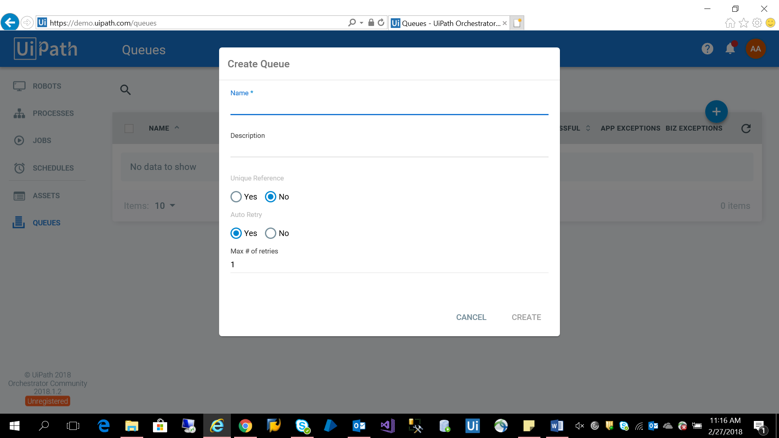

“Click on Queues tab and click on + icon” To create Queue.

**Chapter 3**

**Internal PoC**

**3.1 Product Compliance Automation**

**3.1.1 Description**

Harvesting product data from e-Tailer and validating the harvested data against the Master data from the Customer. If any discrepancy found in the data, send an email to the stakeholders.

**3.1.2 Business Case**

Validating the product data across different e-Tailers for product compliance either on request by Business user or on scheduled basis. The current process is manual, labor intensive prone to errors. The need is scalable automated solution for any product data validation in any e-Tailer on-demand.

**3.1.3 Solution**

Data extraction, Validation, Comparison, Reporting and Reconciliation. We automated data extraction, validation and comparison of data and generation and distribution of reports.

**3.1.4 Scope**

* Search for given product for compliance validation
* Extract product data and details from the results page
* Validate harvested data against the Master or Trusted data
* Create the product compliance discrepancy report from harvested data

**3.1.5 Demo**

Step 1: Open the Amazon browser

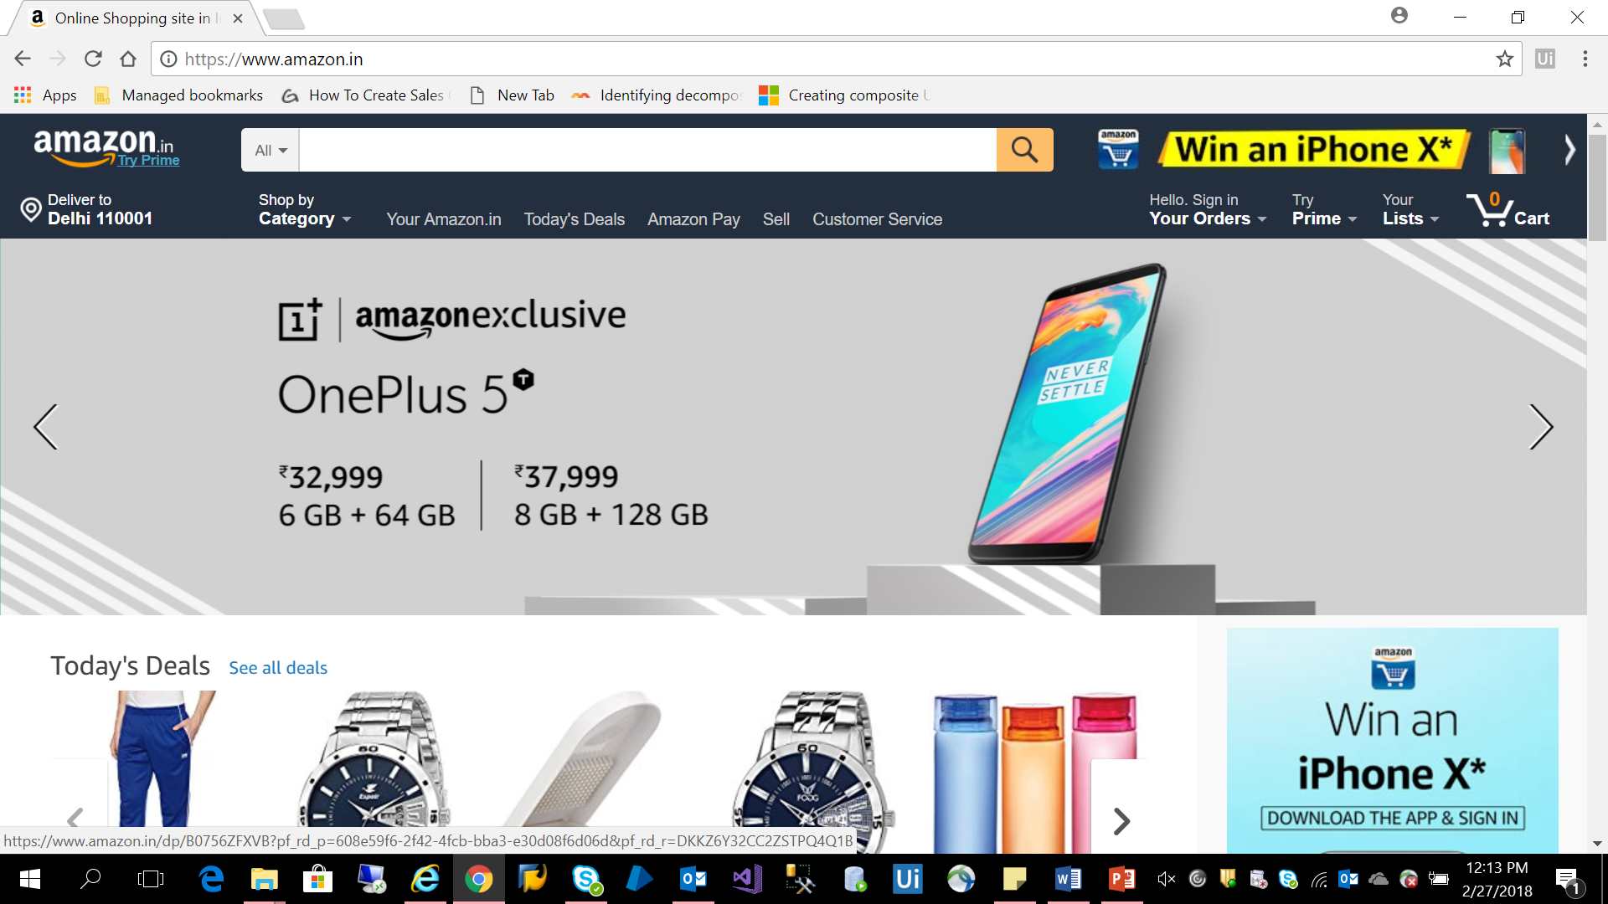

Step 2: Search for “Samsung mobiles” and click on search icon.

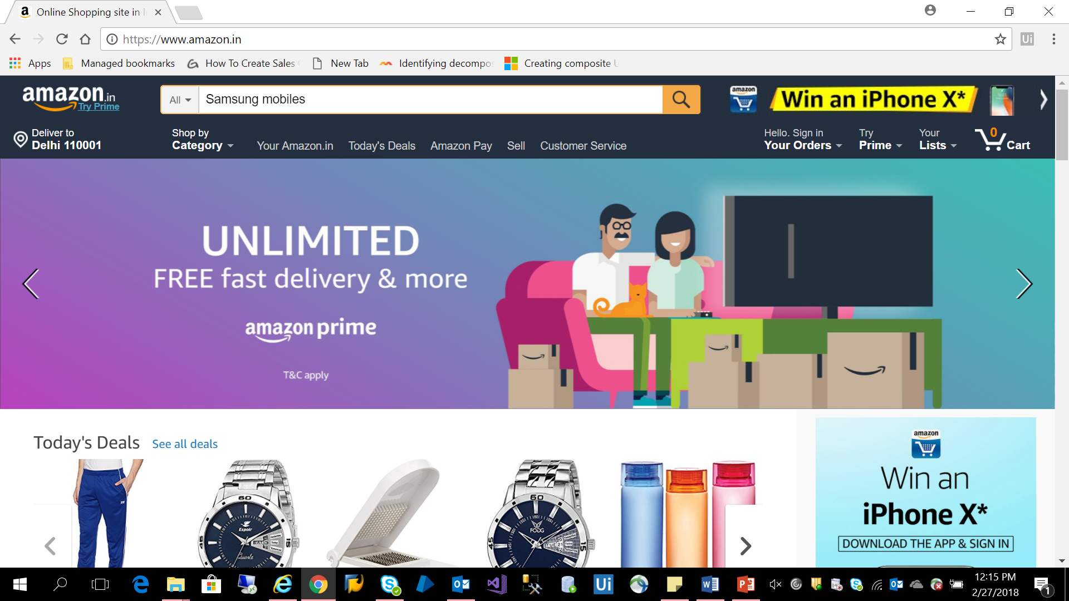

Step 3: Harvest/Scrape the data “Url, Product name, Price” for all the result set displayed using data scraping wizard from UiPath.

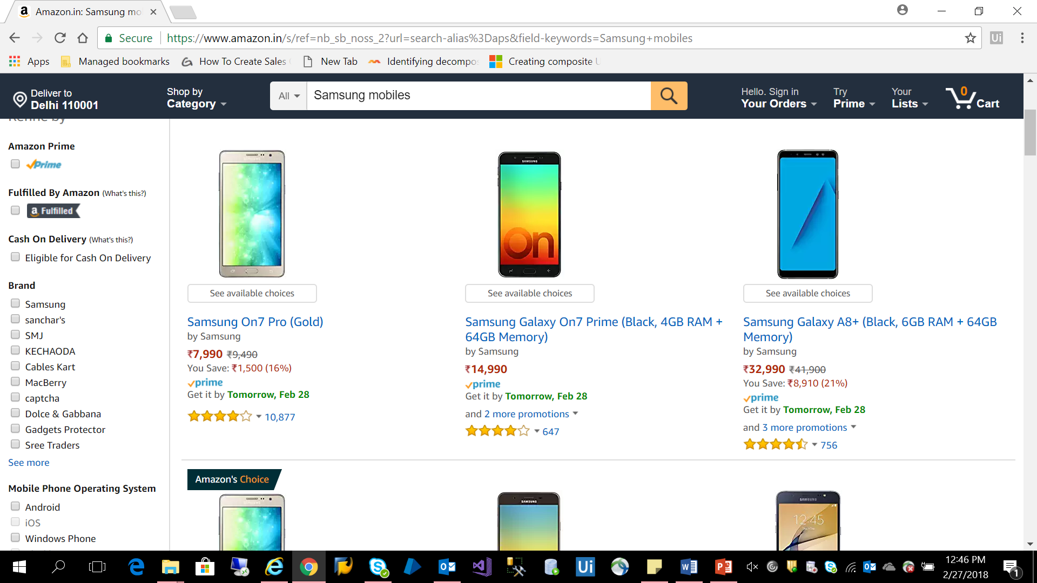

Step 4: After harvesting product data, Remove the Sponsored ad’s using filtering method.

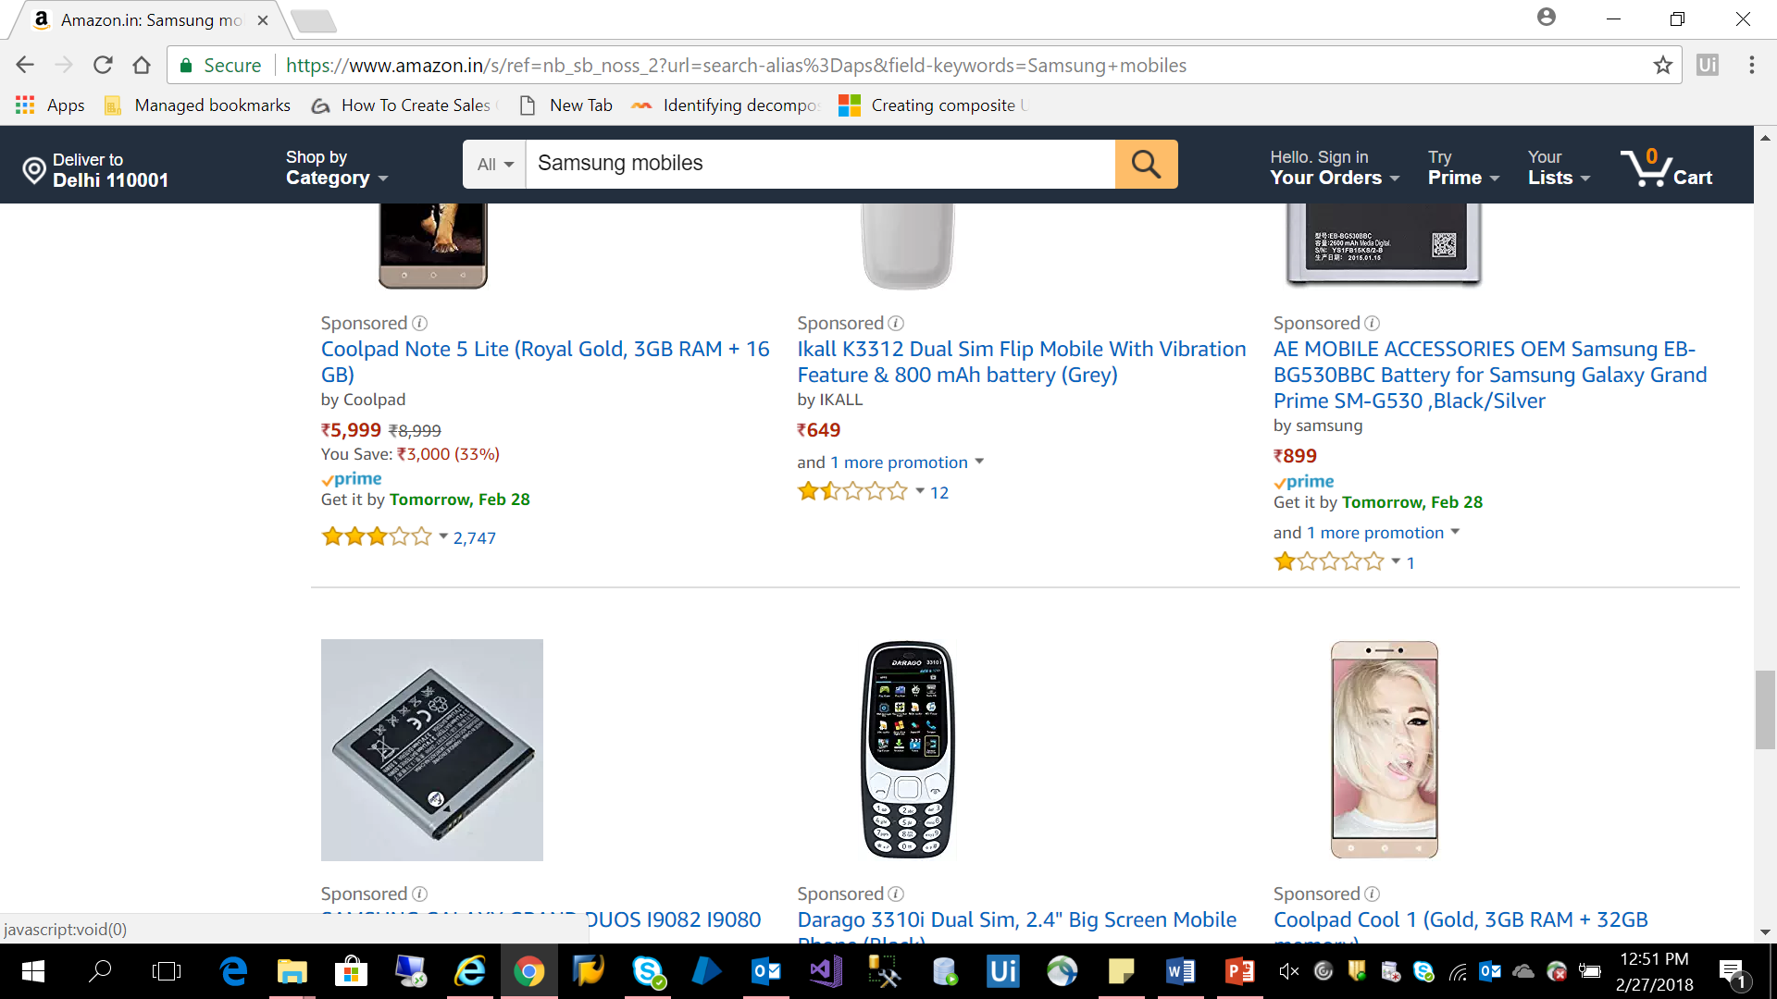

Step 5: After removing the sponsored ads, write the final result set to excel file.

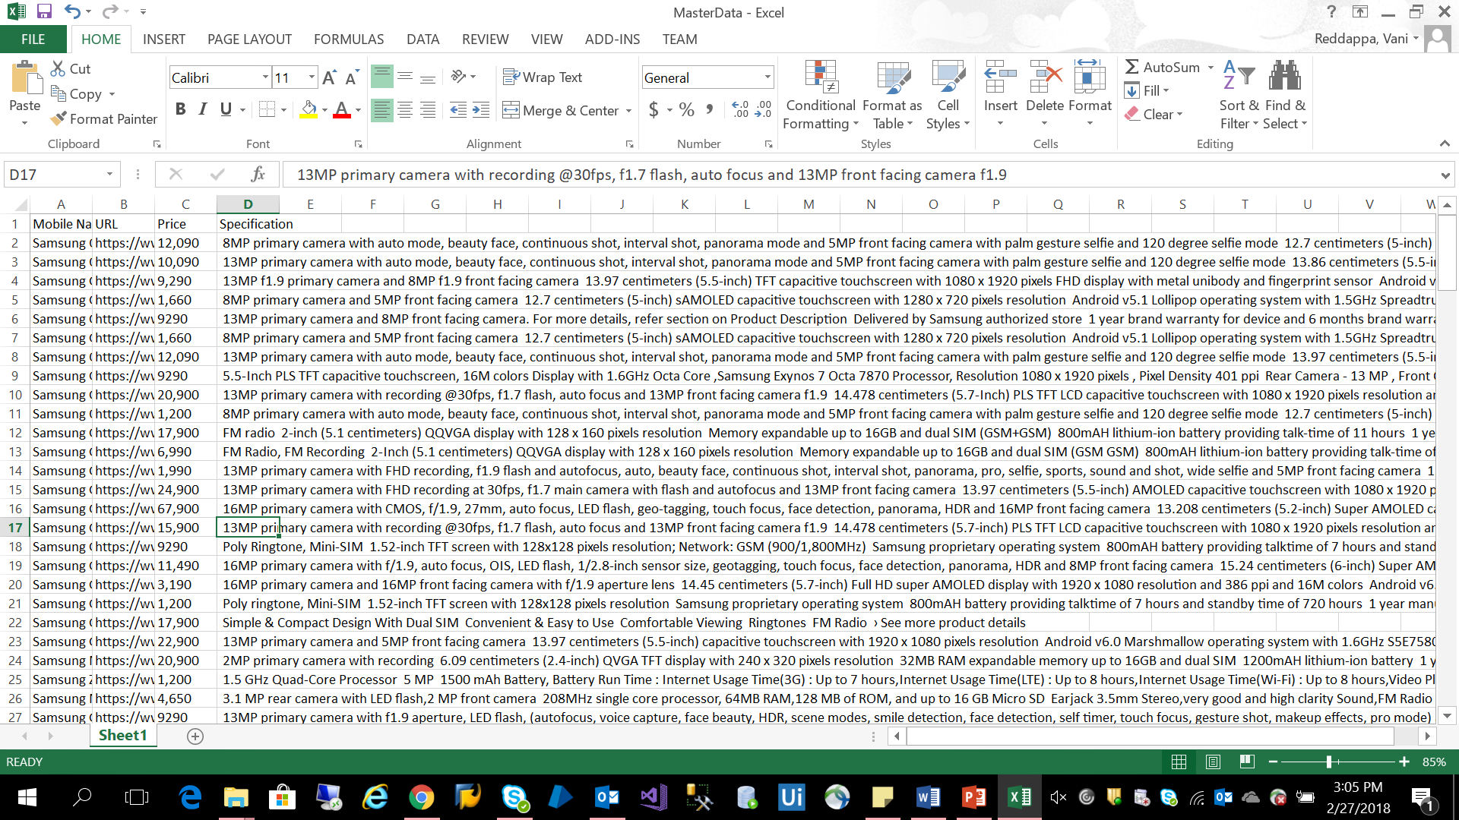

Step 6: Read the extracted Url from excel file and navigate to each Url and scrape the product “Specification, Availability/Stock and Color”. Check if the Color and Stock is there or not. If it is displayed write the value else write NA.

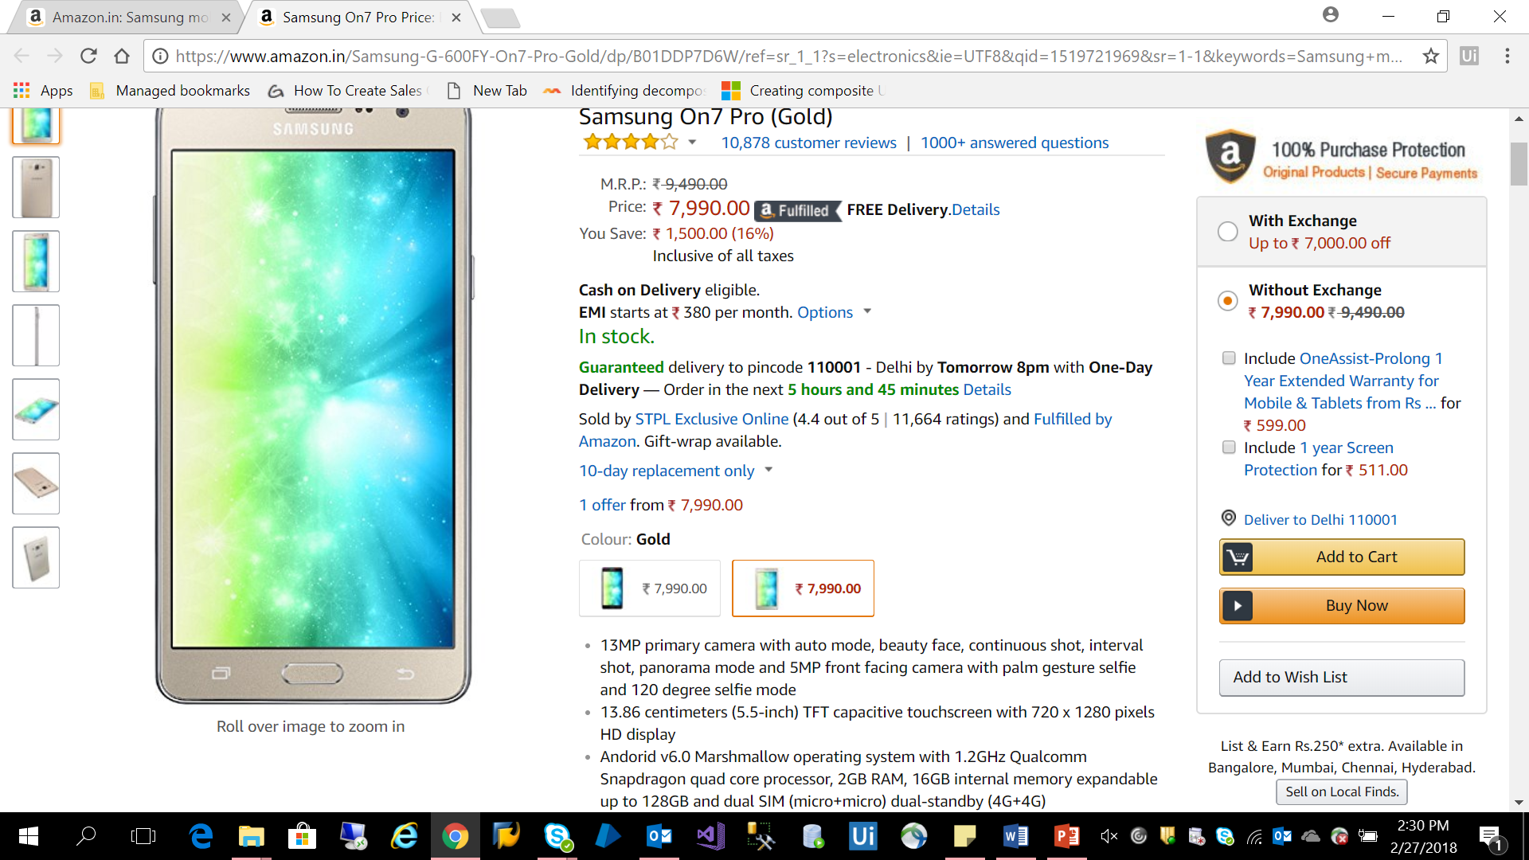

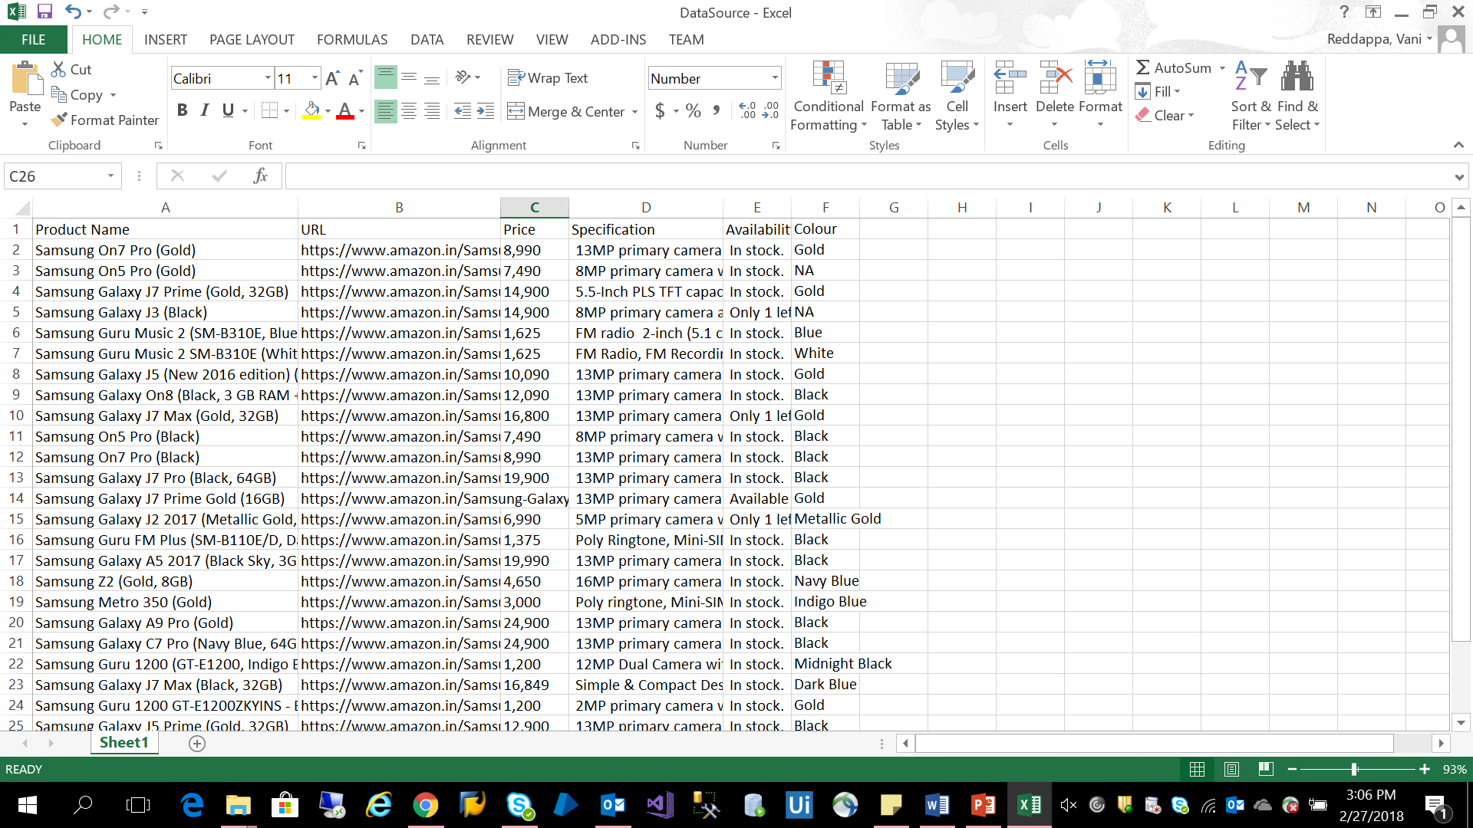

Step 7: Compare the Harvested data against the Master/Trusted data from the customer. If any discrepancy found generate a report and send it to stake holders.

Note: Discrepancy such as Product price mismatch or Image not uploaded properly or Stock discrepancy.

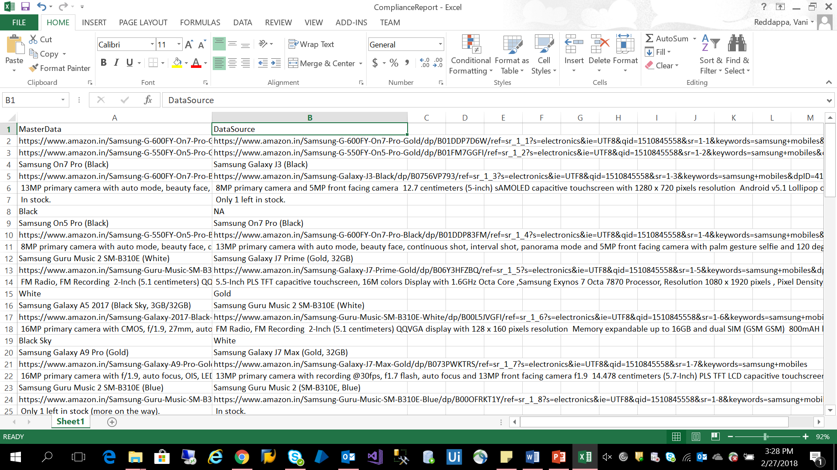

**3.1.6 Benefits**

* Reduce hour long FTE driven process to minutes with complete Automation and no manual intervention
* Reduce recurring cost for customers
* Provide product compliance report on-demand
* Enhance Digital customer experience and ROI

**3.1.7 PoC Challenges and Workaround/Resolution**

|  |  |
| --- | --- |
| Challenges | Workaround/Resolution |
| Filtering the sponsored Ads on the product search results page | Resolved by identifying sponsored Ads URL’s from the harvested result set and filtering them programmatically. |
| Harvesting product details irrespective of availability of data coordinates | Resolved by using indicative screen shot technique and retrieving the product details programmatically. |

**3.2 Salesforce Automation**

**3.2.1 Description**

Creating customer contact and creating multiple opportunities for single customer

**3.2.2 Business Case**

Fetching data from excel, Creating customer contact and Creating opportunities for customer.

**3.2.3 Solution**

Data extraction and Validation. We automated data extraction, creating customer contact and creating opportunities for customer and validation on SFDC platform.

**3.2.4 Scope**

* 1. Create Customer Contact:
     1. Login into the application.
     2. Click on link New Contact.
     3. Enter the required details and save the contact.
     4. Verify that new contact has been created.
     5. Close the browser.
  2. Create Customer Opportunity:
     1. Login into the application.
     2. Click on link New opportunity.
     3. Enter the required details and save the opportunity.
     4. Mark various stages of opportunity as closed.
     5. Verify whether the opportunity has been closed.
     6. Close the browser.
     7. **Demo**

**1. Create Customer Contact**:

Step 1: “Read the data from Input file”

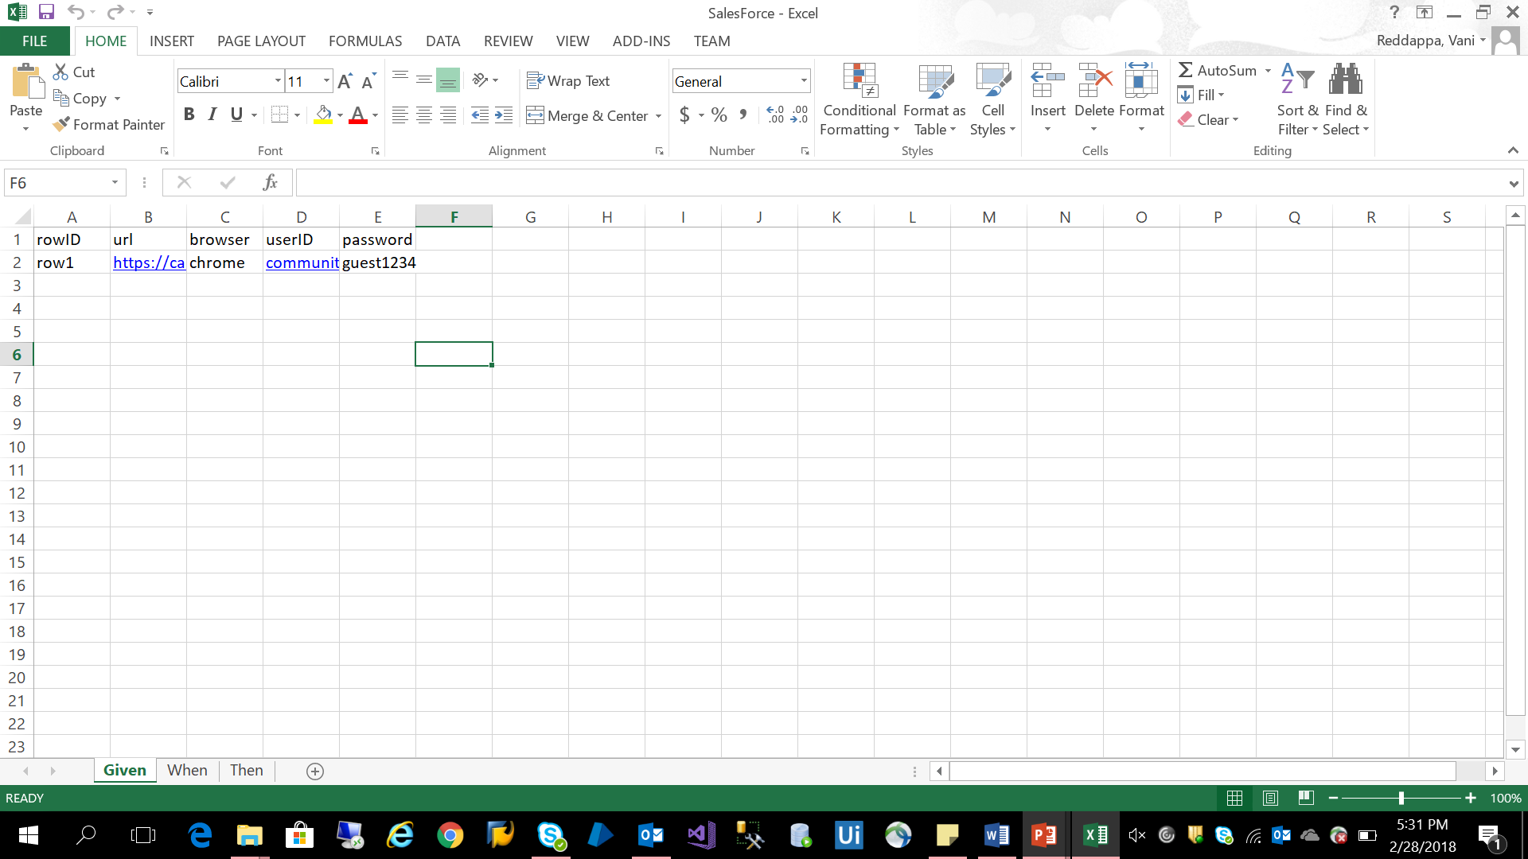

Step 2: Launch the SFDC browser and login with the credentials.

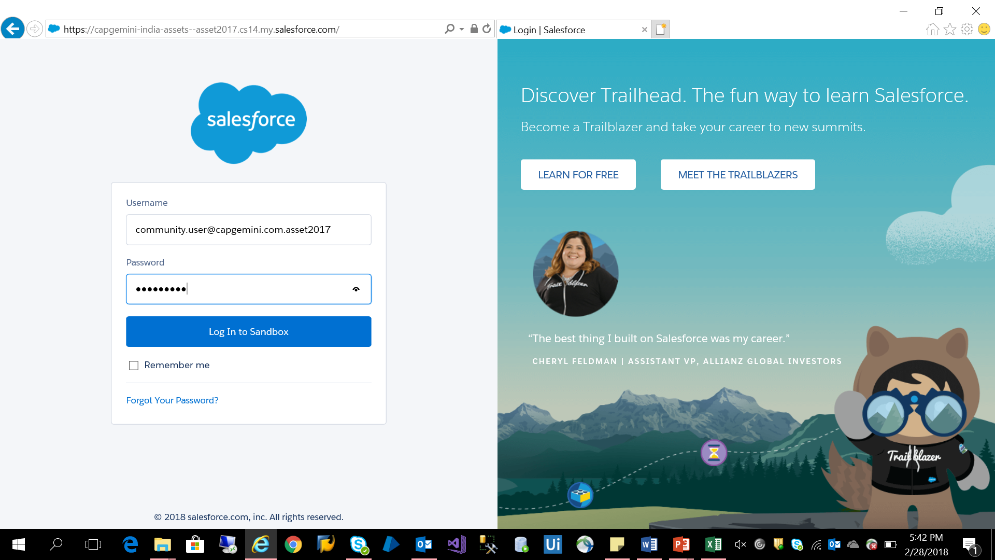

Step 3: Click on “Contacts tab” and then click on “New” to create new contact

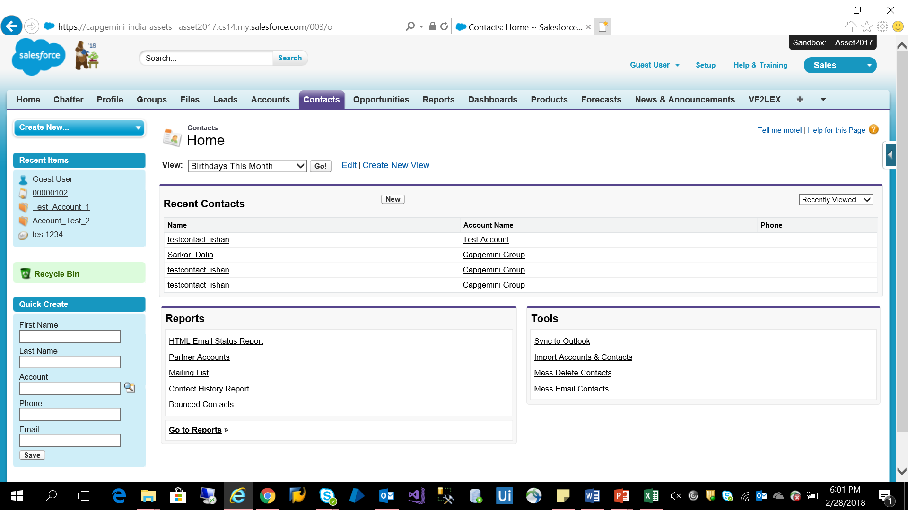

Step 4: Fill the mandatory fields and Save contact

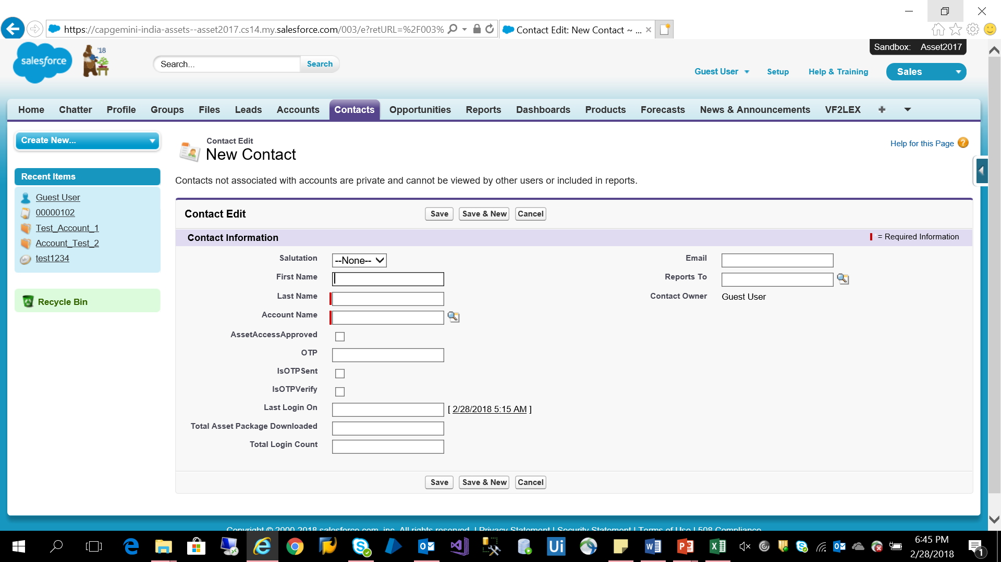

Step 5: Verify customer contact has been saved and logout from SFDC application and close the browser.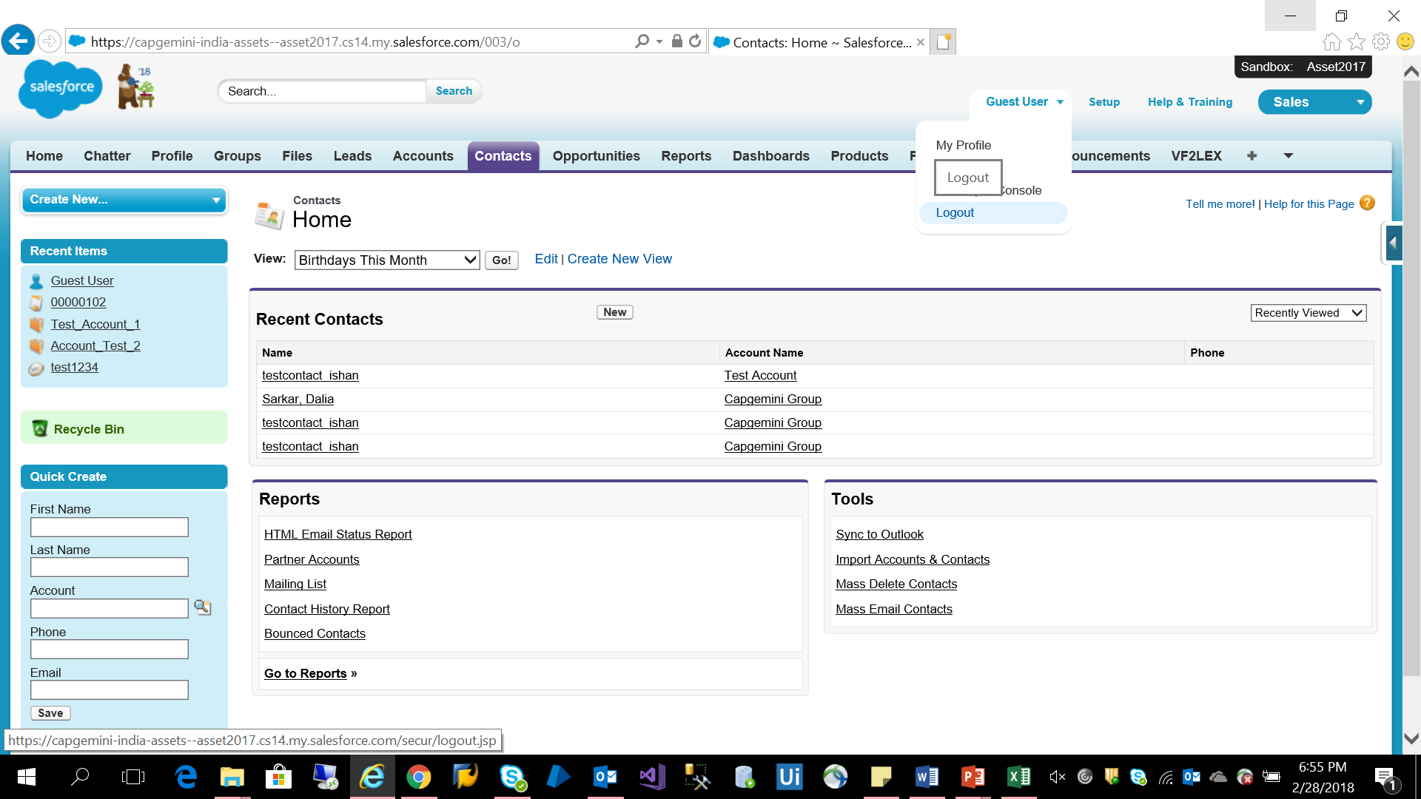

**2. Create Customer Opportunity**:

Step 1: “Read the data from Input file”



Step 2: Launch the SFDC browser and login with the credentials. 

Step 3: Click on “Opportunity tab” and click on “New”

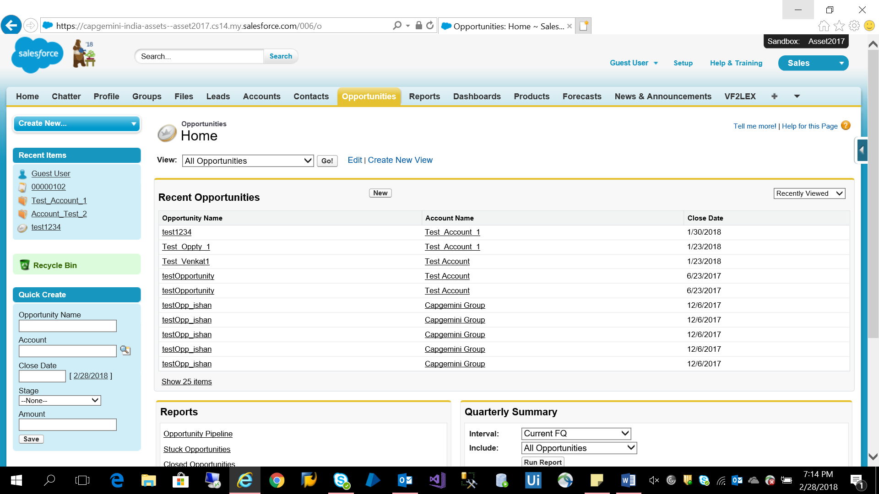

Step 4: Select “Opportunity record type” from dropdown box and click on “Continue”

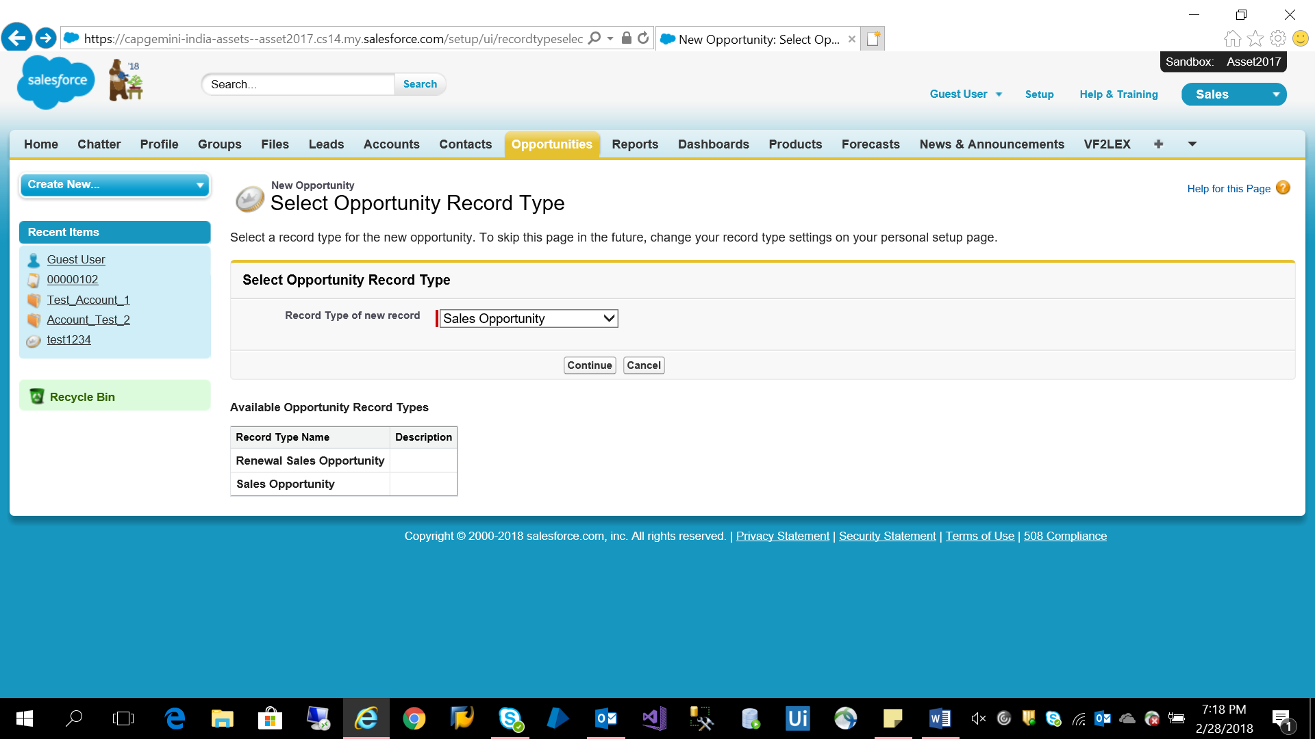

Step 5: Fill the required details and “Save”

Note: Repeat from Step 3 to create multiple opportunities for single customer.

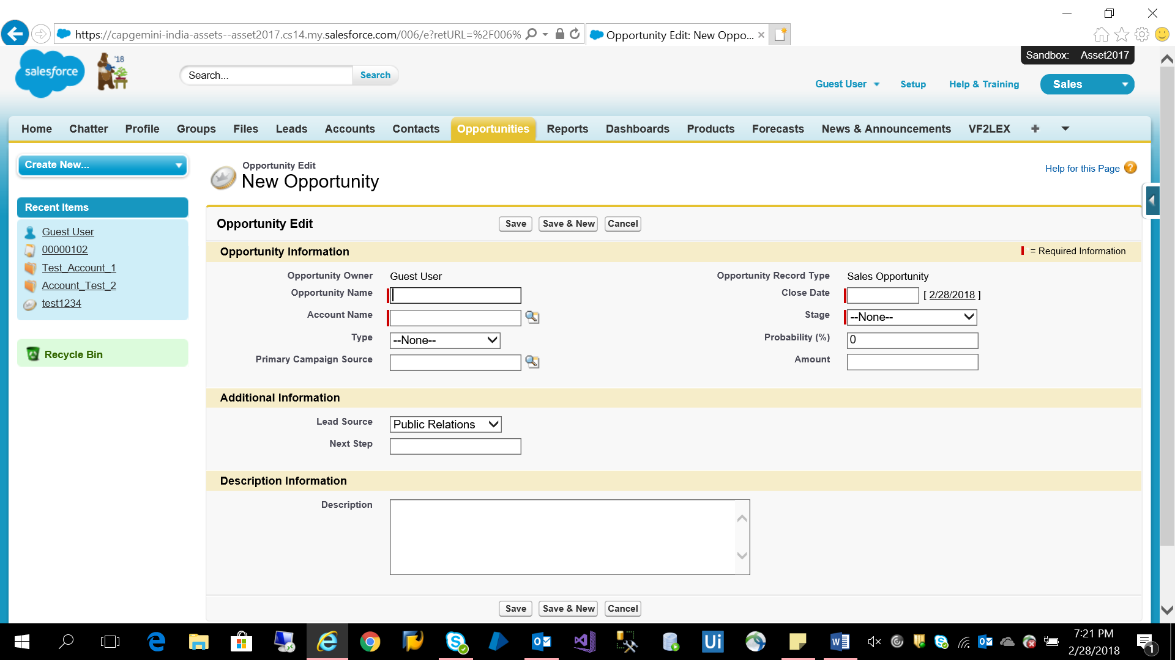

Step 6: Verify the Opportunity created and logout from the application and then close the browser.

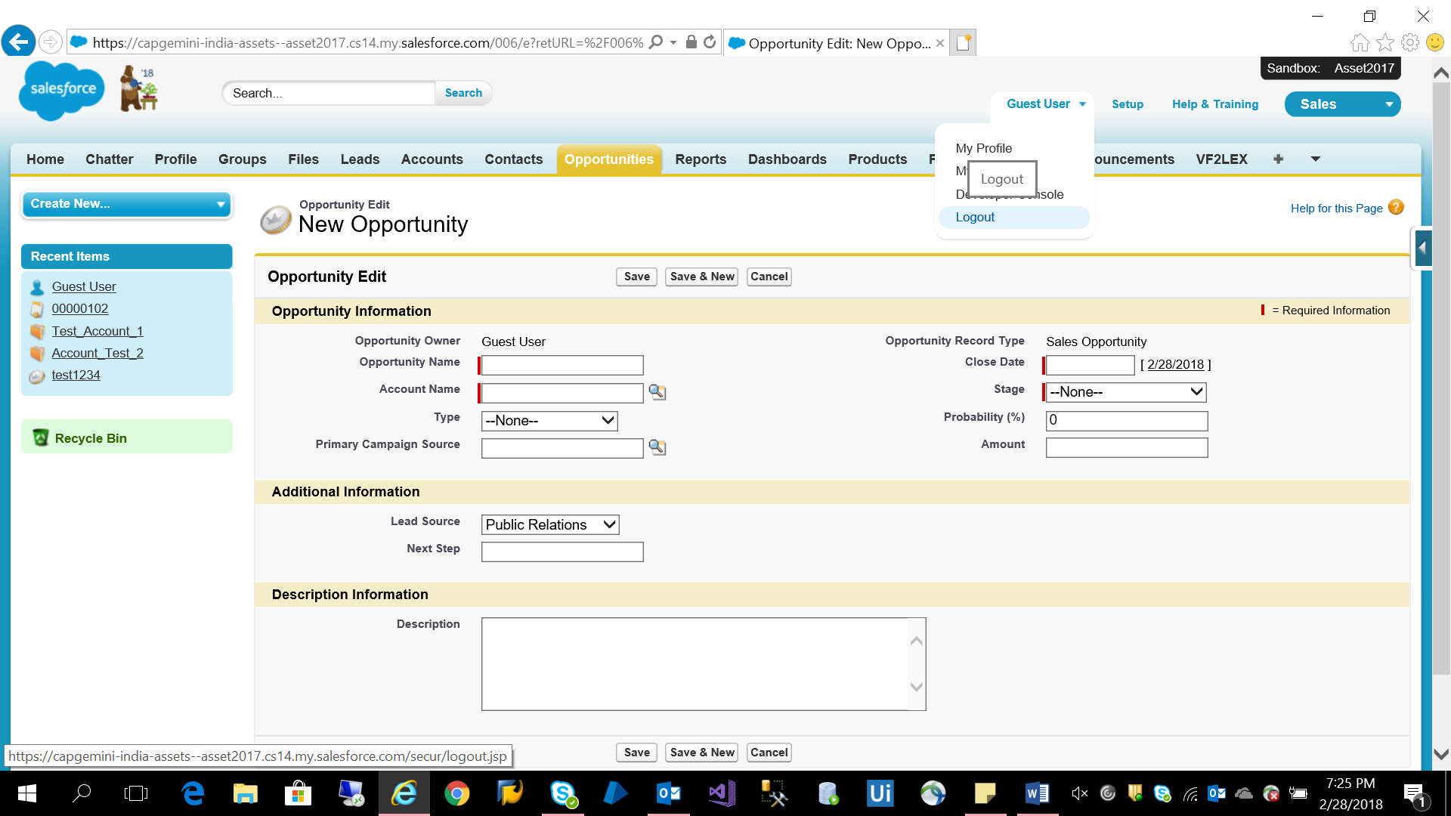

**3.2.6 Benefits**

* Reduce hour long FTE driven process to minutes with complete Automation and no manual intervention
* Reduce recurring cost for customers
* Time saving and eliminates errors
* Accuracy and ROI

**3.2.7 PoC Challenges and Workaround/Resolution**

|  |  |
| --- | --- |
| Challenges | Workaround/Resolution |
| Identification of the UI Elements inside the application which changes at runtime for each user | Resolved by using selectors which provides common identification for each UI Element for each user. |

**3.3 SAP Automation**

**3.3.1 Description**

Creating customer contact and creating multiple opportunities for single customer

**3.3.2 Business Case**

Demonstrating how FICO & SD transactions can be automated. This is usually done as manual activity which is error prone, time consuming and not scalable.

**3.3.3 Solution**

FICO Automation - Posting Transaction, Data Validation.

SD Automation: Creation of Sales order, Shipment, Delivery, Billing and Displaying on SAP platform.

**3.3.4 Scope**

* SAP FICO Automation
  + 1. Posting of Transaction.
    2. To view document or display document
    3. To view A/C balance or G/L accounts balance display
* SAP SD Automation
  + 1. Creating Sales Order
    2. Create Outbound Delivery
    3. Change Outbound Delivery
    4. Create Billing Document
    5. Cancel Billing document
    6. Display Sales Order
    7. **Demo**

1. SAP SD Automation

Step 1: Open SAP application, select the server to login and login with the credentials

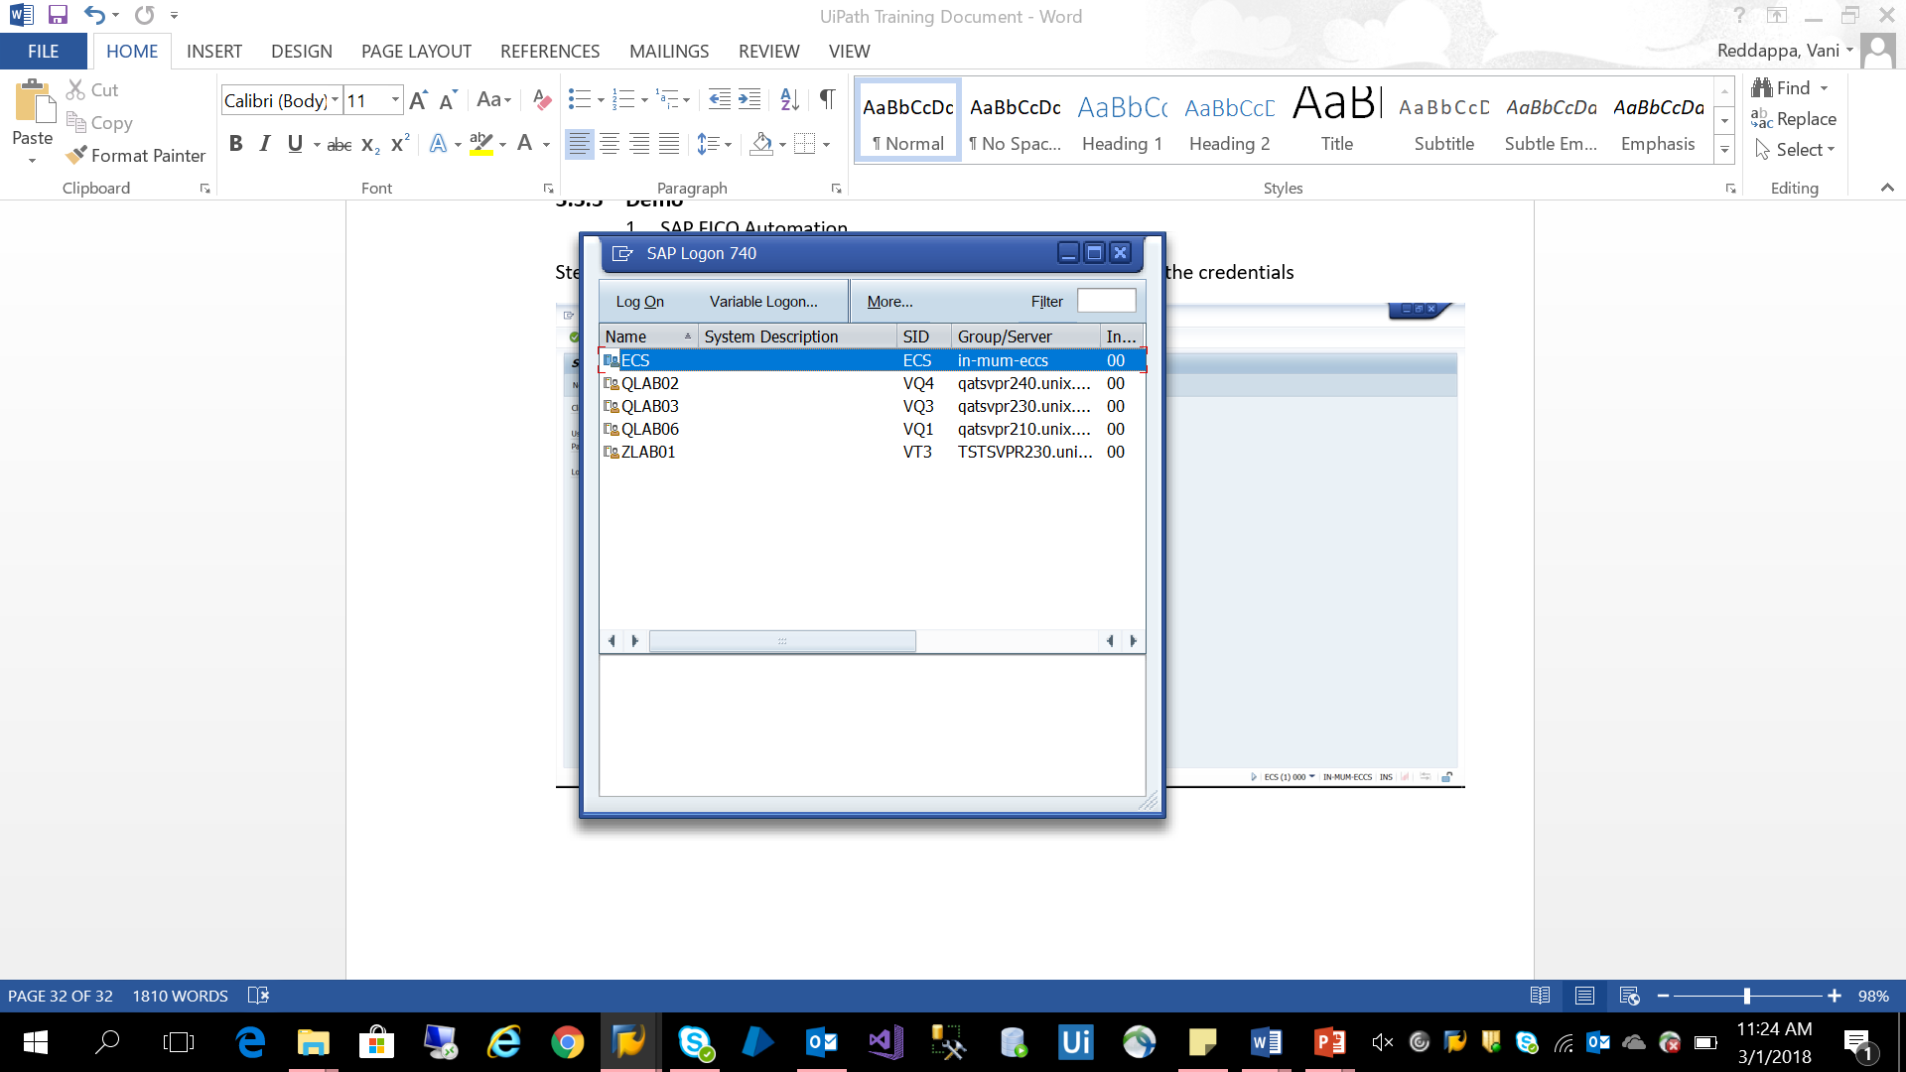

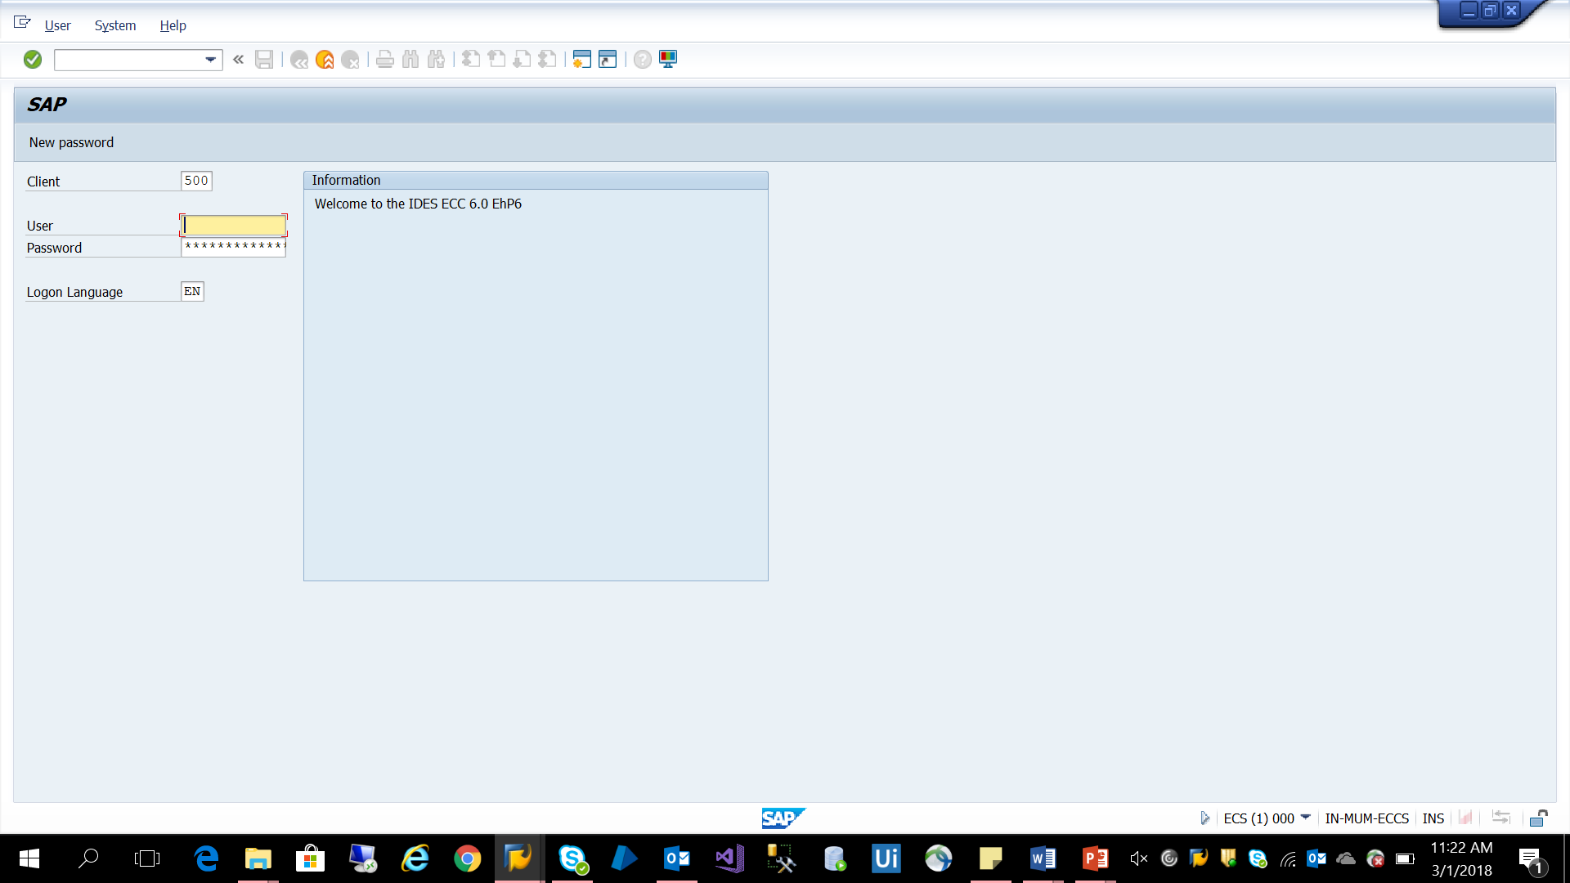

Note: After logging into the SAP application. Please follow the below steps for SAP SD automation.

1. **VA01 – Creating Sales Order with reference**

Step 1: Type T-code “VA01” and “Enter”

Step 2: Order Type – type “OR”

Step 3: Sales Organization – type “1280”

Step 4: Distribution Channel – type “HL”

Step 5: Division – type “UI” and “Enter”

Step 6: Sold to Party – type “200964”

Step 7: Ship to Party – type “200964”

Step 8: Purchase Order – type “demo” (desired number or text)

Step 9: Material – type “710300”

Step 10: Order Quantity – type “1” and “Enter”

Step 11: Pop up dialogue will appear – click on “Continue” and “Enter”

Step 12: Click on “Edit” in menu bar and Click on “Incompletion log” (will get message “document is complete”)

Step 13: Click on “Save” (after saving will get message “Standard Order 1888 has been saved”)

1. **VL01N - Create Outbound Delivery with Order Reference**

Step 1: Type T-code “/nVL01N” and “Enter”

Note: By Default it will take Shipping Point “1100” else take manually from sales order.

Date and Order “1888” if not enter manually

Step 2: Click “Enter” and then click on “Save” (will display message “80001722 has been saved”)

1. **VL02N - Change Outbound Delivery**

Step 1: Type T-code “/nVL02N” and “Enter” and “Enter”

Step 2: Click on “Picking tab”

Step 3: In picked Quantity field – type “1” (same number as in delivery)

Step 4: “Save” and “Enter” (will get batch number “0000001468”)

Step 5: Click on “Loading tab”

Step 6: Select the batch number

Step 6: Click on “Storage location” (it will dummy test value “0001”)

Step 7: Click on “Post Goods Issue” (Display message “Delivery has been saved”)

1. **VF01 - Create Billing Document**

Step 1: Type T-code “VF01” and “Enter”

Step 2: “80001722” and “Enter”

Step 3: Click “Save” (will display message “Billing document is saved”)

1. **VF11 – Cancel Billing Document**

Step 1: Type T-code “VF11” and “Enter”

Step 2: Click “Save” (Display message “Document has been saved”)

1. **VA03 - Display Sales Order**

Step 1: Type T-code “VA03” and “Enter”

Step 2: Order “1888” and “Enter”

Step 3: Click on “Display Document” (will display all results)

1. SAP FICO Automation

Step 1: Open SAP application, select the server to login and login with the credentials

Note: After logging into the SAP application. Please follow the below steps for SAP FICO automation.

**1) Posting of Transaction (F-02)**

Document Date:  *                               Type       : SA                 Co Code: CAPB*

Posting Date     :    default                            Period     :     default                     Currency: INR* (default)

Posting Key      :     40*                          Account   : 300000*

Enter

Amount           :

Text                 :

Posting Key      :   50*                       Account        : 200100*

Amount           : 200*

Cost Center      :

Text                 :   demo *       → Document→Simulate→----

**2) How to view Document or Display Document:**

PATH: Accounting> Financial Accounting >General Ledger>Document>Display

(TC=FB03)

Select Document List Button

Company Code           :

Document Type            : SA (For General Ledger)

Select Execute Button (F8), It shows document posted.

**3) To View A/c Balance or G/L Accounts Balance Display (FS10N)**

Account NO           :

Company Code      : CAPB

Fiscal Year             :2017

Select Execute Button (on the Top Left side)

Double Click on Cumulative Balance amount

Double Click on Document, Press ‘Enter’

**3.3.6 Benefits**

* Reduce hour long FTE driven process to minutes with complete Automation and no manual intervention
* Reduce recurring cost for customers
* Time saving and eliminates errors
* Accuracy and ROI

**3.3.7 PoC Challenges and Workaround/Resolution**

|  |  |
| --- | --- |
| Challenges | Workaround/Resolution |
| Identification of GUI Elements inside the SAP application that needs to be accessed remotely using SAP Client | Resolved by using UI Controls which provides access to remote GUI elements in SAP Apps |
| Validating the Success or Failure of given T-Code | Resolved by getting the transaction status and comparing it with the desired value. |

**Chapter 4**

**Client PoC**

**4.1 PoC on SAP Automation on Citrix machine**

**4.1.1 Description**

Interpublic Group was looking for a tool which would be suitable for automating IPG’s various Business Scenarios through Robotic Process Automation tool such as UI Path.

UiPath tool was identified as a RPA tool to interpret the user interface of IPG SAP application with SAP Net weaver portal, R3, Fiori client App and BPC landscape and to execute steps identically to a human user.

**4.1.2 PoC Objective**

The objective of creating POC is to check whether UiPath tool is feasible to automate the sample test scripts for various IPG’s landscapes such as SAP Net weaver portal, R3, Fiori client App and BPC.

**4.1.3 Automation tool details**

|  |  |
| --- | --- |
| Tool | UiPath |
| Version | [UiPath v2016.2.6379](https://www.uipath.com/release-notes/uipath-v2017.1-sp1) |

**4.1.4 Applications under test**

|  |
| --- |
| Application |
| SAP Net Weaver |
| SAP R3 |
| SAP Fiori Client |
| BPC Excel Application |

**4.1.5 Scope**

For the pilot, the following test scripts have been identified.

|  |  |
| --- | --- |
| Test scripts identified for POC | Application |
| Billable Job Creation | SAP Net Weaver |
| PO Approval | Fiori Application |
| SAP JE upload script | SAP R3 |
| BPC Script | Excel Application |

The above test cases will be automated using UI Path v2017 and following parameters are set to be evaluated:

* Installation
* Scripting Methodology
* Ease of scripting
* Data Driven testing
* Script Reusability
* Script maintenance : In terms of efforts & time required
* Flexibility to run scripts
* Validations
* Tool performance for large no of steps in a test script
* Handling business flow variations
* Avoiding manual intervention

**4.1.6 Estimates**

|  |  |
| --- | --- |
| Task | Time Required |
| Installation and setup of UI Path trail version on local machine | 0.5 hour |
| Reusable Activity Creation | 0.5 hour |
| Workflow Creation by linking designed activities. | 0.5 hour |
| Updating existing Activities for object changes. | 0.5 hour |
| Parsing automation artifacts created including workflow changes. | 1 hour |

**4.1.7 What Worked Well**

The PoC was successfully able to execute all the components individually and in integration mode i.e. in a single test scenario execution session.

* Installation:

The UiPath adds in for UiPath installation process is pretty straightforward just by downloading the UiPath trail version installation package from UiPath site through registration.

* Coding Skills Required:

Coding skills are not required for creating automation scripts.

* Ease of scripting:

Multiple types of workflows are available in Studio (Sequences, Flowcharts and State machines) that helps to build the automation workflow according to our business requirement.

* No Synchronization issue

UiPath provides robust solution for synchronization of web pages.

* Modular & Data Driven Scripts:

The processes can be parameterized and data driven scripting is possible.

* Flexibility to Run Scripts:

In case something goes wrong during execution, there is flexibility to resume the execution instead of running from scratch which will save time, reduce manual and user dependency.

* Handling Manual Intervention:

UiPath provided flexibility to do attended automation allowing manual intervention. It works on the same workstation as a human and is usually triggered by the user through their actions (user events). We cannot start processes from Orchestrator on this type of Robots, and it cannot be executed under a locked screen.

**4.1.7 What did not Work Well?**

This PoC has encountered challenges of different nature and severity. These challenges can be an excellent input for planning future Test Automation activities. The challenges have been overcome with either solutions / workarounds and are detailed below.

**We need continuous Script maintenance and dry runs before execution.**

|  |  |
| --- | --- |
| Challenge 1 | Unable to record script for SAP Net Weaver Portal |
| Description | After successful installation of UI Path on local desktop and connected to VPN for IPG network, once we start with Script,  UiPath was unable to recognize elements on the page through recording mode used for Web based automation. Due to this we were not able to record/Create script for net weaver portal. |
| Workaround/Resolution | To Record/Create new script using UiPath for Net Weaver application, need to use recording mode for Citrix application. Citrix recording is an image based automation. |

|  |  |
| --- | --- |
| Challenge 2 | Unable to identify combo box(drop down list) |
| Description | UiPath feature “Click Element” was unable to identify combo box (drop down list) control to select specific value from the combo box. |
| Workaround/Resolution | The solution provided by IP team was to use “Type Into” activity by using relative property of the combo box. By using Citrix recording mode, we scraped the relative element on the screen relative to that combo box and then used “Type Into” activity which selects the specific combo box as element and selects the given value from the drop down. We can provide the value to be selected from drop down as parameter to the “Type Into” activity. |

|  |  |
| --- | --- |
| Challenge 3 | Unable to recognize “Job Description” field |
| Description | Identification of Job Description field was not working. |
| Workaround/Resolution | The solution was designed by offshore team as to use “Send Hot Key” feature of UiPath. By using “Tab” key as hot key we set focus on job description field. After that we used Hot key for sending text to the job description field which worked successfully. |

|  |  |
| --- | --- |
| Challenge 4 | Scrolling issue to identify elements. |
| Description | Unable to identify elements which are not within display window due to scrolling issue. |
| Workaround/Resolution | The workaround for this challenge is to use “Send Hotkey” feature of UiPath. We provided “Page Up” and “Page Down” keyboard keys as parameter to “Send Hot Key” activity. |

|  |  |
| --- | --- |
| Challenge 5 | Unable to read text from element |
| Description | UiPath was unable to read text from element which shows successful job creation message. So unable to validate that message. |
| Workaround/Resolution | Offshore team has arrived at resolution by implementing Screen scraping feature of UiPath which enables us to extract structured data from any browser, application or document. |

**4.1.8 Demo**

**Step 1:** Login to SAP Netweaver portal and click on Client Management tab.

**Step 2:** Create Billable Job - Enter all mandatory fields on Job maintenance screen and click on save button. Validate the message displayed for successful job creation

**Step 3:** Log Off from SAP portal

**4.1.9 Conclusion**

PoC was successfully completed and delivered.

**4.2 PoC on E2E Automation with T-Mobile**

* + 1. **Description**

T-Mobile was looking for E2E automation approach eliminating manual touch points using desperate tools for automating processes involving Front end, SAP, and EIP DB systems.

**4.2.2 PoC Objective**

The objective of creating POC is to check whether UiPath tool is feasible to automate the sample test scripts for various T-Mobile’s landscapes such as Web, SAP and EIP.

**4.2.3 Automation tool details**

|  |  |
| --- | --- |
| Tool | UiPath |
| Version | [UiPath v2016.2.6379](https://www.uipath.com/release-notes/uipath-v2017.1-sp1) |

**4.2.4 Application under test**

|  |
| --- |
| Application |
| AAL (Web) |
| QVXP - Jump Upgrade (Web & VMware) |
| SAP Logon 740 |
| EIP Database |

**4.2.5 Scope**

For the pilot, the following test scripts have been identified.

|  |  |
| --- | --- |
| Test scripts identified for POC | Application |
| AAL | Web |
| QVXP Jump Upgrade | Web |
| QVXP Jump Upgrade | VMware |
| SAP | Desktop application |
| EIP DB | Oracle Database |

The above test cases will be automated using UiPath and following parameters are set to be evaluated:

* Installation
* Scripting Methodology
* Ease of scripting
* Script Reusability
* Script maintenance : In terms of efforts & time required
* Flexibility to run scripts
* Validations
* Tool performance for large no of steps in a test script
* Handling business flow variations
* Avoiding manual intervention

**4.2.6 Estimates**

|  |  |
| --- | --- |
| Task | Time Required |
| Installation and setup of UiPath trail version on local machine | 0.5 hour |
| KT on QVXP, DocuSign, SAP and EIP Validations (E2E scenario) | 1 day |
| Workflow Creation by linking designed activities.  - QVXP (Jump Upgrade)  - DocuSign(Email Verification)  - SAP (Jump Upgrade)  - QC request  - Run batch job and EIP Database Validations  - Integration of Workflows | 1 day  0.5 day  1 day  1 day  1 days  2 days |
| Updating existing Activities for object changes. | 0.5 hour |
| Parsing automation artifacts created including workflow changes. | 1 day |

**4.2.7 RPA Design Approach**

The E2E flow was broken down into multiple flows. Each of them handled separately and anchored by main flow as follows.

|  |  |
| --- | --- |
| **System** | **Proposed Bot Description** |
| Front end | * Reads the data from Input file and manually triggered. * Launch the browser, executes the flow and generates the PO number. * Verifies the email by clicking on the link in an email and e-sign the agreement. |
| SAP | * Reads the data from Input file. * Triggered automatically on the availability of PO number file from Web Bot. * Launch the SAP application, selects the environment as per Input file and login to SAP application. * Performs Delivery, IDOC mockup, Shipment and generates the fulfillment file. * Invokes the QC application, Launch the QC browser. * Creates a new defect and drops the fulfillment file to middleware application. |
| EIP database | * Reads the data from Input file. * Triggered automatically on the availability of PO number file from SAP Bot. * Runs batch job and connects with the EIP database to perform DB validations. * Generates a report of DB validations. |

**4.2.8 What Worked Well**

The PoC was successfully able to execute all the components individually and in integration mode i.e. in a single test scenario execution session.

* + Installation:

The UiPath adds in for UiPath installation process is pretty straightforward just by downloading the UiPath trail version installation package from UiPath site through registration.

* + Coding Skills Required:

Coding skills are not required for creating automation scripts.

* + Ease of scripting:

Multiple types of workflows are available in Studio (Sequences, Flowcharts and State machines) that helps to build the automation workflow according to our business requirement.

* + No Synchronization issue

UiPath provides robust solution for synchronization of web pages.

* + Modular & Data Driven Scripts:

The processes can be parameterized and data driven scripting is possible.

* + Flexibility to Run Scripts:

In case something goes wrong during execution, there is flexibility to resume the execution instead of running from scratch which will save time, reduce manual and user dependency.

* + Handling Manual Intervention:

UiPath provided flexibility to do attended automation allowing manual intervention. It works on the same workstation as a human and is usually triggered by the user through their actions (user events). We cannot start processes from Orchestrator on this type of Robots, and it cannot be executed under a locked screen.

**4.2.9 What did not work well?**

This PoC has encountered challenges of different nature and severity. These challenges can be an excellent input for planning future Test Automation activities. The challenges have been overcome with either solutions / workarounds and are detailed below.

**We need continuous Script maintenance and dry runs before execution.**

|  |  |  |
| --- | --- | --- |
| **Challenge** | **Description** | **Workaround/Resolution** |
| Image recognition on VMware desktop | We couldn’t install UiPath on client VDI for security reasons. Hence UiPath was installed on Capgemini local machine and automated on client VDI for QVXP Jump upgrade flow with UiPath Citrix automation which is image based automation which was not viable. | Automated the QVXP Jump upgrade web flow on Capgemini local machine where UiPath was installed with T-Mobile VPN access. |
| Oracle database Connectivity form UiPath | For automating an EIP database validations flow, Need to connect with EIP database which is remotely hosted on the client environment. Establishing connection with the database was the issue. | With the help of Oracle in ORA client, able to connect with EIP database which is remotely hosted. |
| Reading XML file from fulfillment path for particular to PO number. | In SAP automation, while generating fulfillment files. XML files used to get create frequently. | Once XML file is generated for particular PO Number, read the file path of recently generated XML file and copy the path and pass it to QC to attach the particular file. |
| Irrespective of environment flow need to be executed. | There are different environments, each environment has different Input data like credentials, Url, MSISDN, Account number, different databases. | Input the values, credentials, and environment to spread sheet which will be the Input file for all workflows. |

**4.2.10 Demo**

1. **QVXP Jump upgrade (Web Application)**

Step 1: Read data from Input file.

Step 2: Launch browser and Login with credentials

Step 3: Click on test harness link

Step 4: Click on toggle to QVXP

Step 5: Select “super care” from dropdown box, enter Account number and MSISDN. Then click on “Toggle”

Step 6: Select check box for upgrade and click on "JUMP! Trade in 1 device "button.

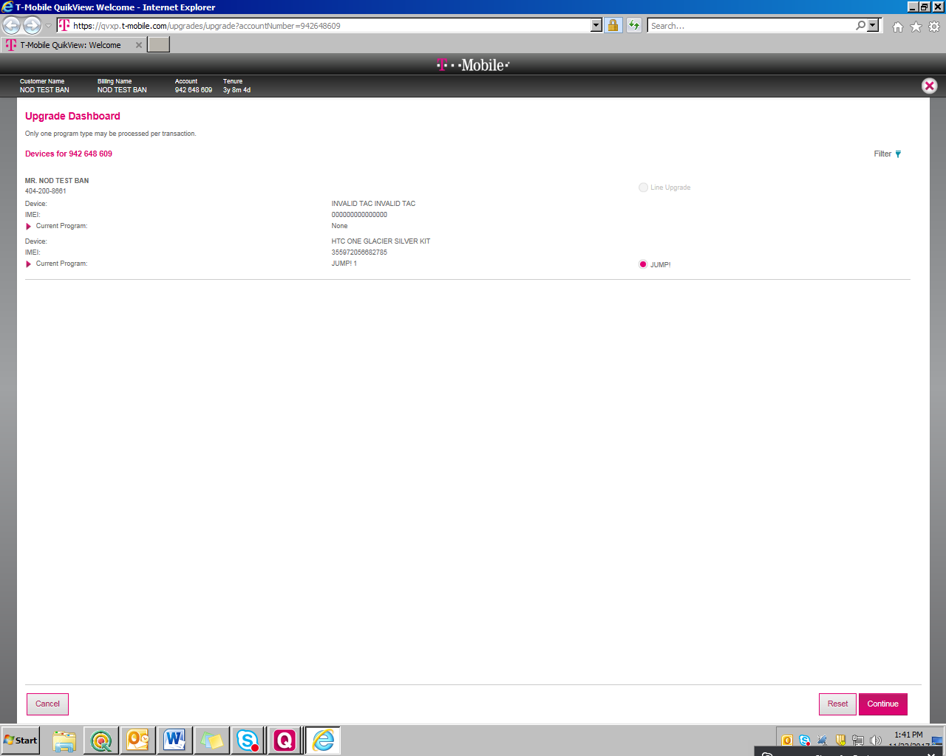

Step 7: Perform trade-in device and click on "View Jump Quote" button.

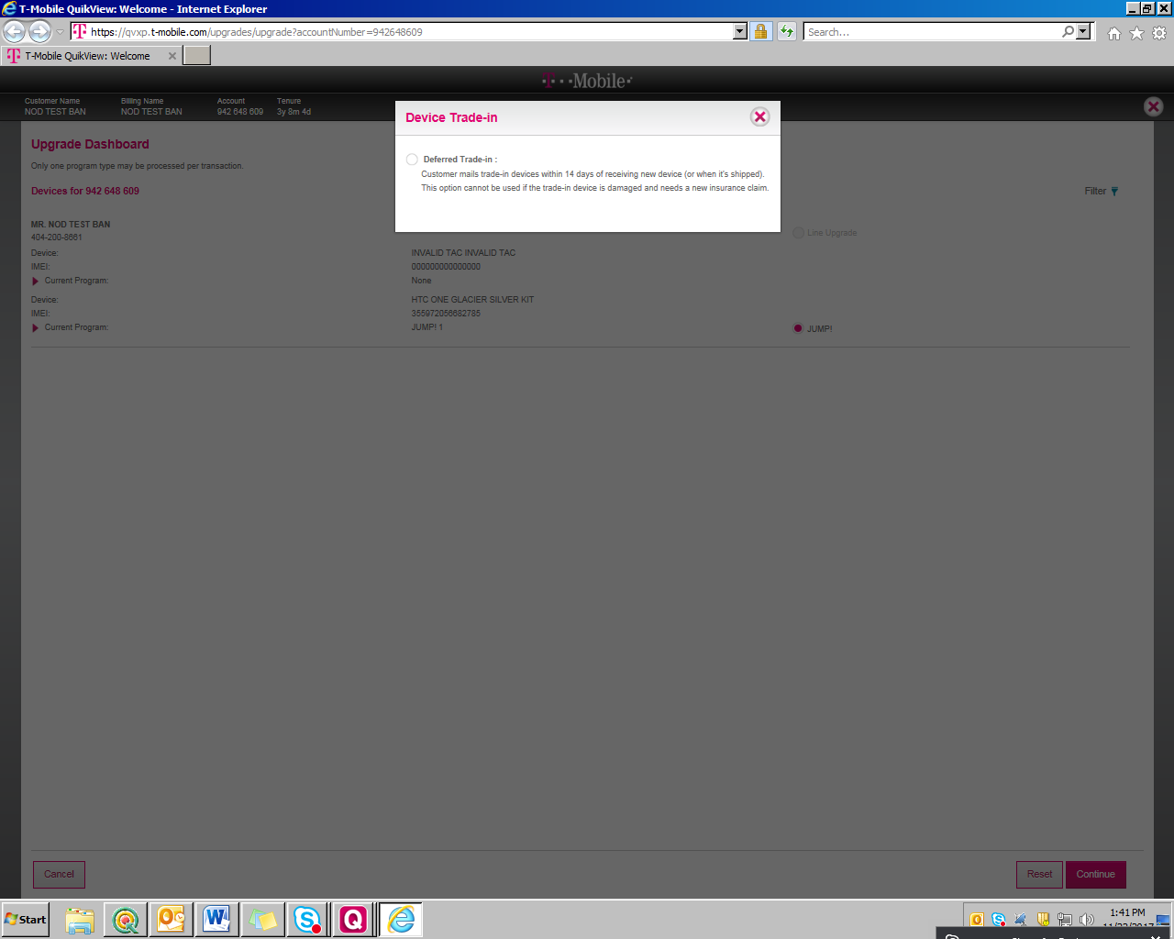

Step 8: Select the answers for security questions

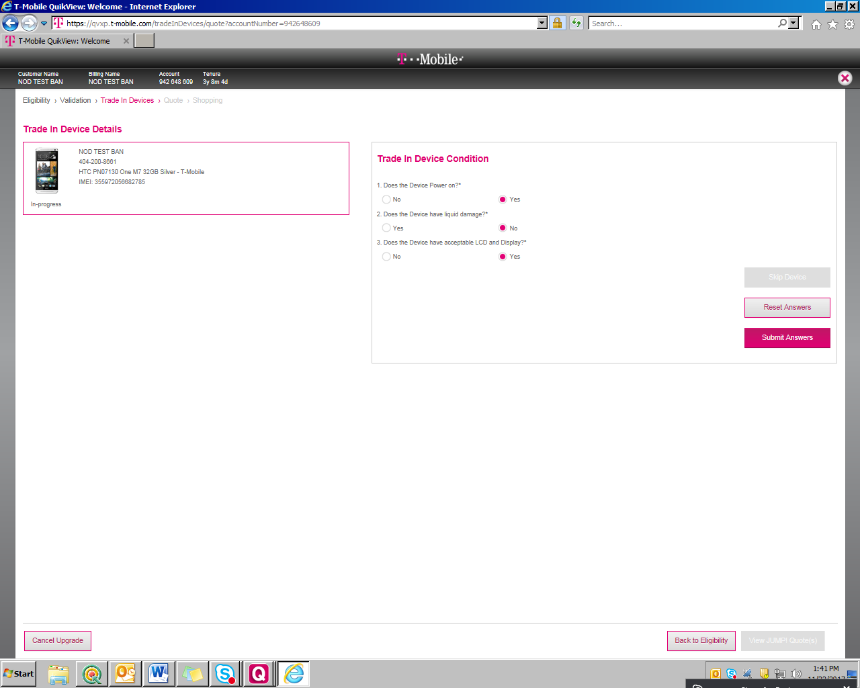

Step 9: Click on "Shop for 1 new device" on quote screen.

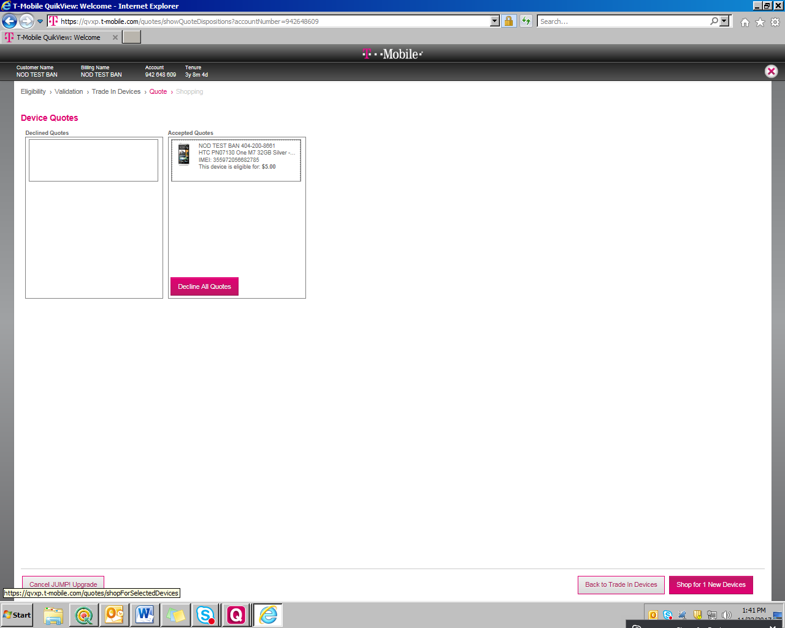

Step 10: User navigates to device selection (Shopping) screen.

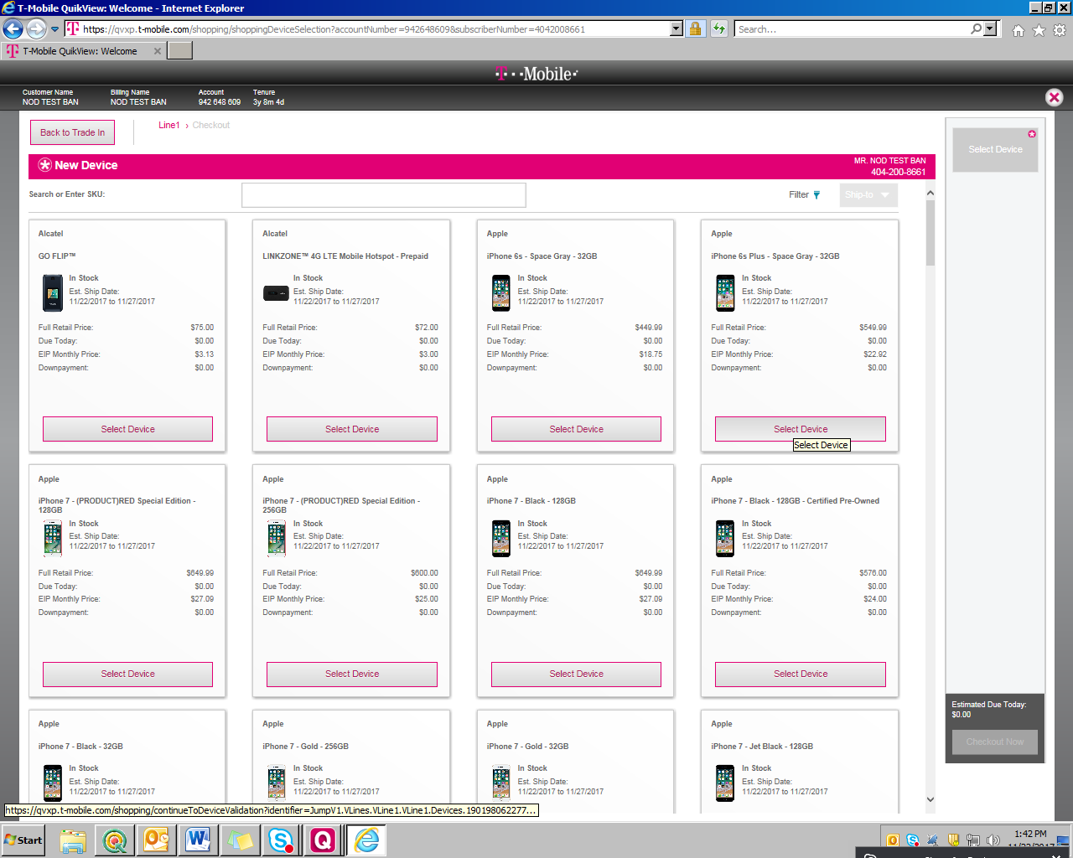

Step 11: Add any device in cart. Select Pricing plan and PHP. Click on checkout button.

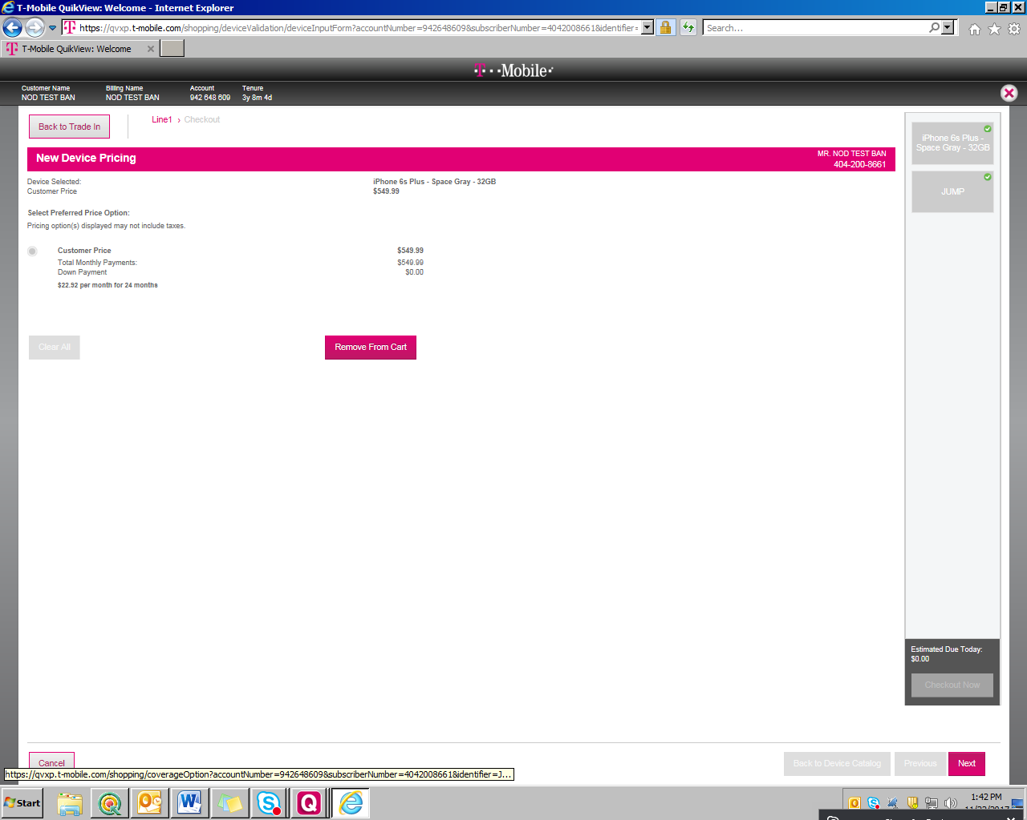

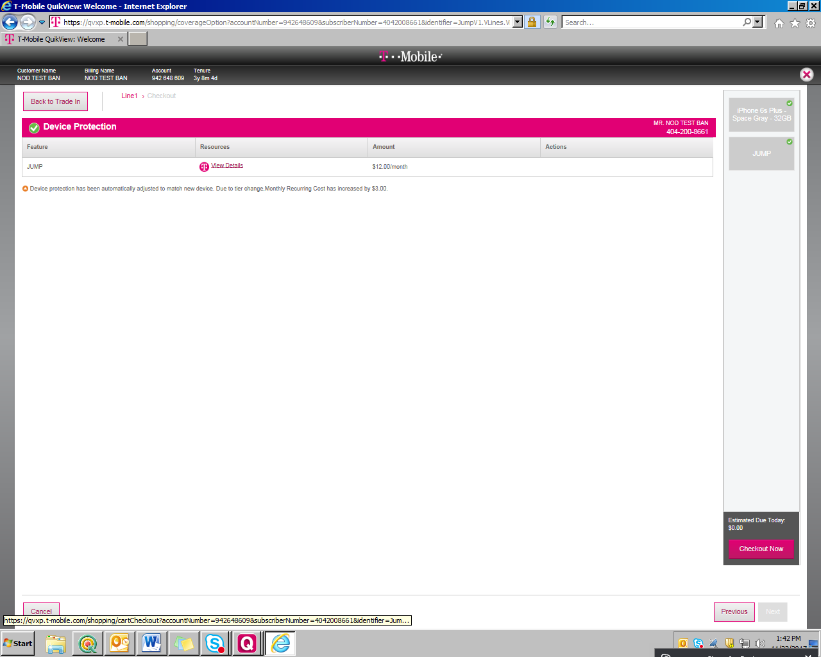

Step 12: Click "Continue to E911 address" on cart screen.

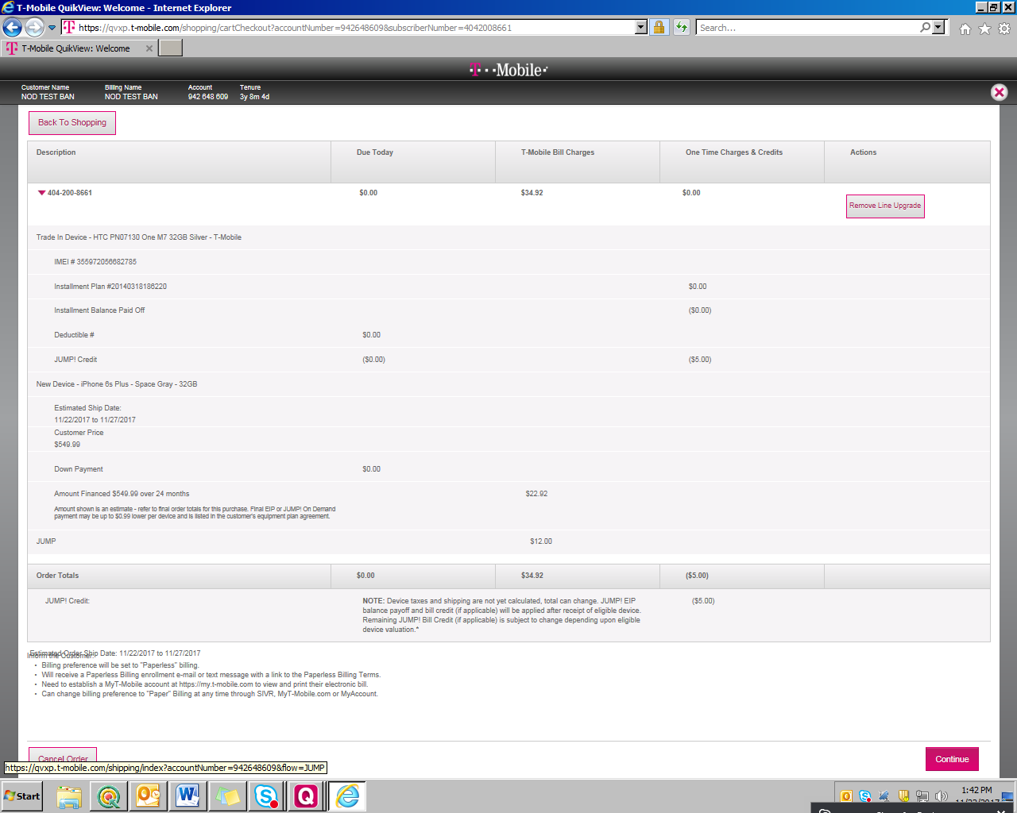

Step 13: Check E911 address and click on "Continue to Shopping and order Preferences" button.

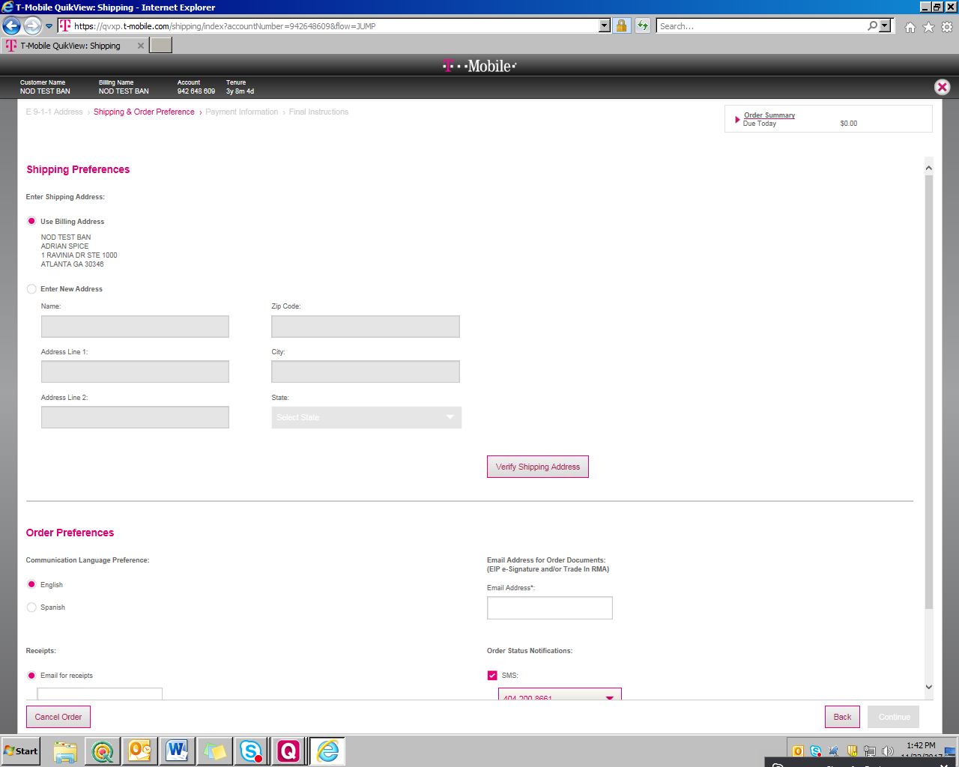

Step 14: Verify Shipping address on "Shipping & order Preferences" screen.

Step 15: Select Email Id and click on "payment Information". Enter Credit card details and select "English" radio button for T&C language.

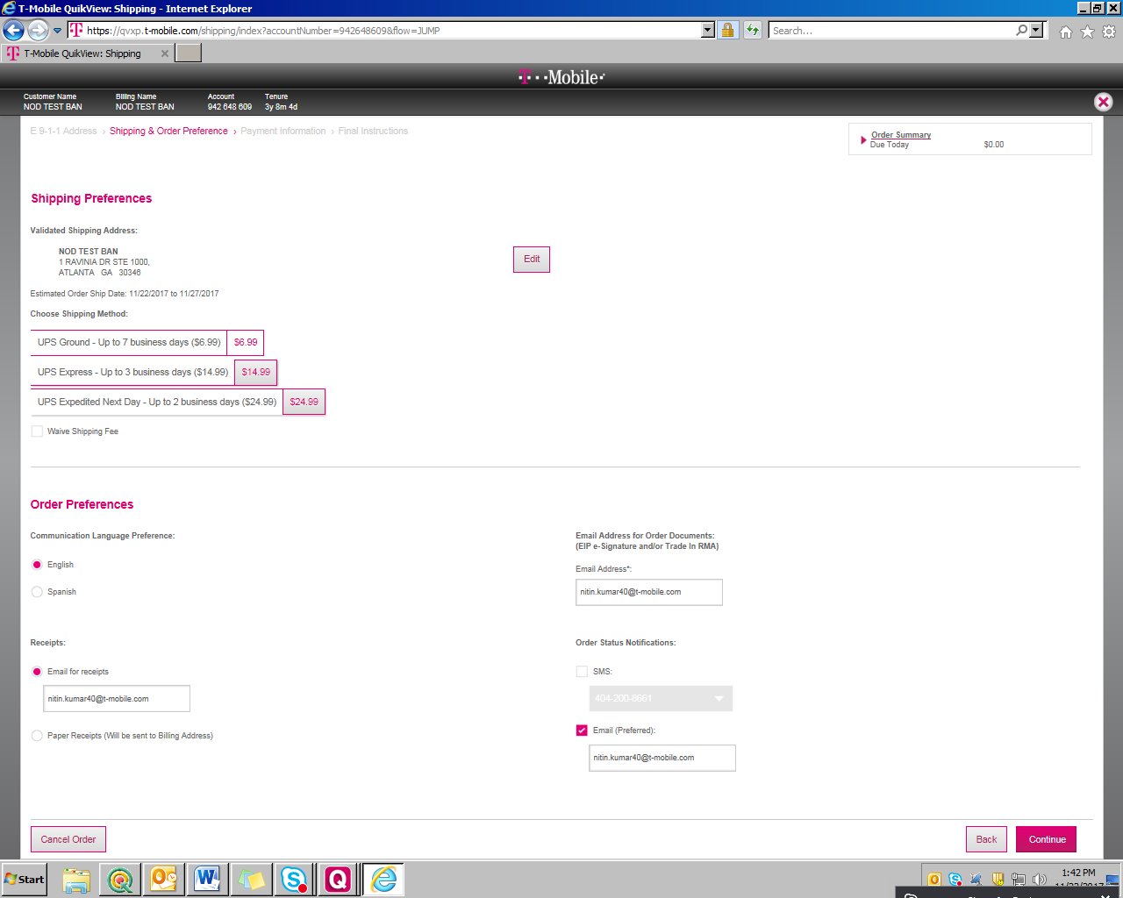

Step 16: Click on "Continue to final instruction" button.

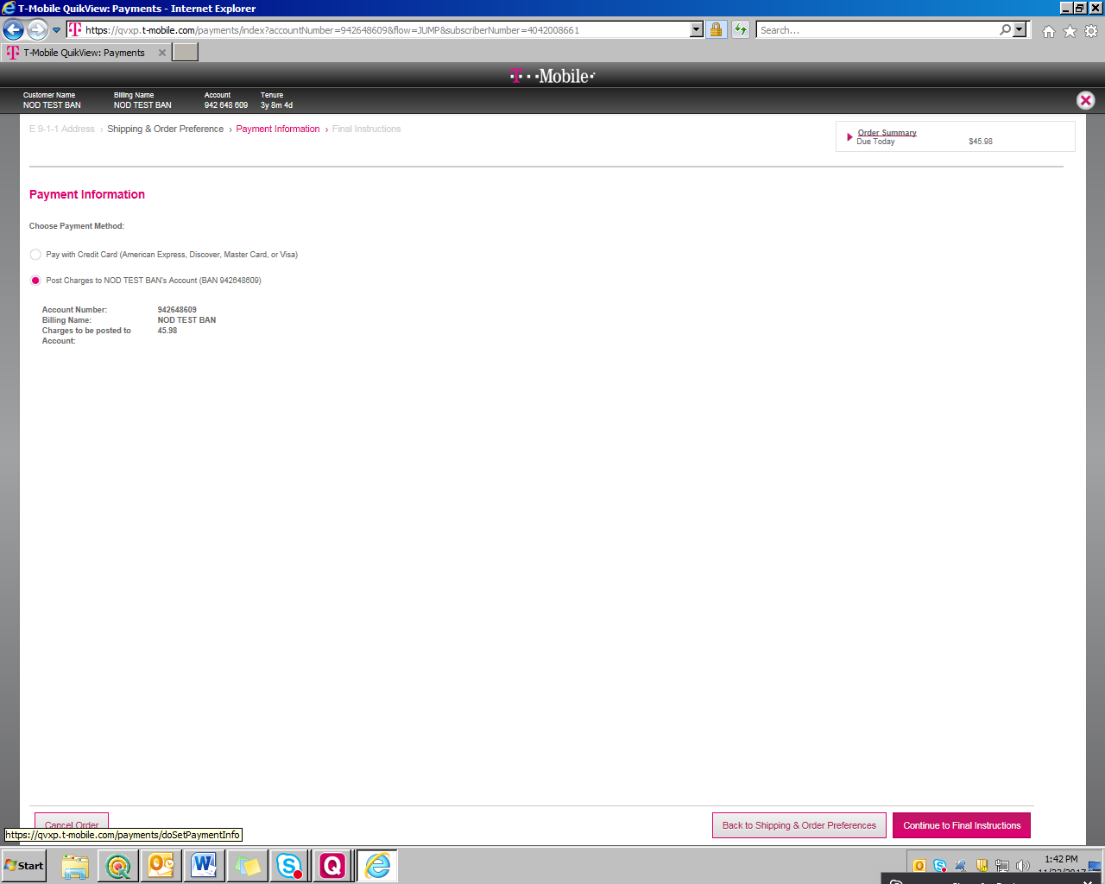

Step 17: Click save button on final instruction page. 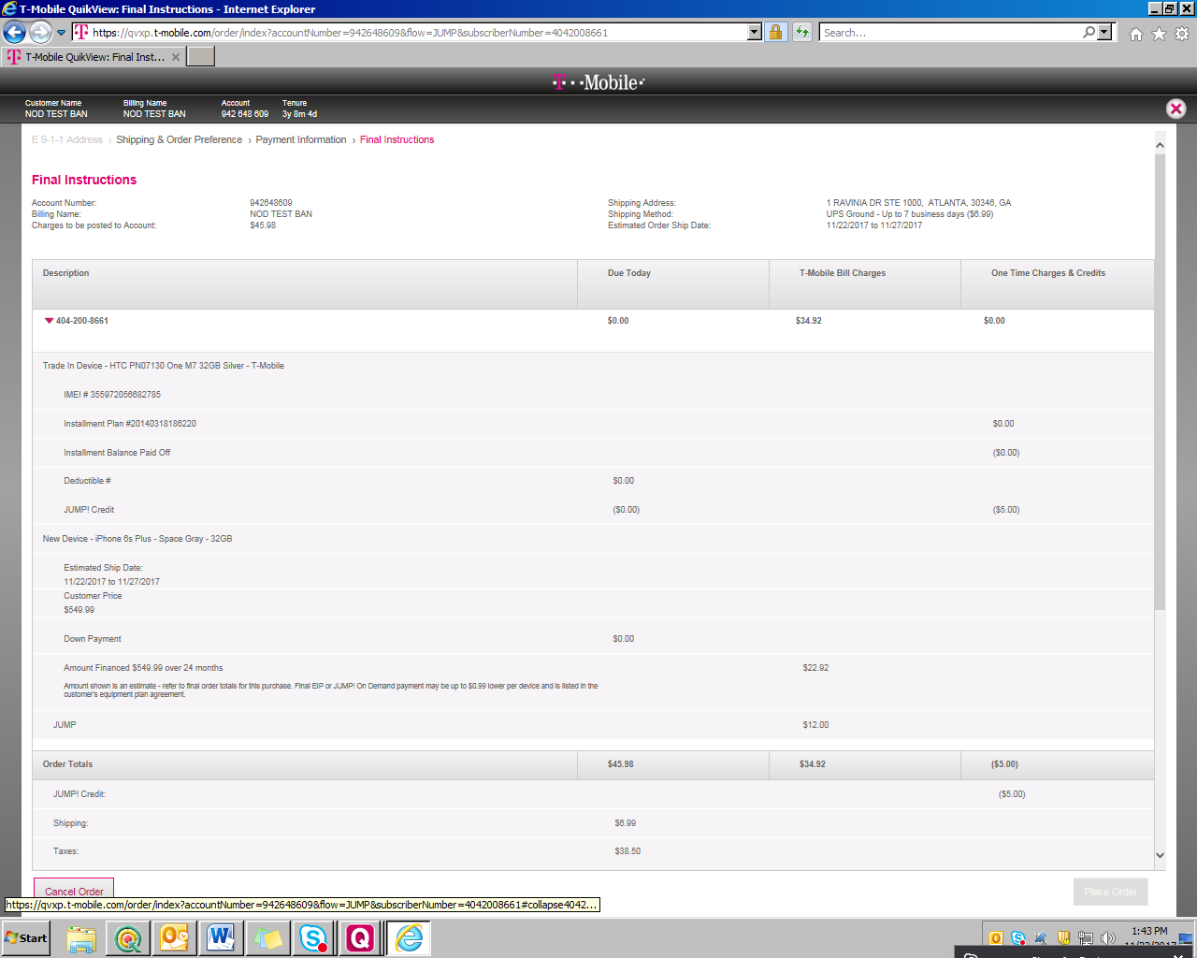

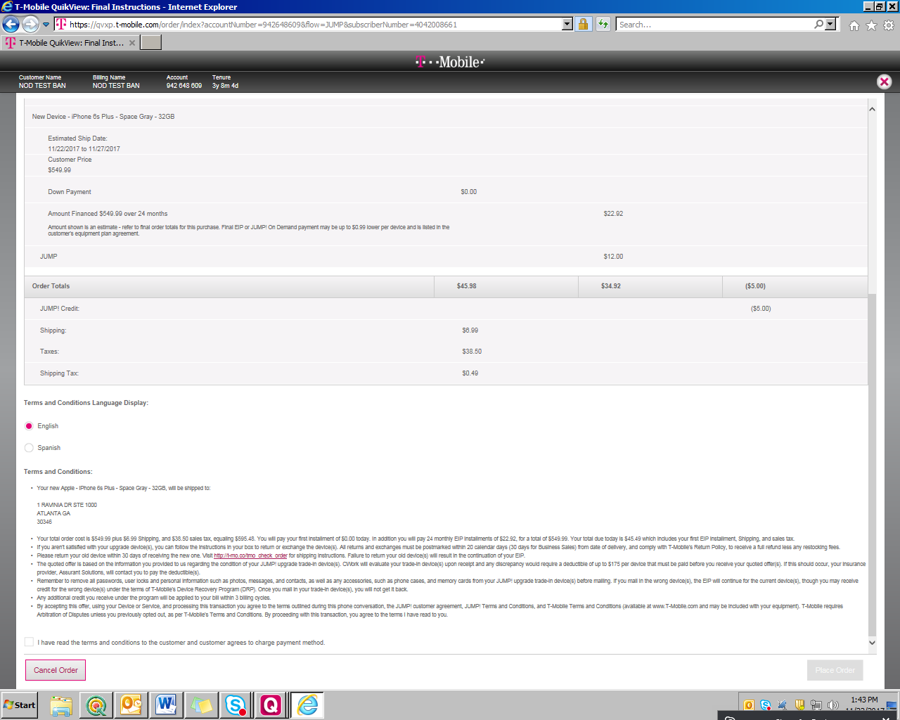

**After Placing Order:**

After placing order, sign the e-sign received in the mail for EIP orders only and the ORDER ID and TIME STAMP should be sent to SAP for confirmation and shipment.

**DocuSign Steps:**

Note: After placing Order from Front end, We will receive an email to e-sign the agreement.

Step 1: Open an email

Step 2: Click on mail you want read and e-sign

Step 3: Click on link in mail and go through the mail

Step 4: E-sign the agreement and submit it.

**After E-Sign:**

**Order status in Order look up:** PartiallyWorkInProgress

**EIP:** Not-Shipped-Pending

1. **SAP Jump upgrade (Desktop Application)**

**Steps:**

1. Go to VA03 T-code and Give the Purchase Order Number

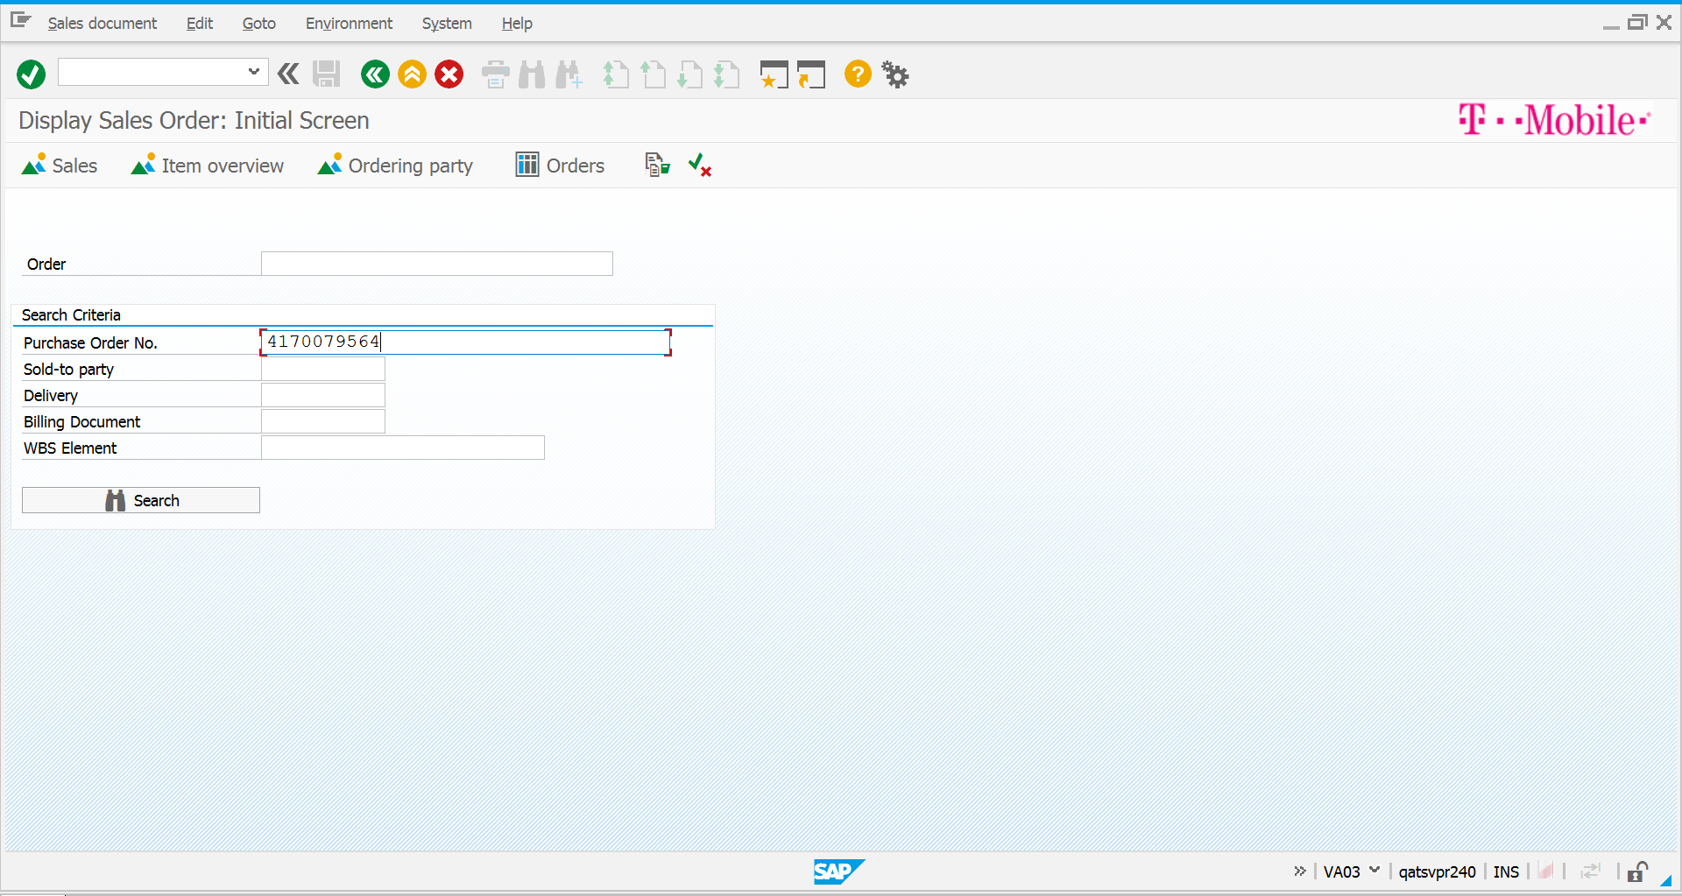

1. Click on Search

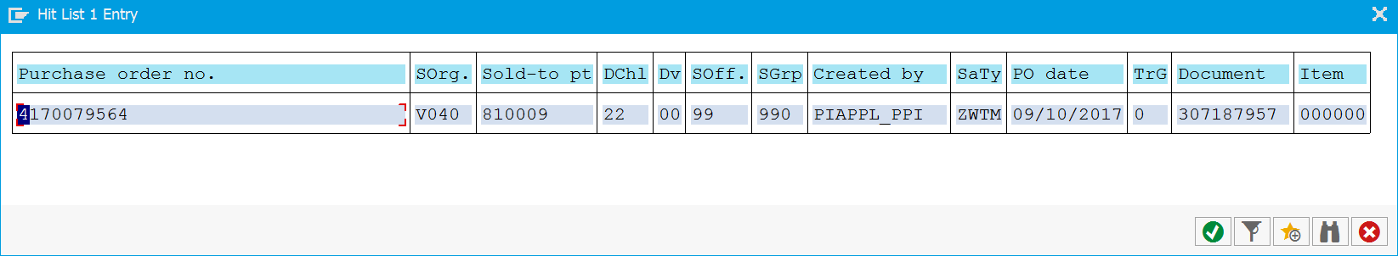

1. Click on Enter

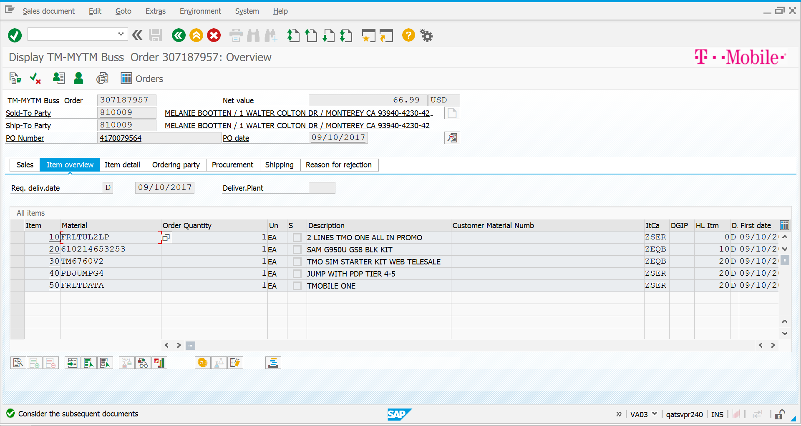

1. Validate the Sold To party and Ship to Party



1. Click on Header Idoc beside PO Date Field

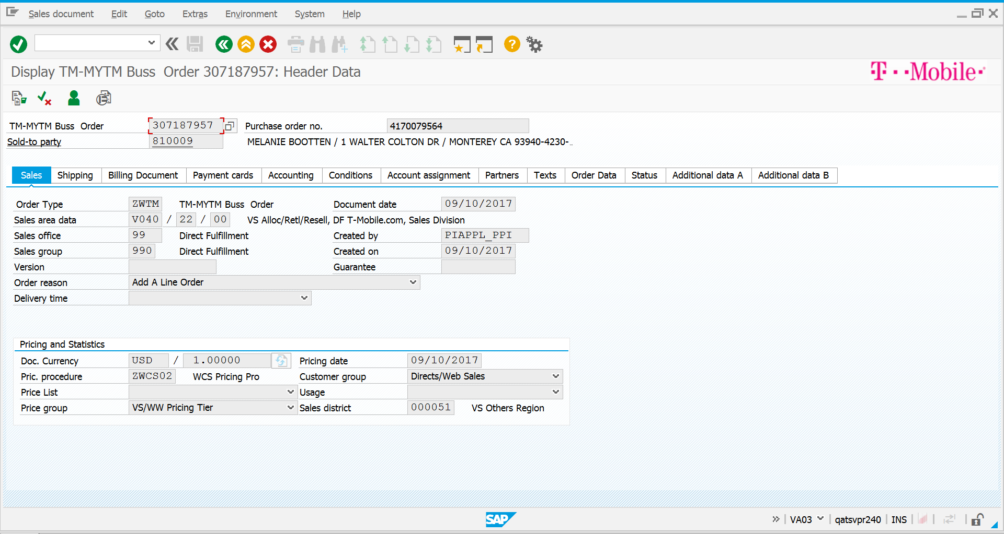

1. Click on Sales Tab and validate the Order Type, Distribution channel, Order Reason



1. Click on Shipping Tab and validate Shipping Condition

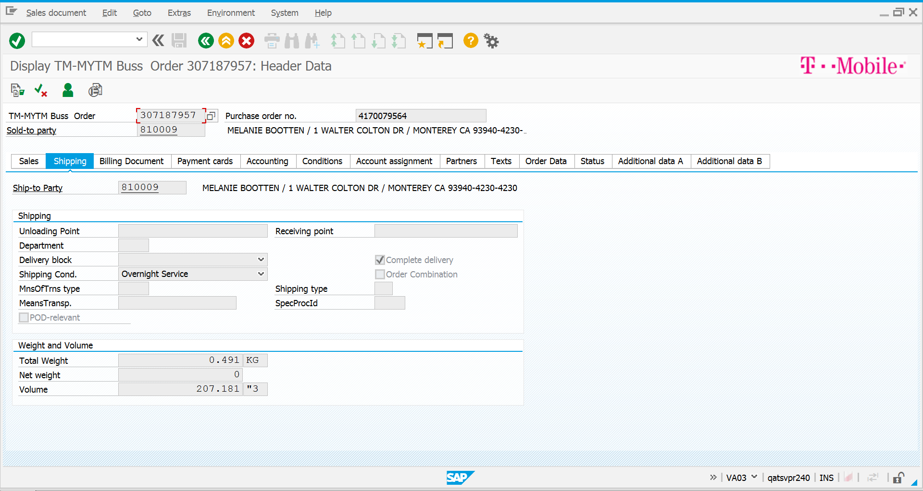

1. Validate Terms of Payment: NCC

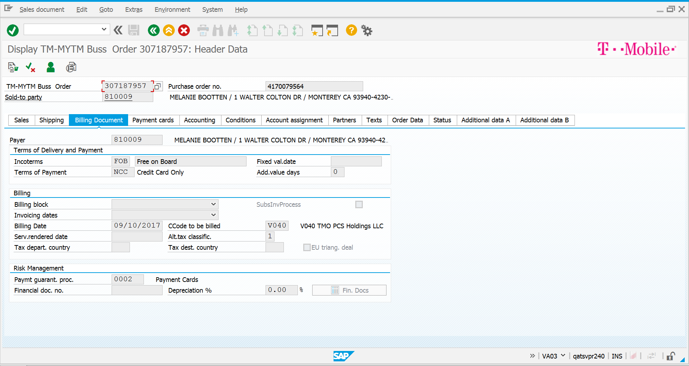

1. Validate the payment cards tab

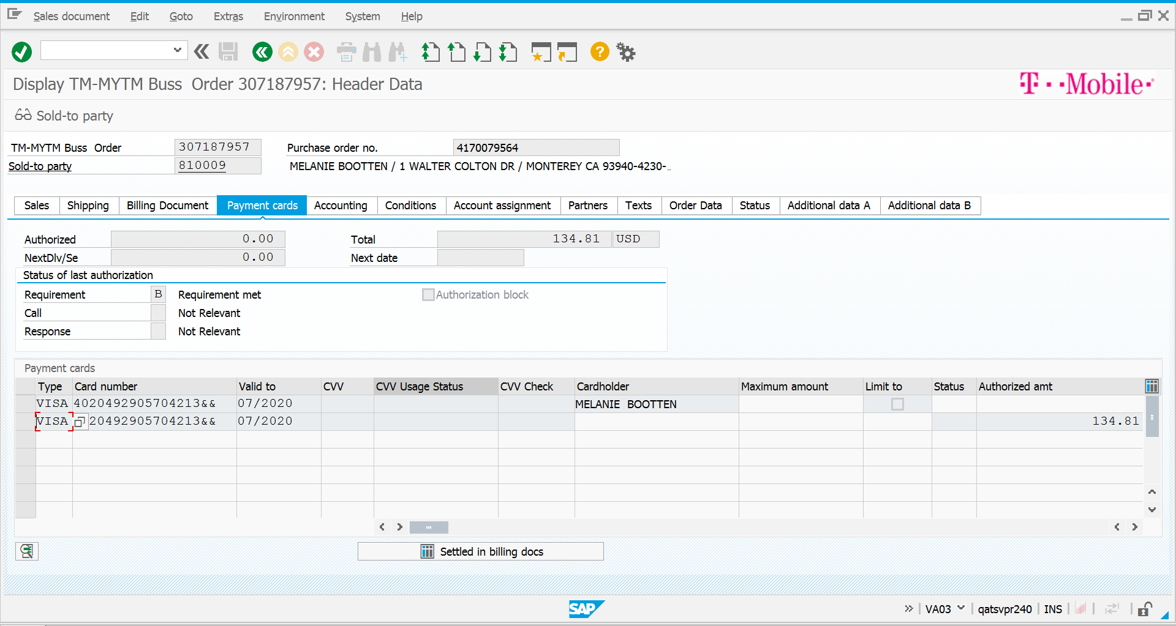

1. Validate the conditions Tab the Net Amount And Tax should match with front end

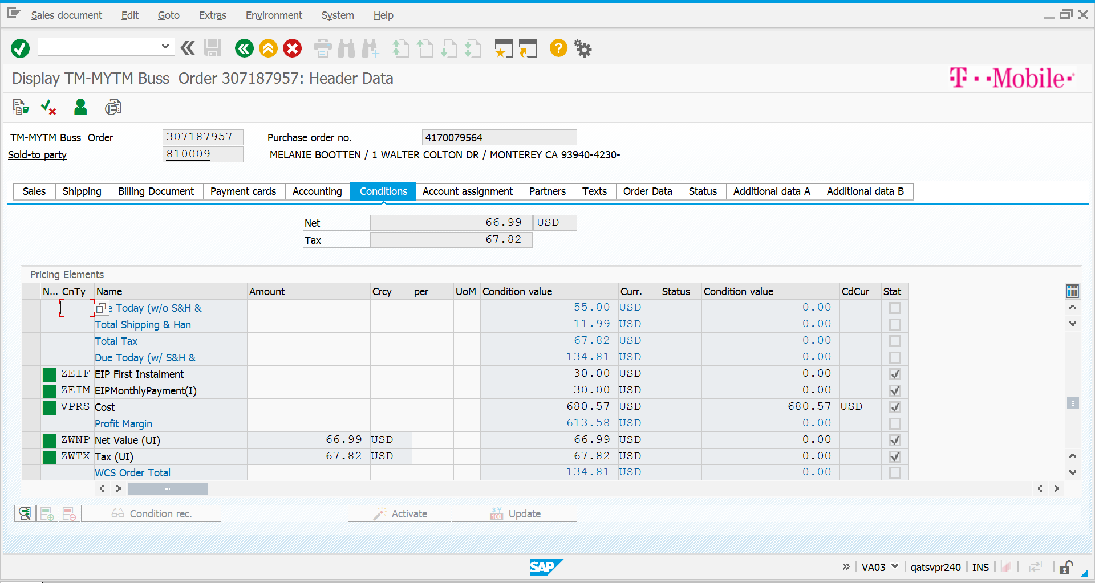

1. Validate the Ship to party & Sold to party in partners

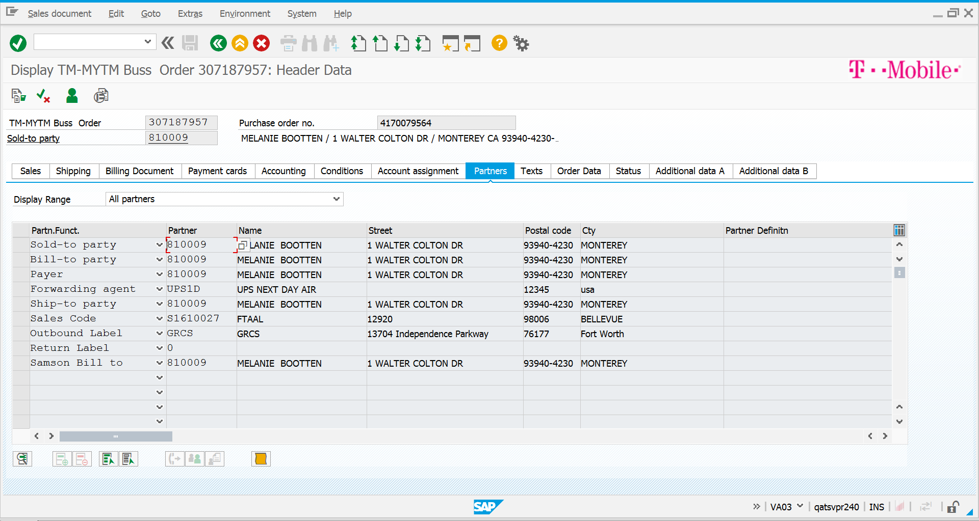

1. Validate customer Group 4 for EIP customer in Additional Data A tab

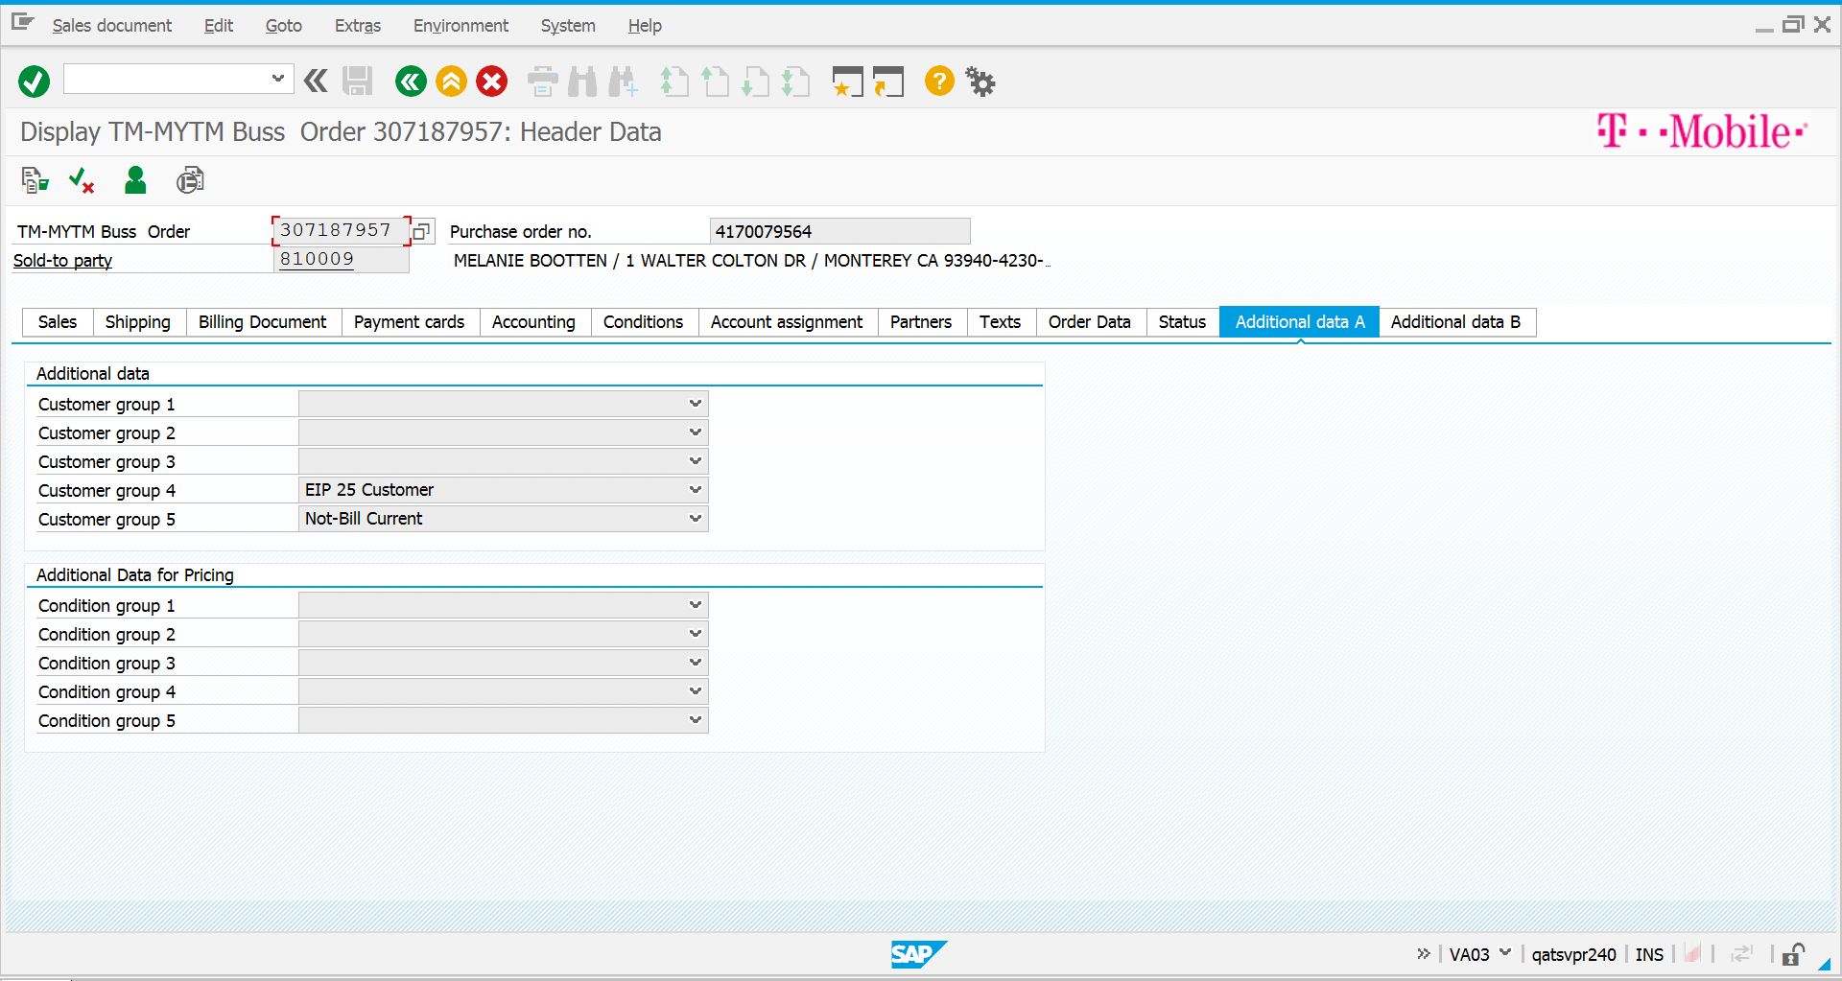

1. Go to Extras 🡪 Output🡪 Header and validate output types

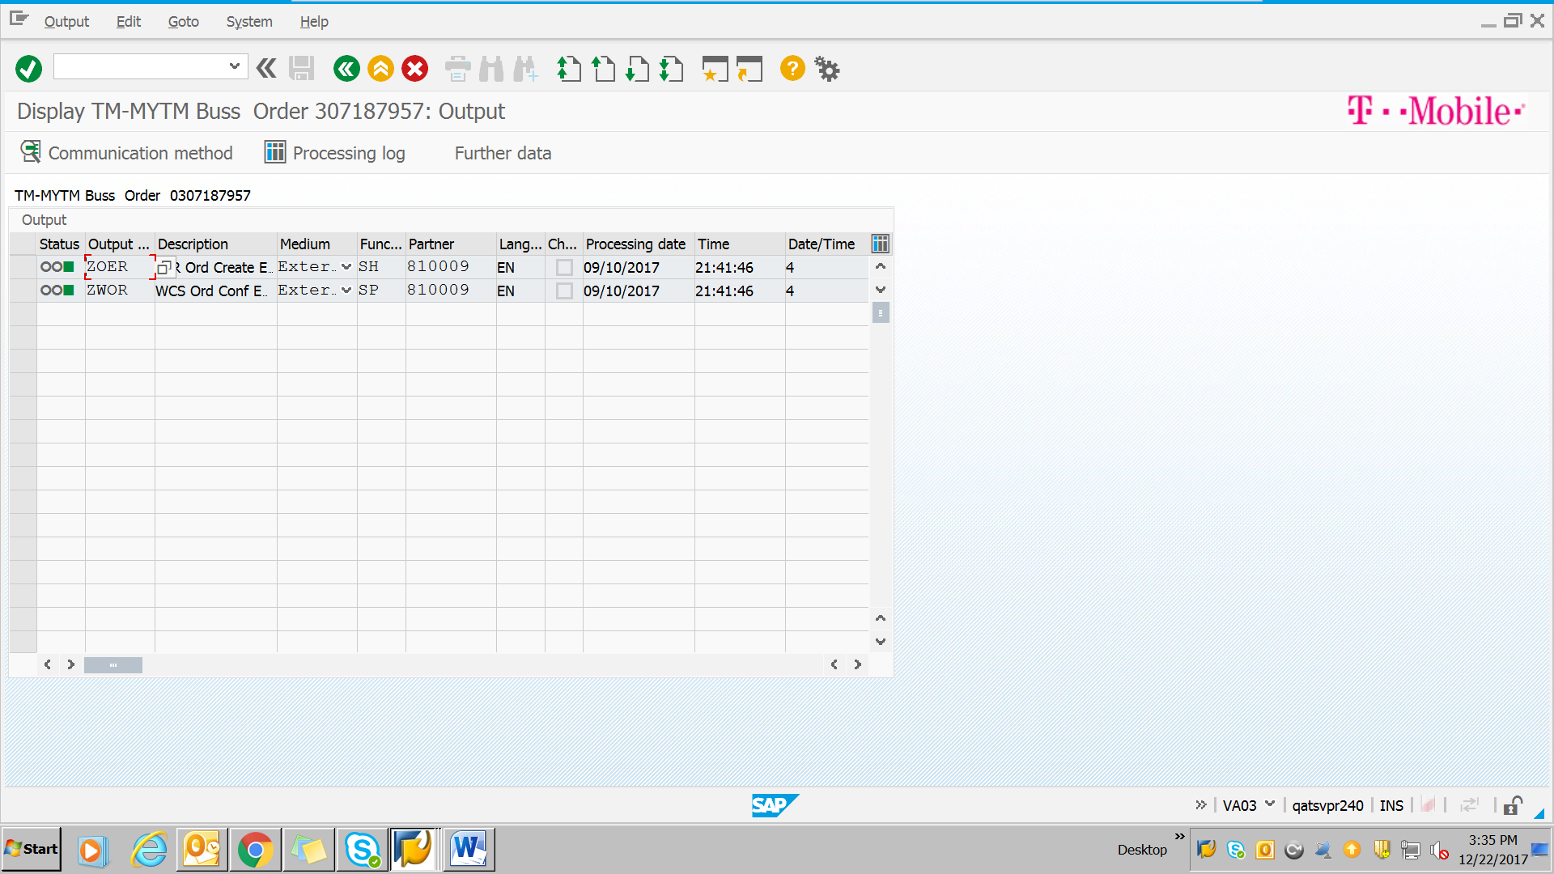

1. Go to sales Document and click on Delivery

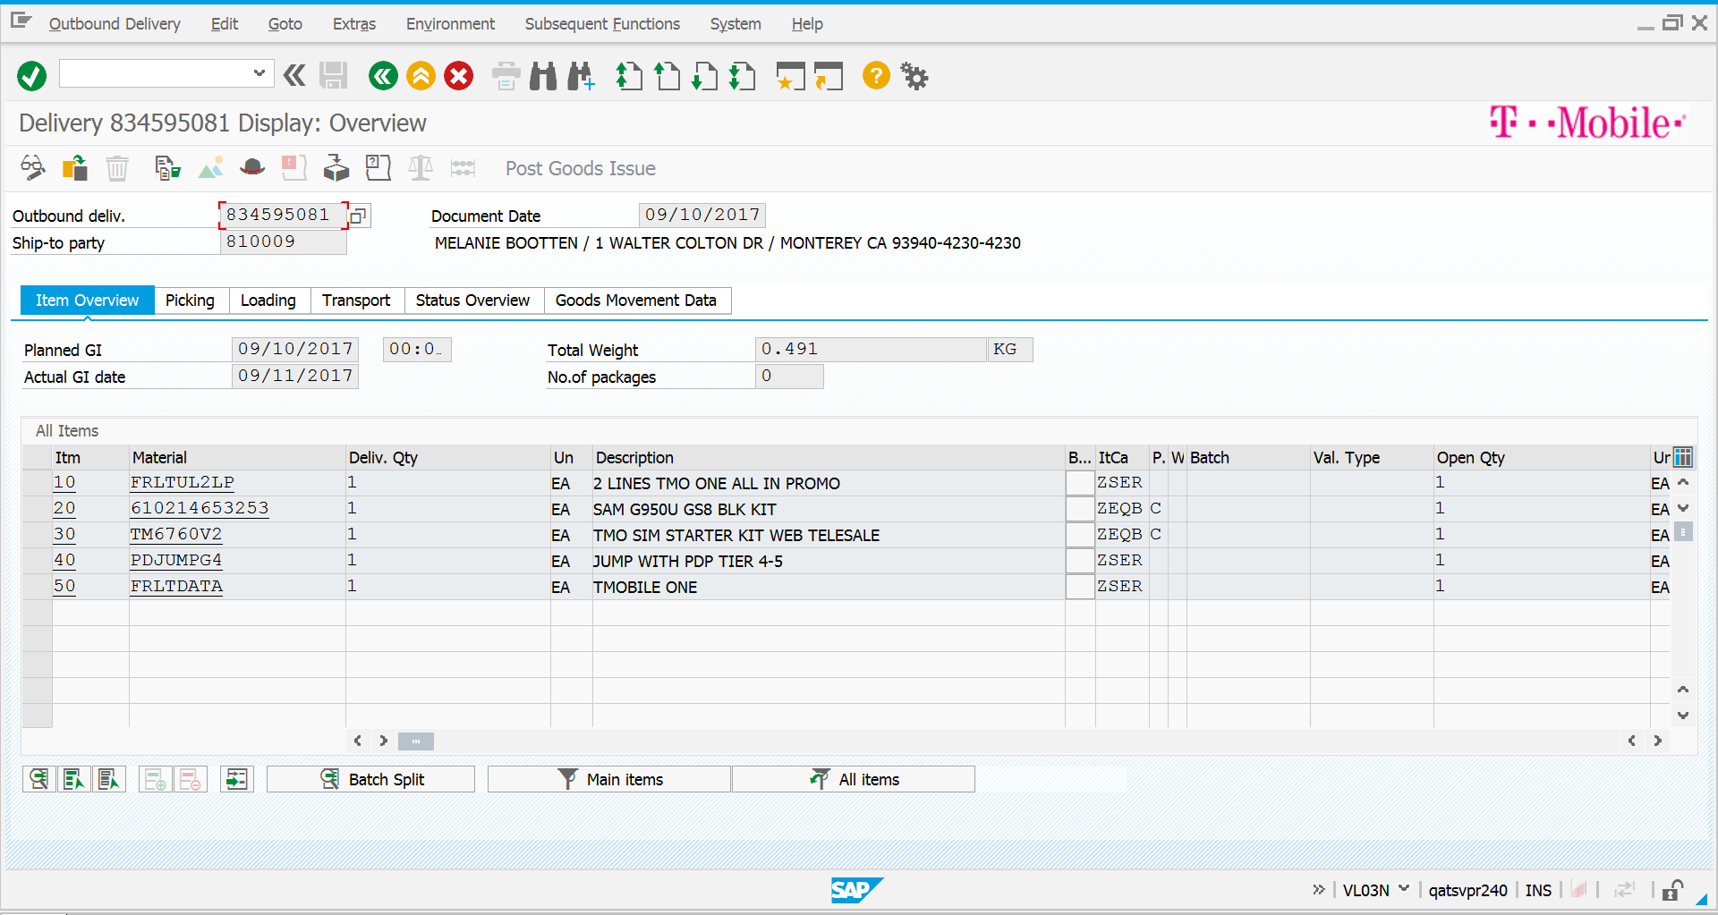

1. Click on Save the Delivery document will be generated



1. Go to We19 and do the Idoc mock up

Note: This IDOC mock up is related to order:

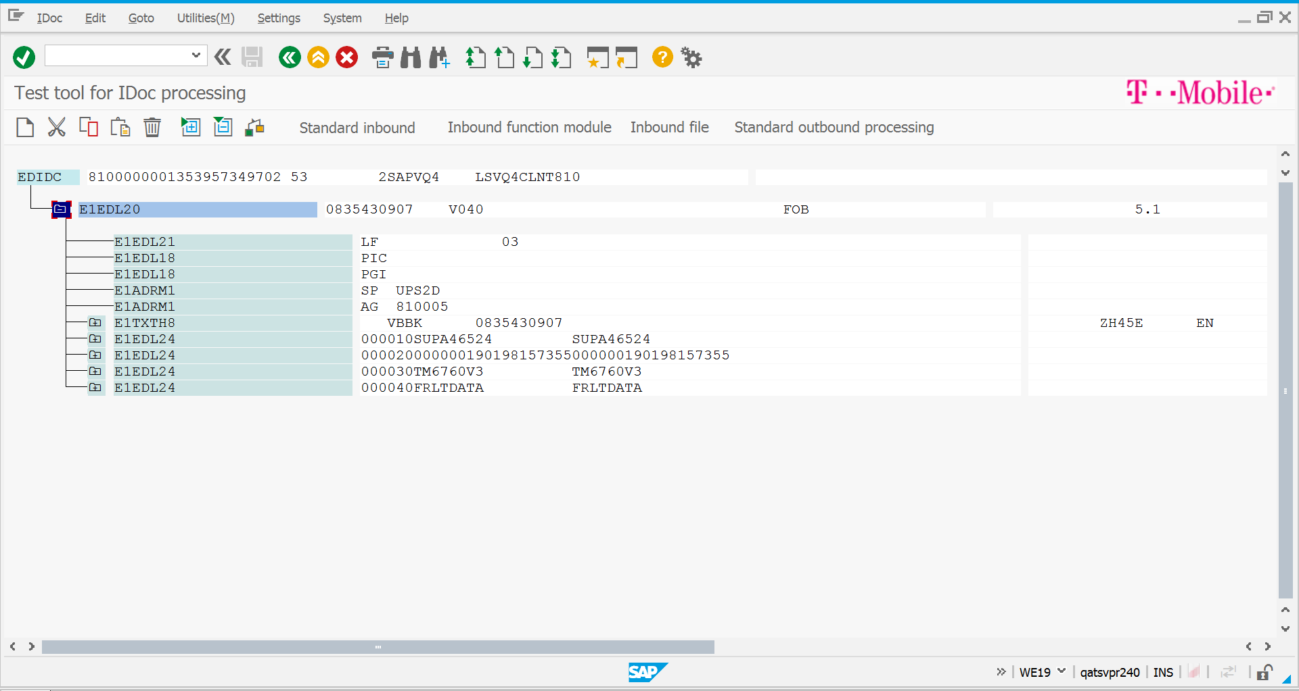

1. Click on Standard Inbound an IDOC will be generated
2. Go to SE38 and give the program name

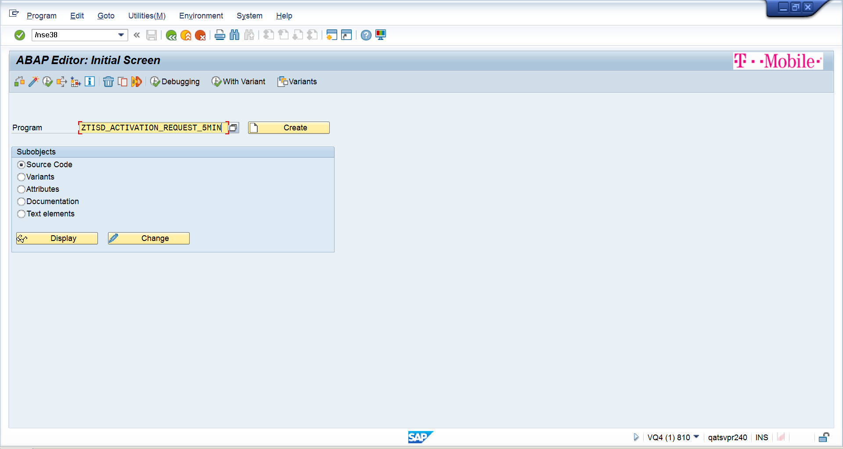

1. Give the details & Click on execute. The Activation file will be generated in C drive in startek folder

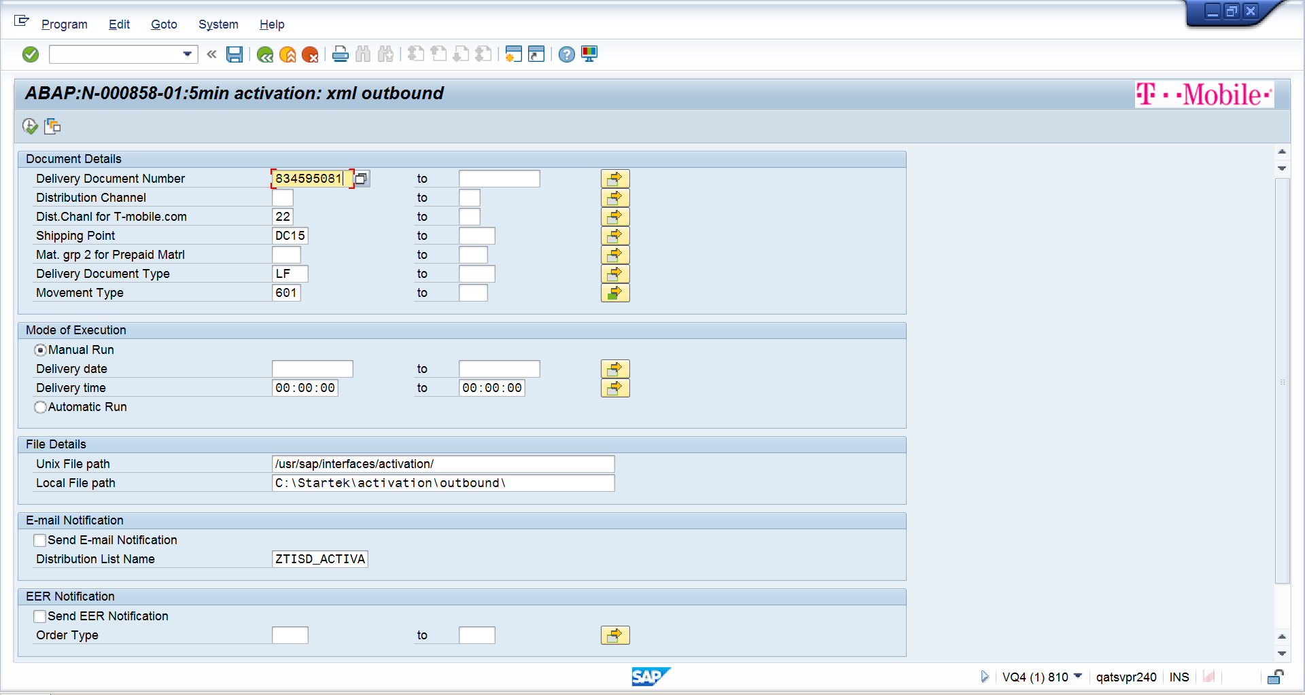

1. Pick the file and drop in below location

\\gsm1900.org\dfsroot\AS\UQA_INTF\activation\outgoing81

1. Validate the Response in ZTSD_ACT_RESP Table .Go to SE16 and give the Table name as ZTSD_ACT_RESP table

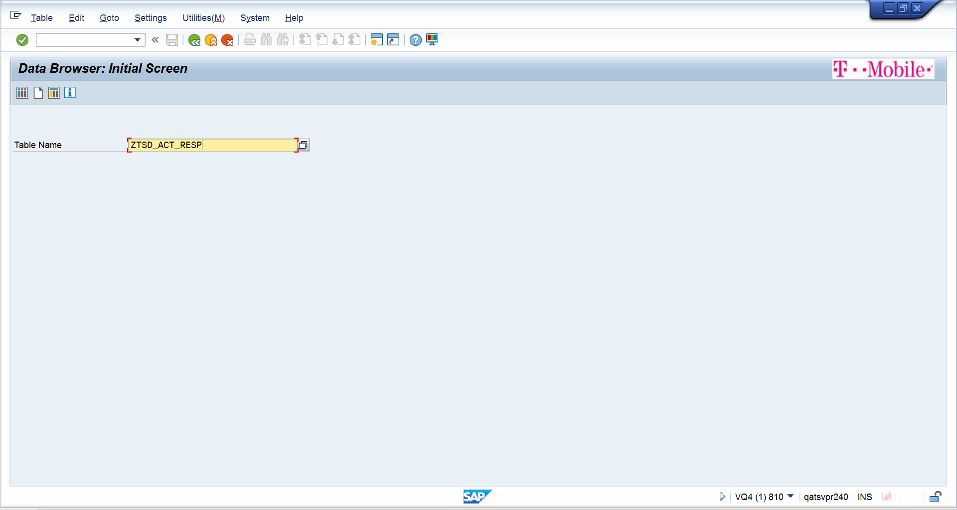

1. Click on Enter

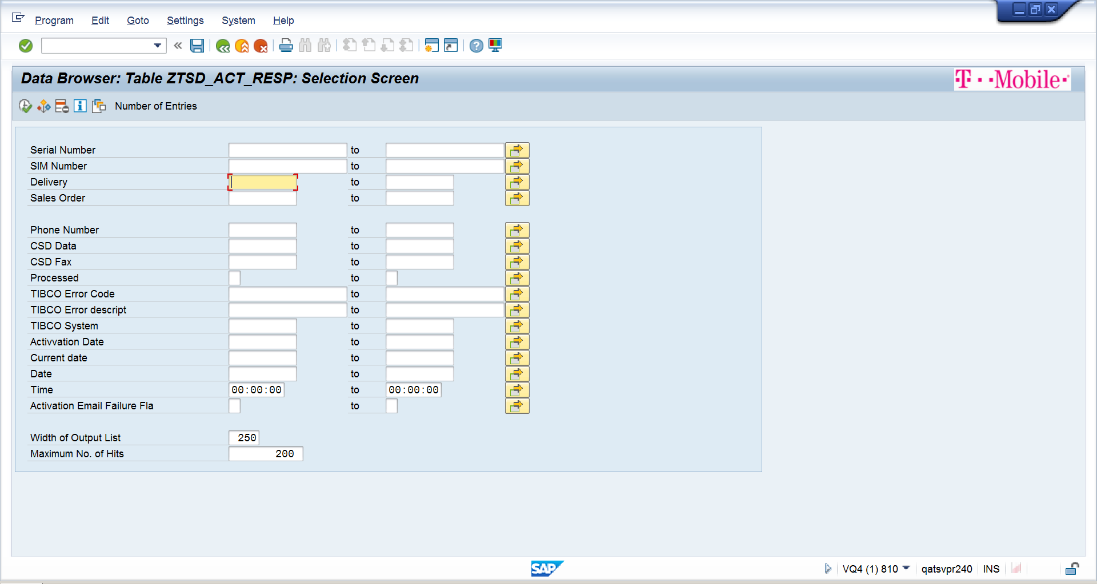

1. Give the Delivery number & Sales order number and click on execute

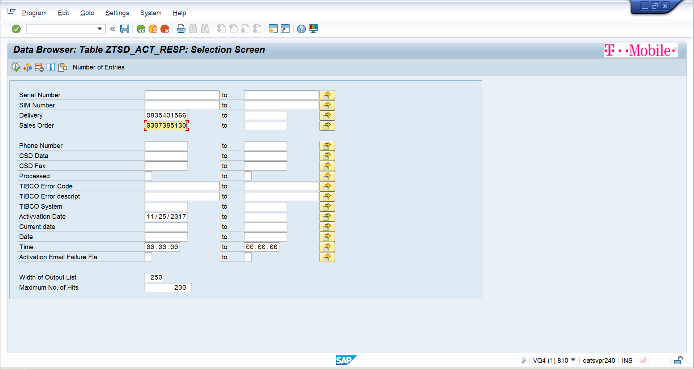

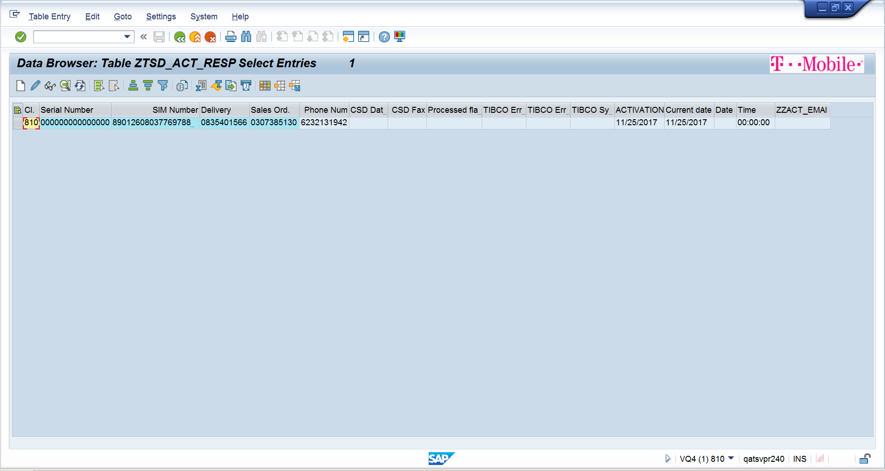

EIP Fulfilment file generation:

1. Go to SE38 and give the program name:

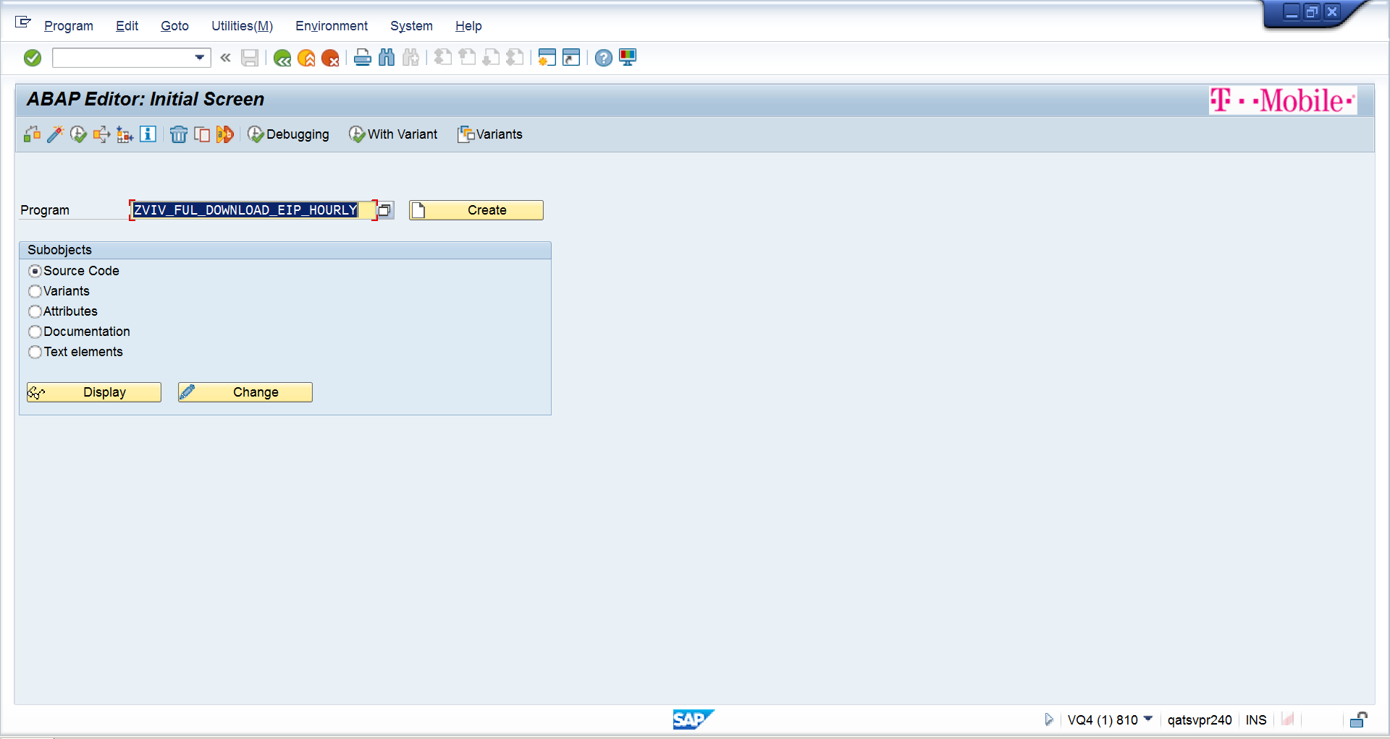

1. Click on With Variant and select EIP_FF_HRLY

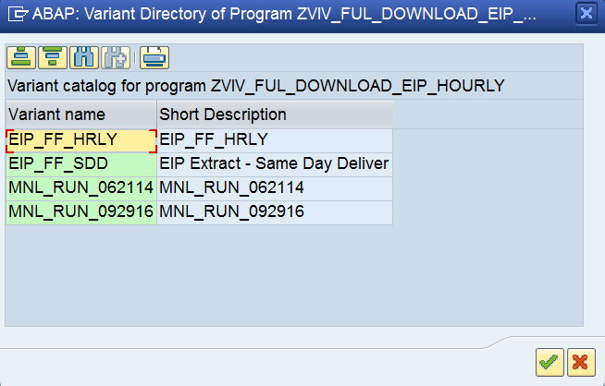

1. Click on enter

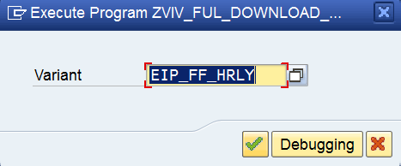

1. Select the Radio button Manual Run and give the SAP Sales order and Created on Date From and To date ( i.e Order Shipped date) and click on execute

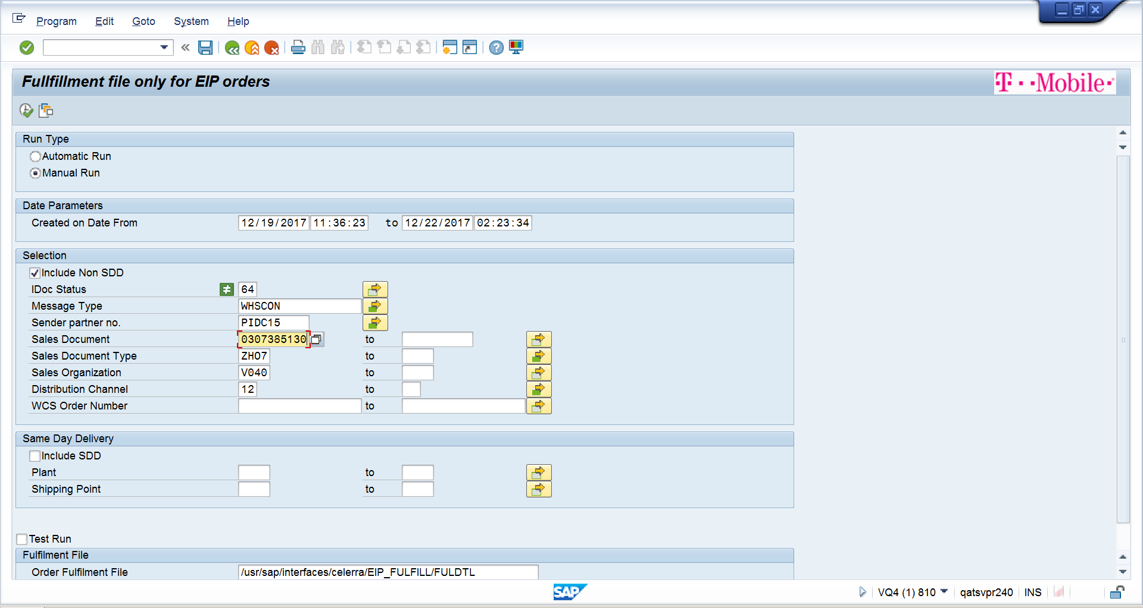

1. The fulfilment file is generated in below path . Take that fulfilment file and attach in QC

\\gsm1900.org\dfsroot\as\UQA_INTF\EIP_FULFILL

**After Order is shipped and fulfilled:**

**Order status in Order look up:** Shipped

**EIP:** Active Shipped

**QC Request:**

Note: After SAP fulfilment file generation, copy the fulfilment file from shared network and drop the file in middleware.

Steps:

1. Launch the browser
2. Login with credentials
3. Click on Defect tab and click on New defect
4. Fill the all mandatory results
5. Click on attach and attach the XML file generated from SAP.
6. Click on submit.
7. Close the browser
8. **EIP Database Validations**

Step 1: Launch the browser and run the batch job for SAP.

Step 2: Read the data from the Input file.

Step 3: Establish the connection with EIP database.

Step 4: Execute the query.

Step 4: Perform the Validations.

Step 5: Write the results into Excel file.

* + 1. **Conclusion**

PoC completed successfully.

* 1. **PoC on AS400 automation with Manheim**

**4.3.1 Description**

Automate the legacy AS400 systems/applications and wanted to see if RPA technology can provide the solution within their environment.

**4.3.2 PoC Objective**

Automated AS400 application with RPA Tool/UiPath and Mocha TN5250 emulator

**4.3.3 Automation tool details**

|  |  |
| --- | --- |
| Tool | UiPath |
| Version | [UiPath v2016.2.6379](https://www.uipath.com/release-notes/uipath-v2017.1-sp1) |

**4.3.4 Application under test**

|  |
| --- |
| Application |
| AS400 |

**4.3.5 Scope**

For the pilot, the following test scripts have been identified.

|  |  |
| --- | --- |
| Test scripts identified for POC | Application |
| Word Order Creation for Consignor | AS400 |

The above test cases will be automated using UiPath and following parameters are set to be evaluated:

* Installation
* Scripting Methodology
* Ease of scripting
* Script Reusability
* Script maintenance : In terms of efforts & time required
* Flexibility to run scripts
* Validations
* Tool performance for large no of steps in a test script
* Handling business flow variations
* Avoiding manual intervention

**4.3.6 Estimates**

|  |  |
| --- | --- |
| Task | Time Required |
| Installation and setup of UiPath trail version on local machine | 0.5 hour |
| Installation and setup of Mocha TN5250 emulator | 0.5 hour |
| Work Order Creation for Consignor | 7 hours |

**4.3.7 What Worked Well**

The PoC was successfully able to execute all the components individually and in integration mode i.e. in a single test scenario execution session.

* + Installation:

The UiPath adds in for UiPath installation process is pretty straightforward just by downloading the UiPath trail version installation package from UiPath site through registration.

* + Coding Skills Required:

Coding skills are not required for creating automation scripts.

* + Ease of scripting:

Multiple types of workflows are available in Studio (Sequences, Flowcharts and State machines) that helps to build the automation workflow according to our business requirement.

* + No Synchronization issue

UiPath provides robust solution for synchronization of web pages.

* + Modular & Data Driven Scripts:

The processes can be parameterized and data driven scripting is possible.

* + Flexibility to Run Scripts:

In case something goes wrong during execution, there is flexibility to resume the execution instead of running from scratch which will save time, reduce manual and user dependency.

* + Handling Manual Intervention:

UiPath provided flexibility to do attended automation allowing manual intervention. It works on the same workstation as a human and is usually triggered by the user through their actions (user events). We cannot start processes from Orchestrator on this type of Robots, and it cannot be executed under a locked screen.

**4.3.8 What did not work well?**

This PoC has encountered challenges of different nature and severity. These challenges can be an excellent input for planning future Test Automation activities. The challenges have been overcome with either solutions / workarounds and are detailed below.

**We need continuous Script maintenance and dry runs before execution.**

|  |  |  |
| --- | --- | --- |
| **Challenge** | **Description** | **Workaround/Resolution** |
| Automating AS400 application using Terminal activities in UiPath | We couldn’t use Terminal based activities to automate the AS400 application as client emulator was old version. | Automated the AS400 application using Citrix automation and by sending the hot keys. |

**4.3.9 Demo**

Step 1: Go Recon1- 01 menu option and enter the VIN

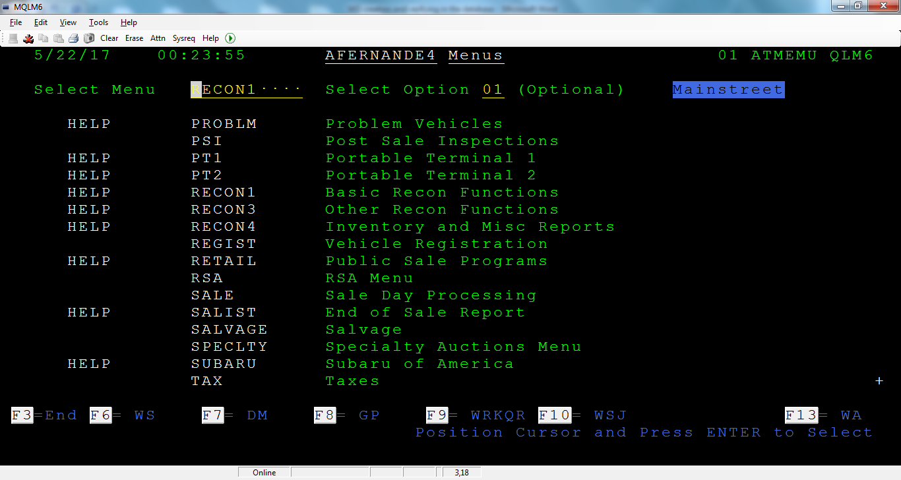

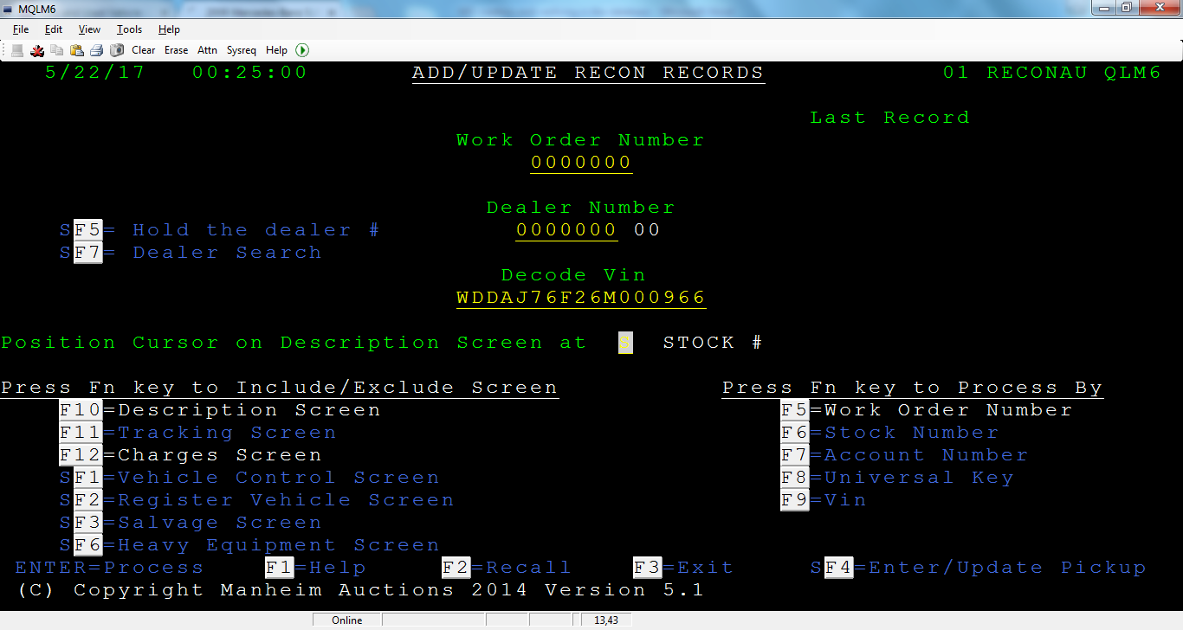

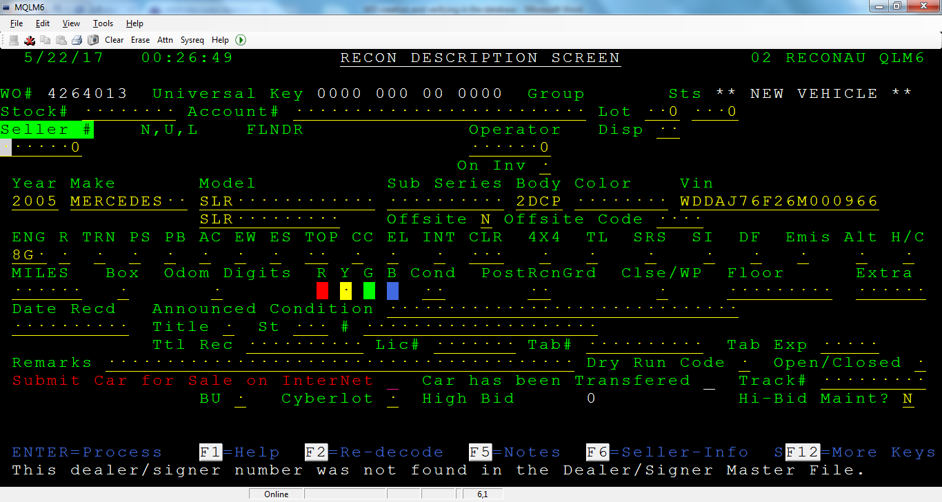

Step 2: Fill in the required details

SF7 for selecting Seller Number

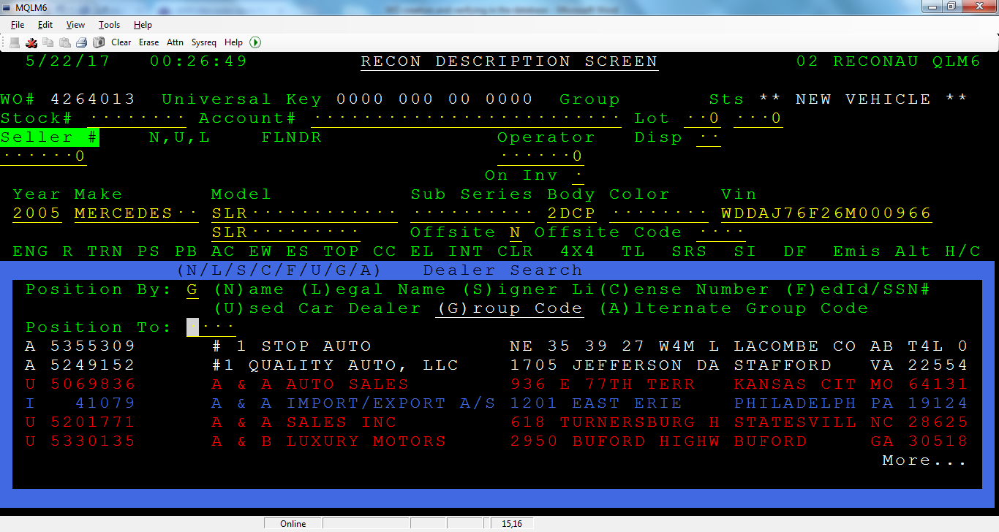

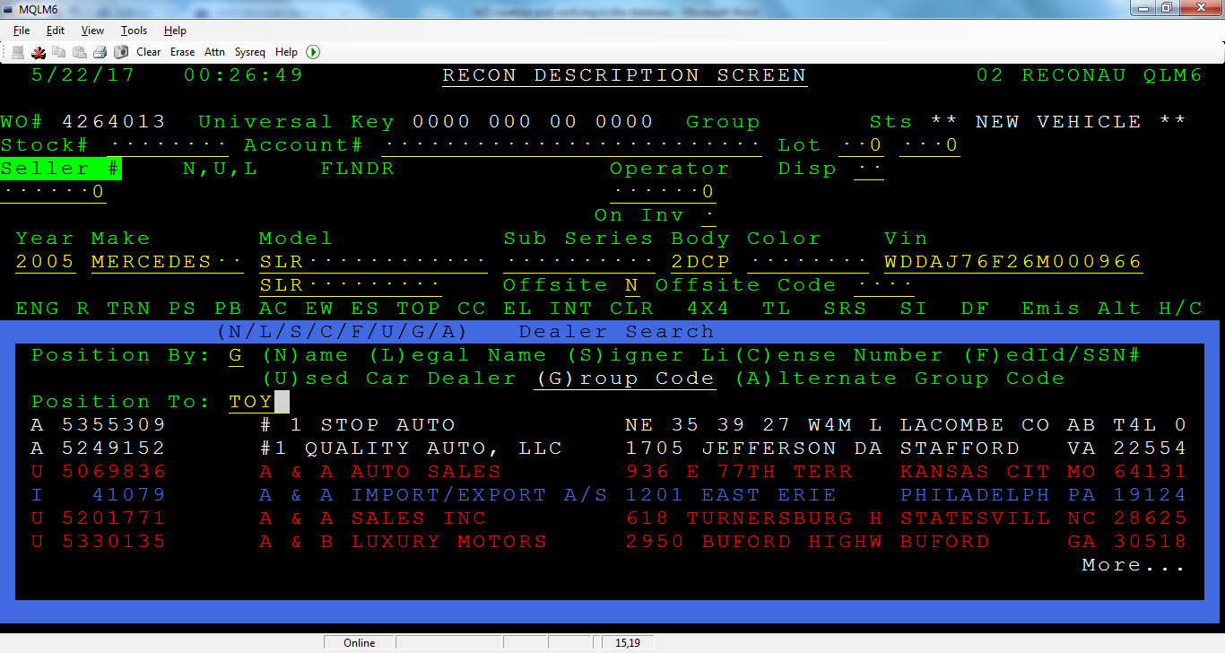

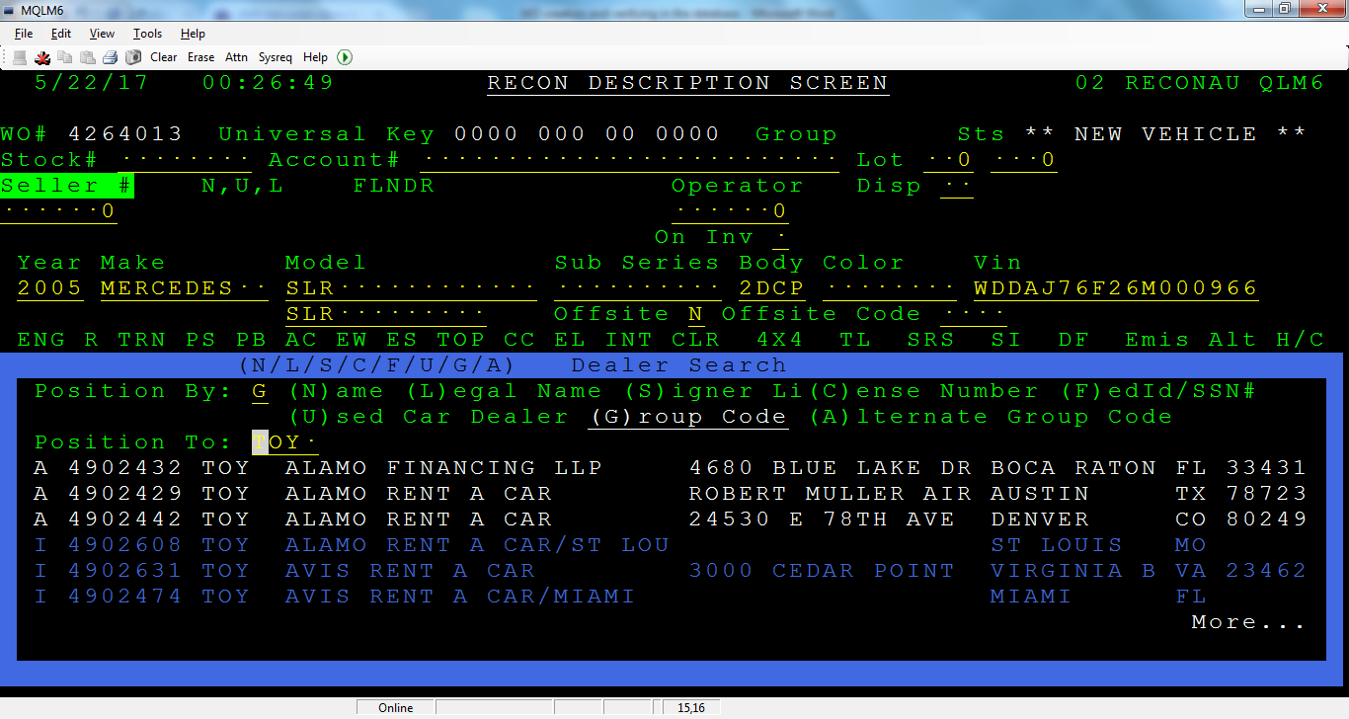

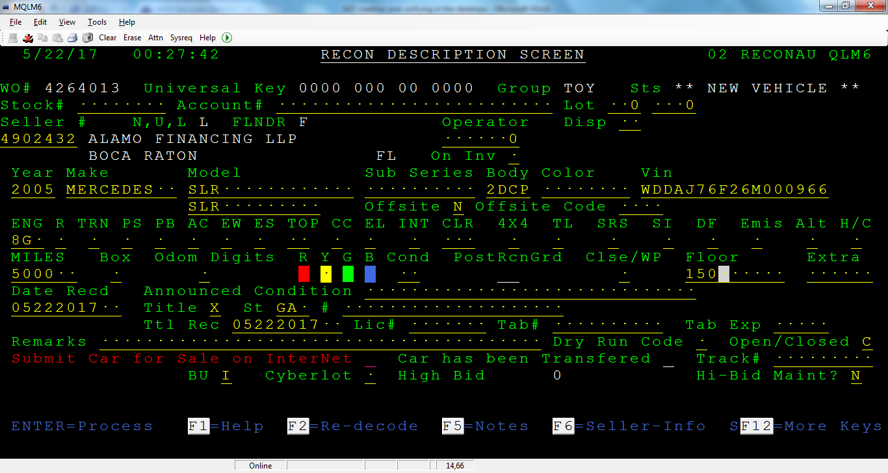

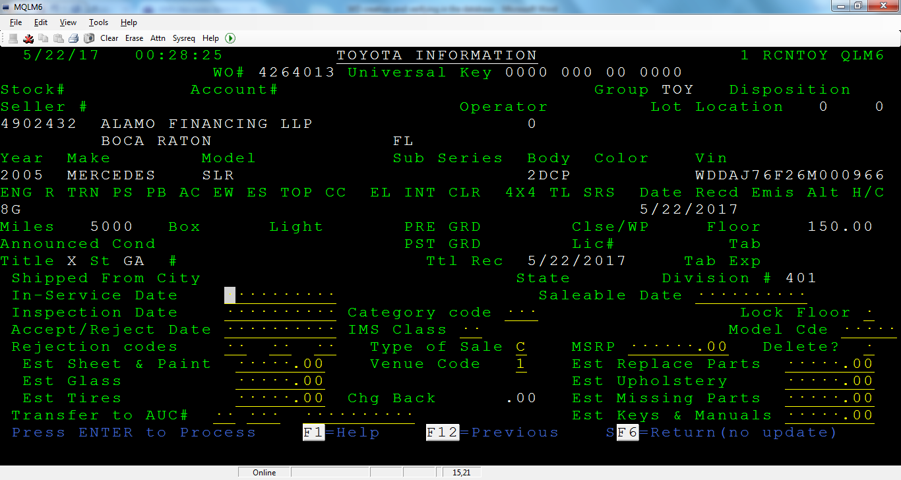

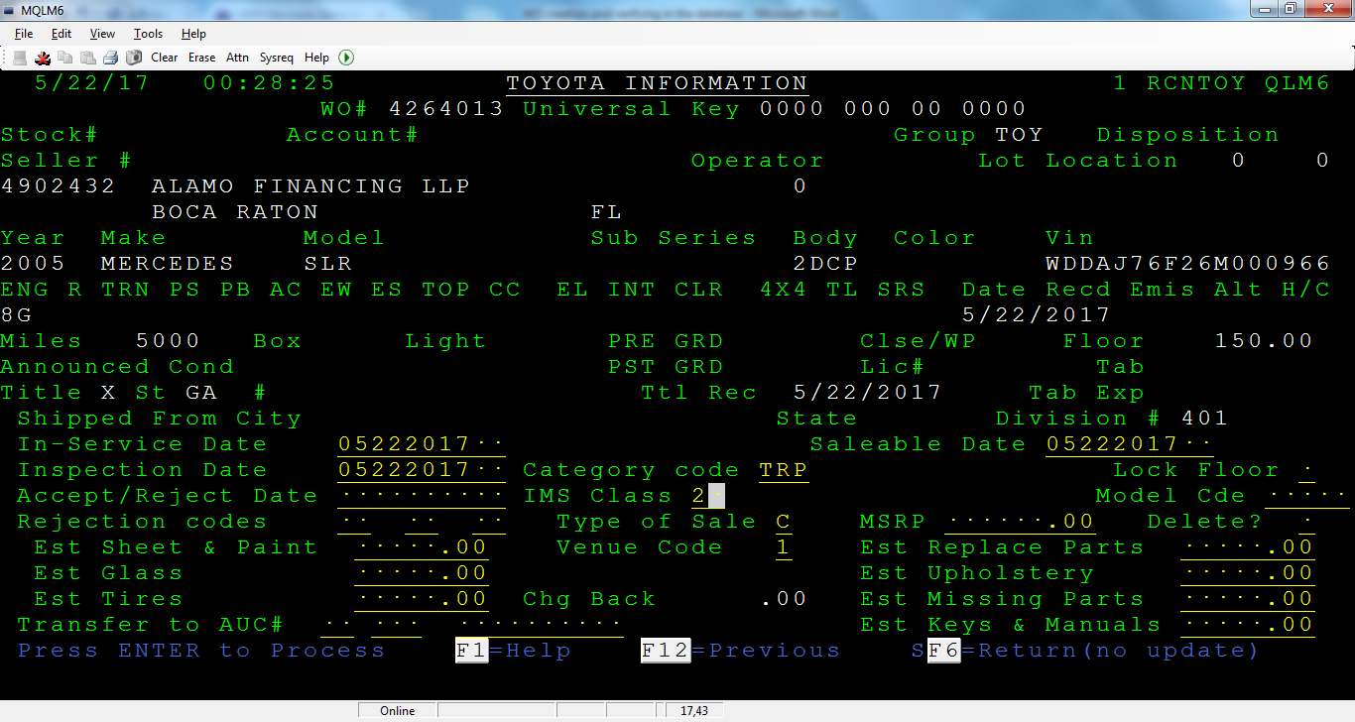

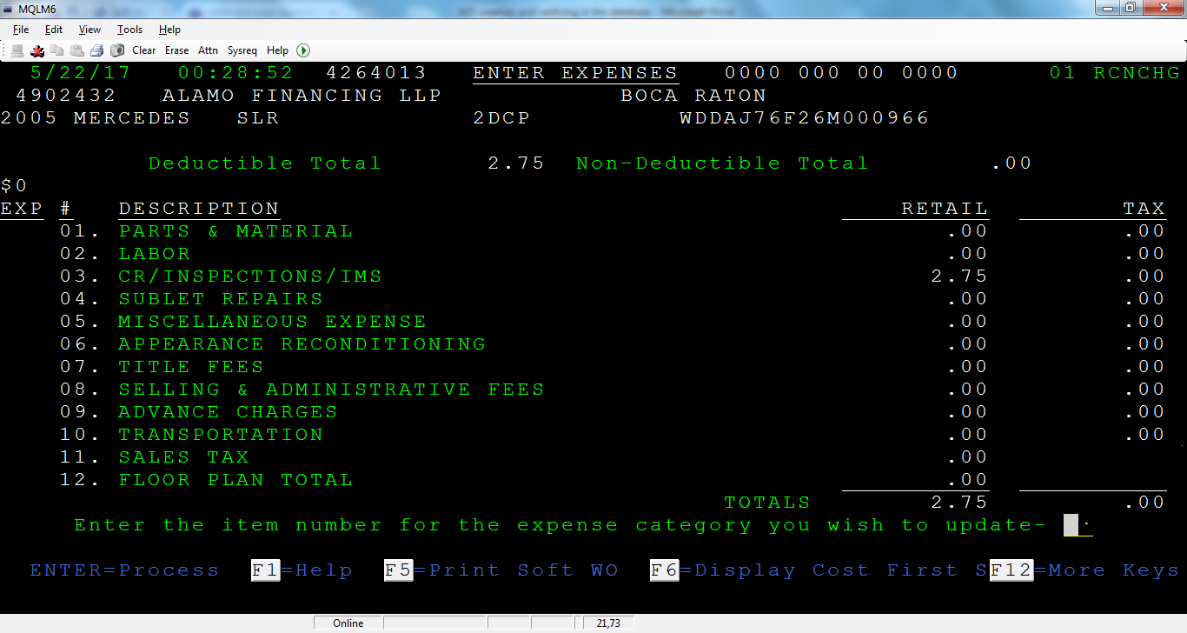

Step 3: Enter the expenses

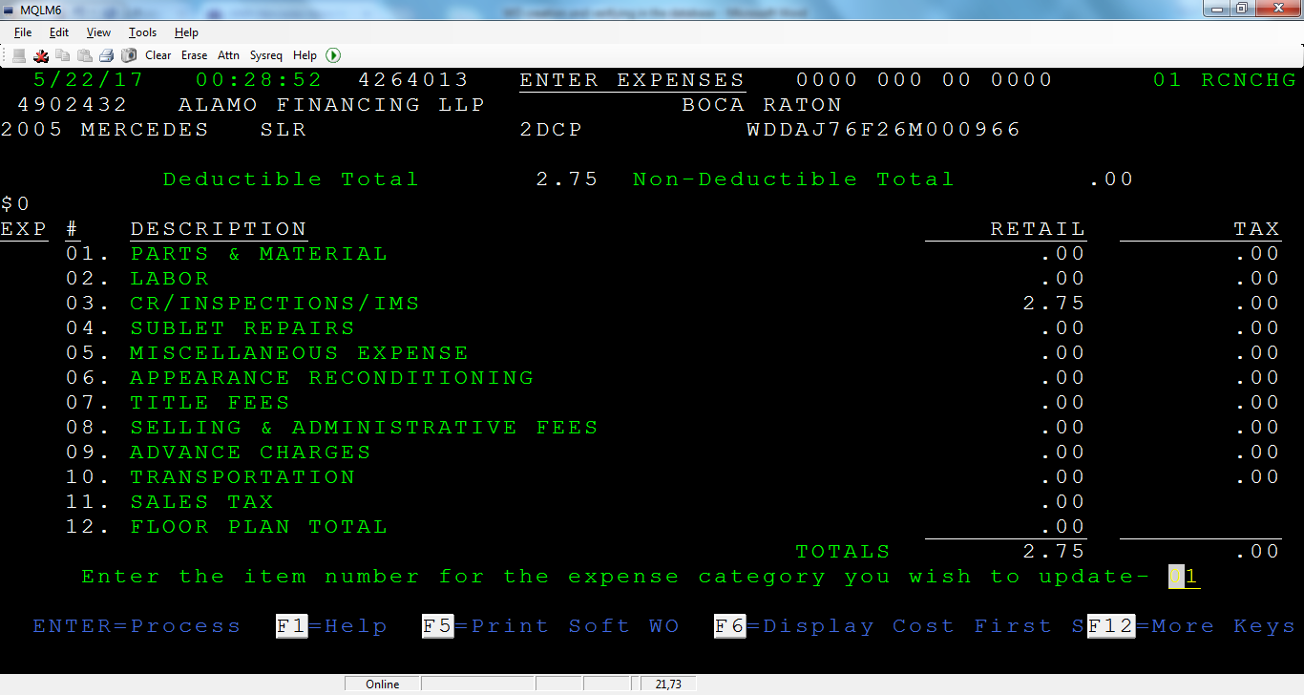

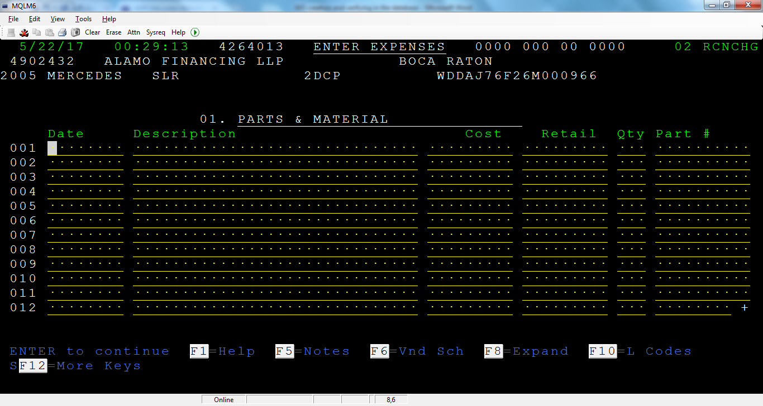

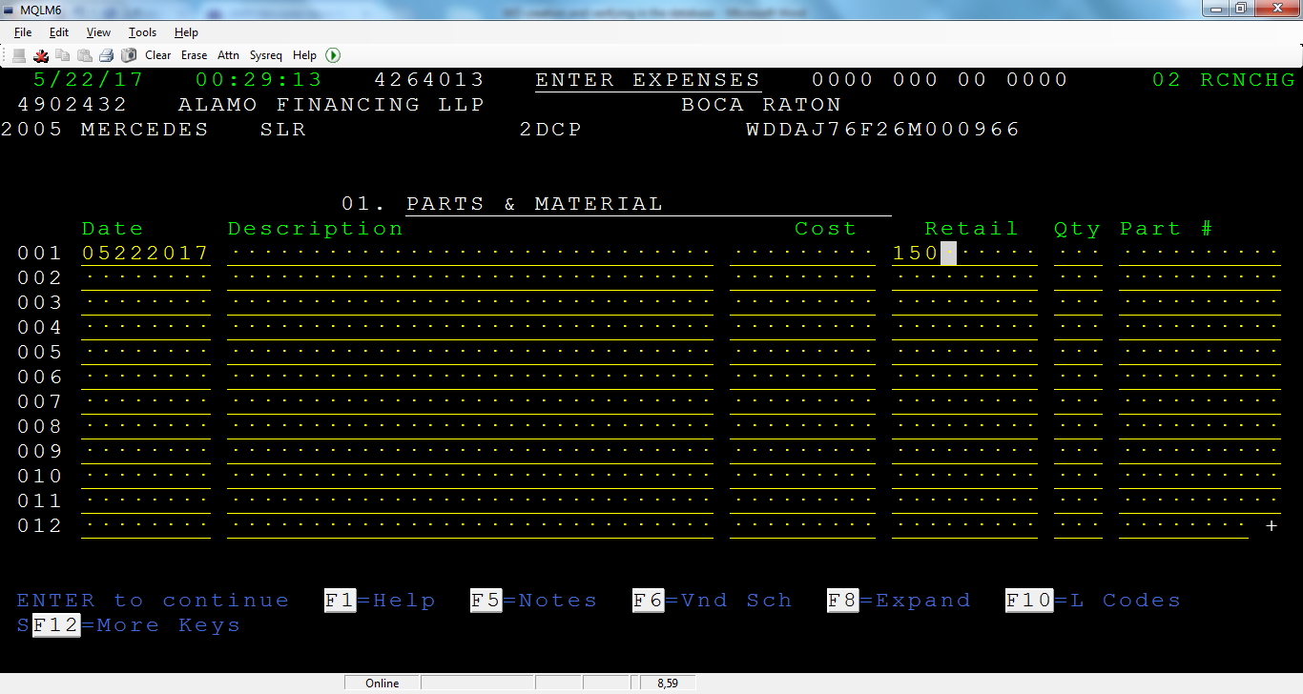

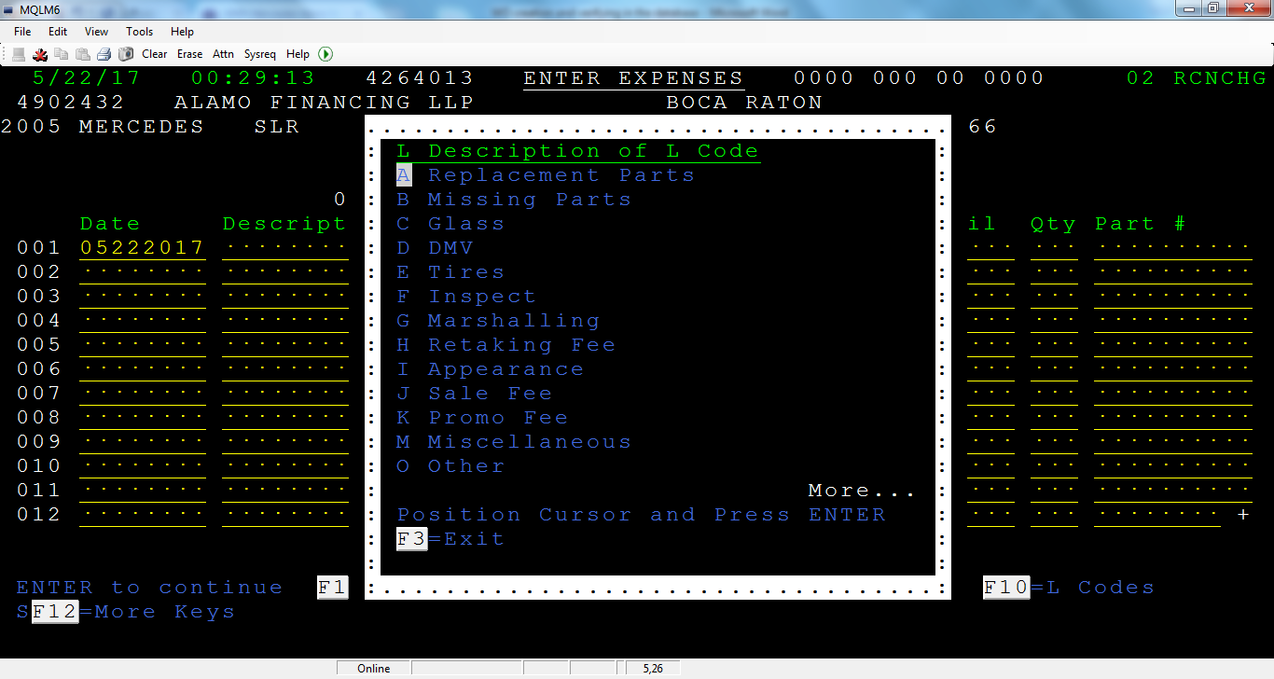

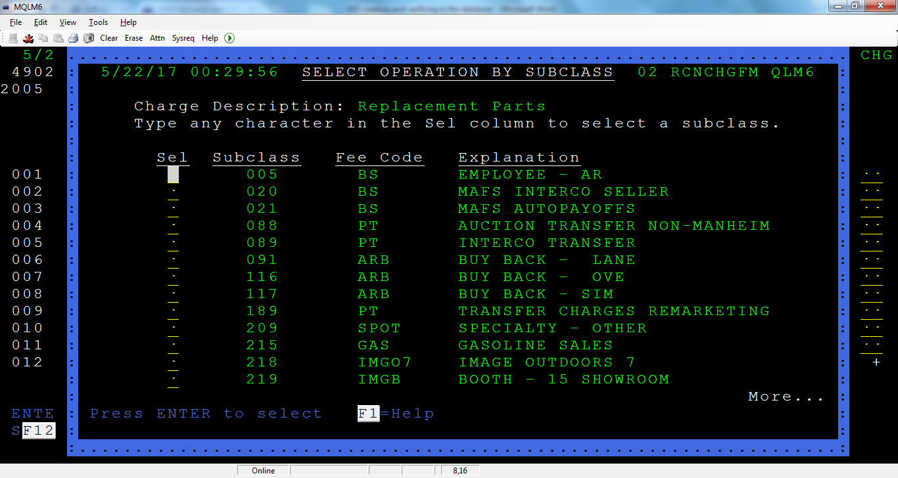

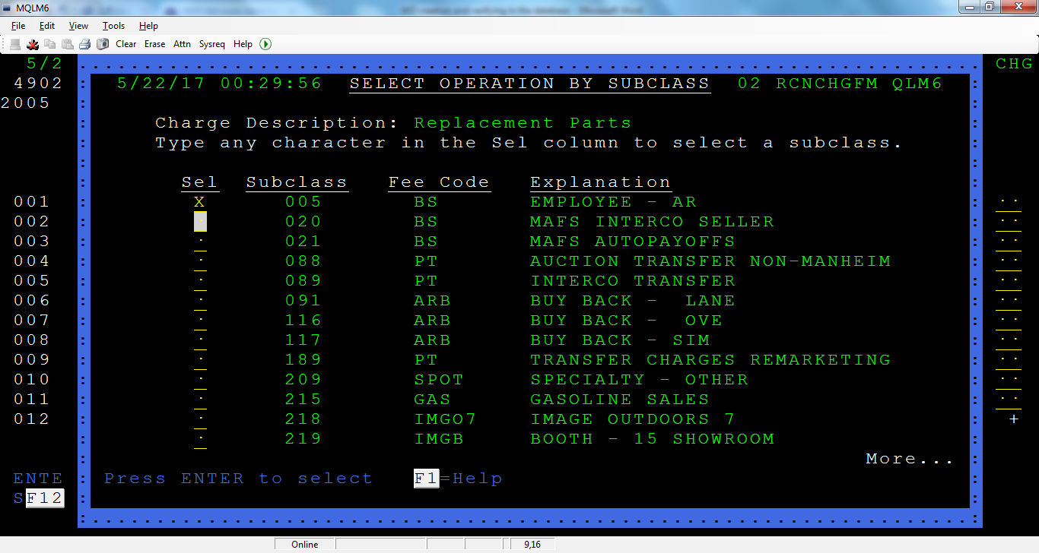

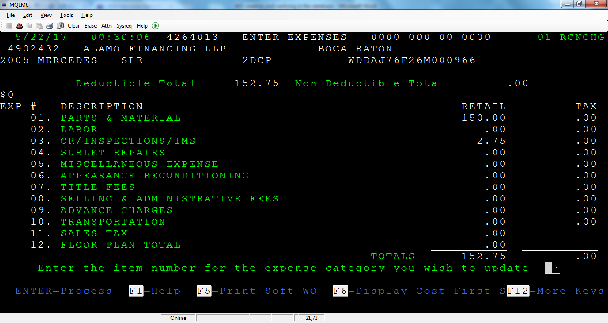

Step 4: The WO should go to RC-INVENTORY status

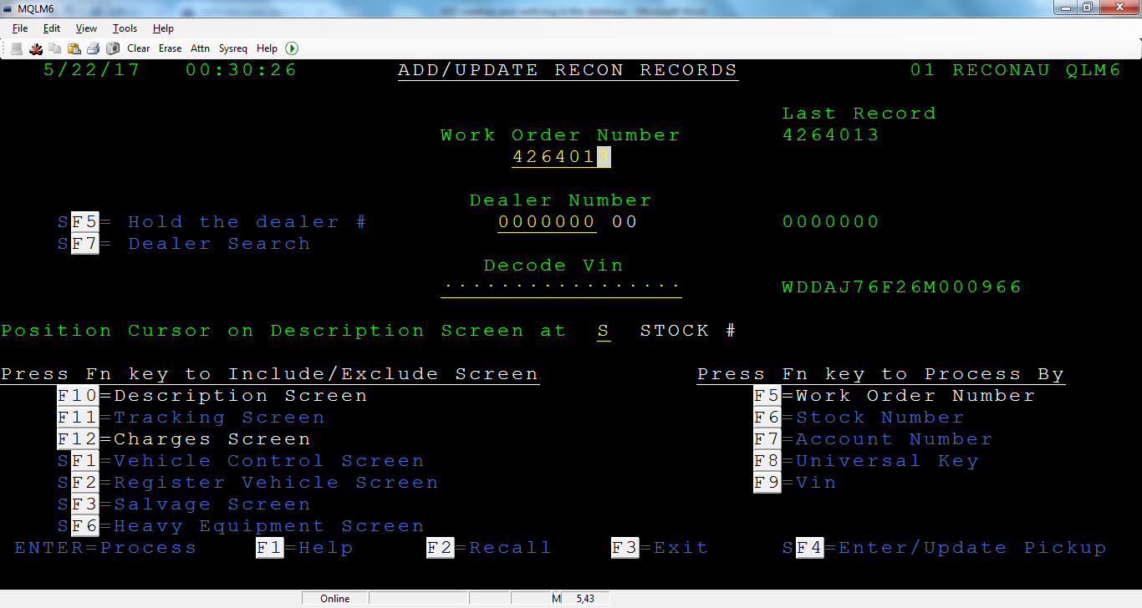

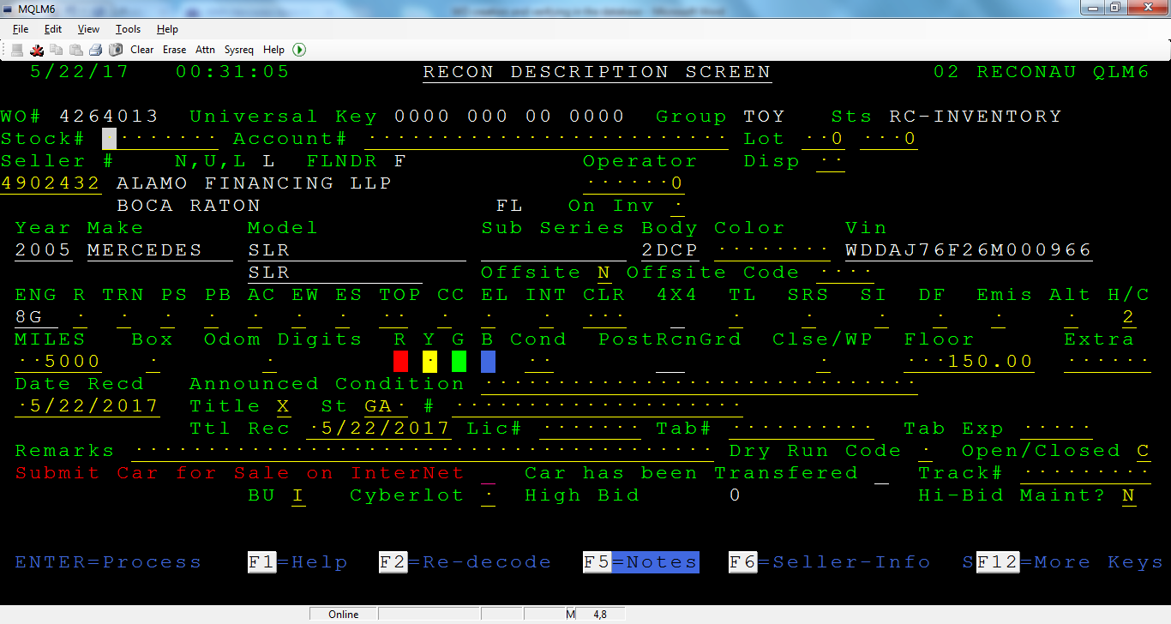

Step 5: Register the vehicle

Recon1-04

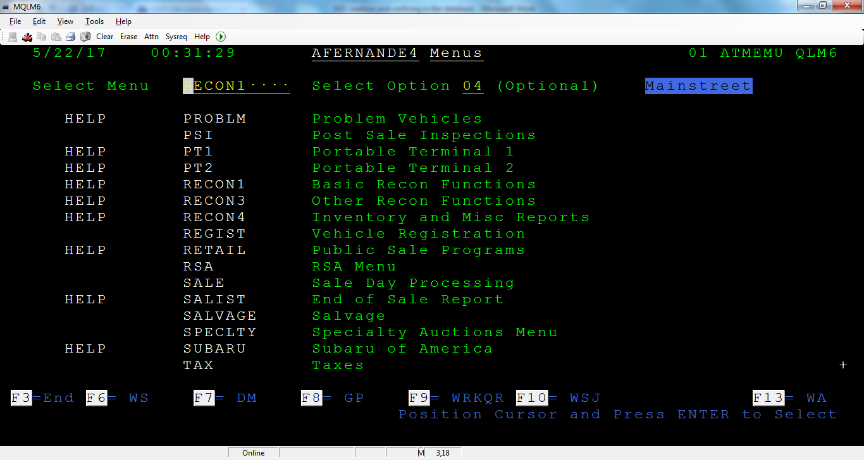

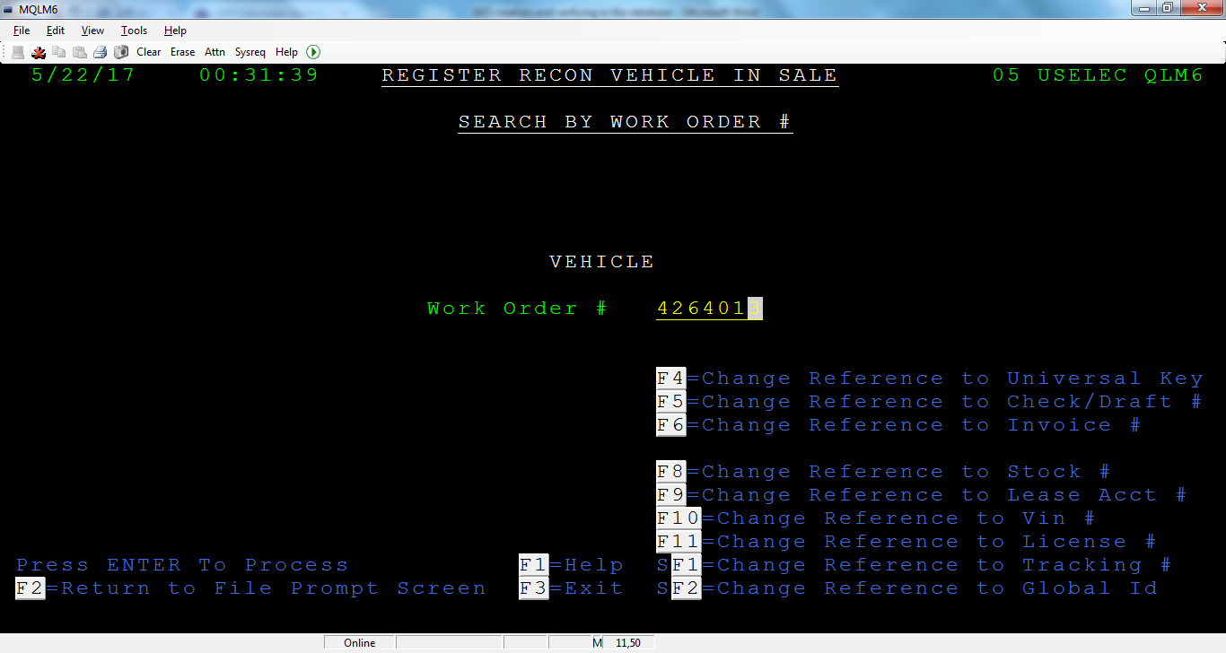

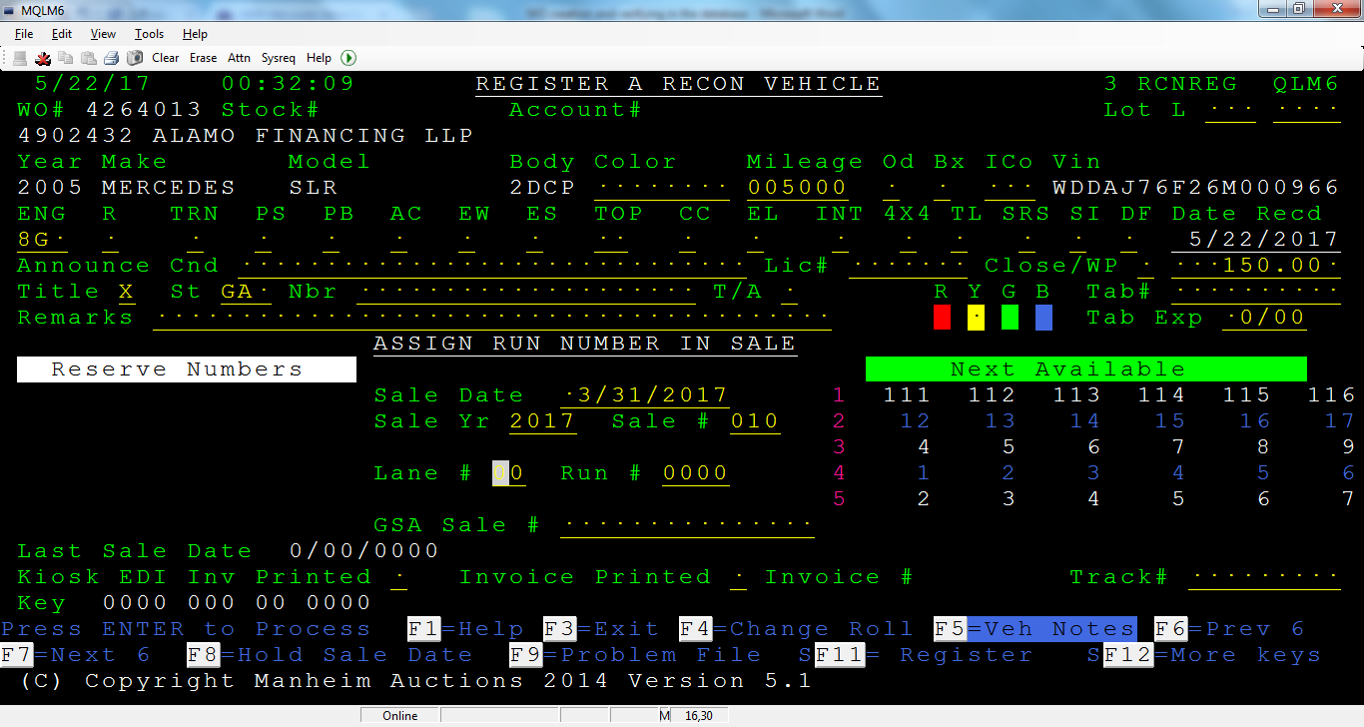

Step 6: Enter the Sale date, Sale Yr, Sale #, Lane # and Run #

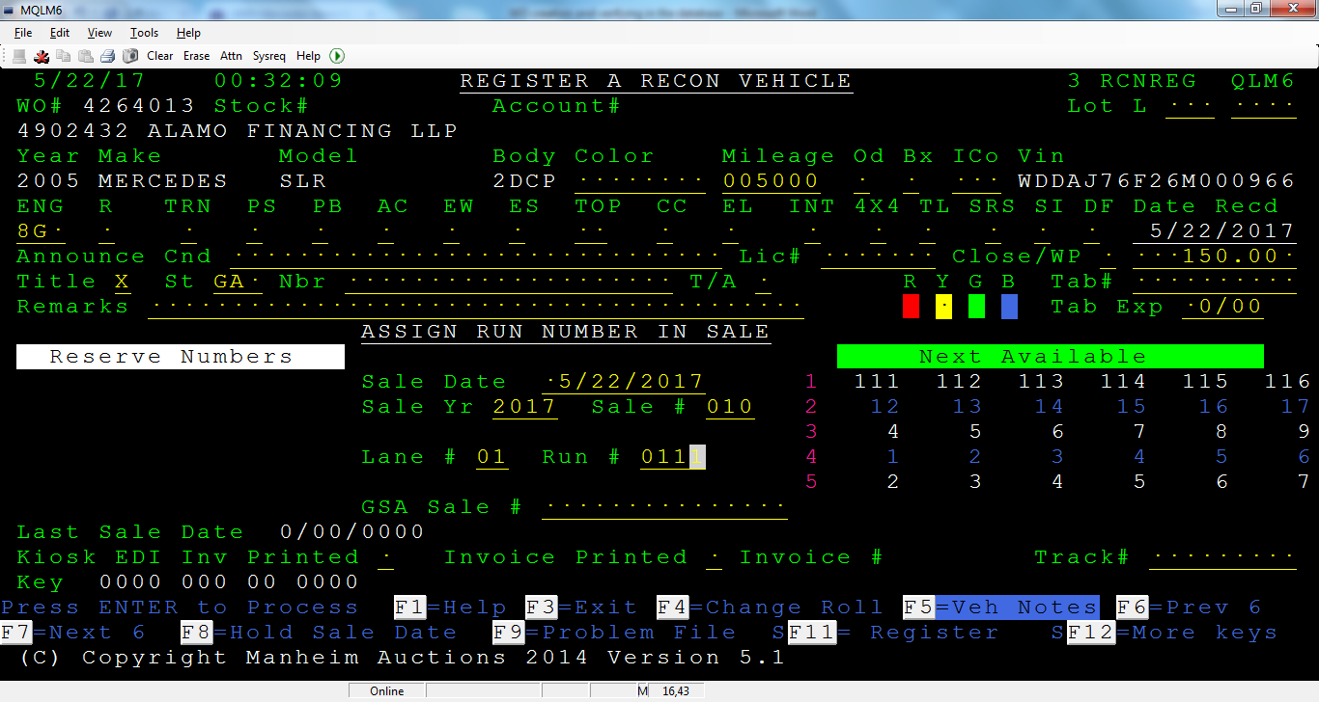

Step 7: SR- REGISTERED

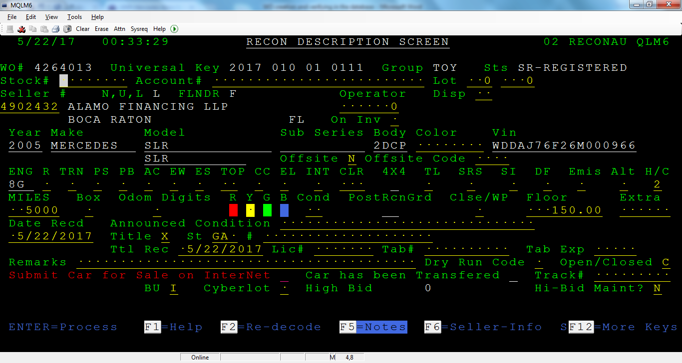

Step 8: Sale 13:

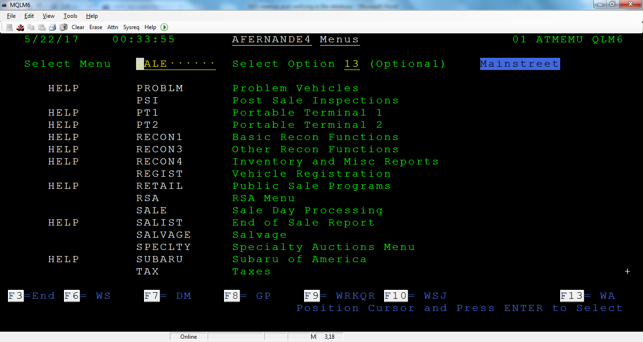

Step 9: Enter the Universal Key

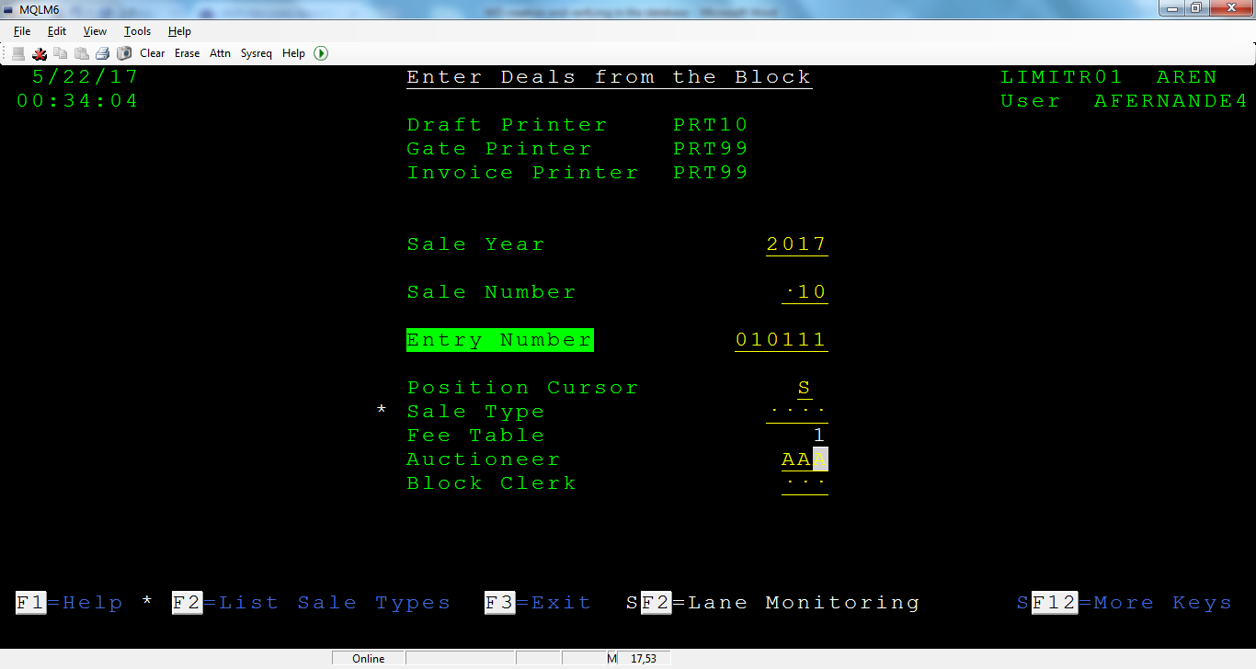

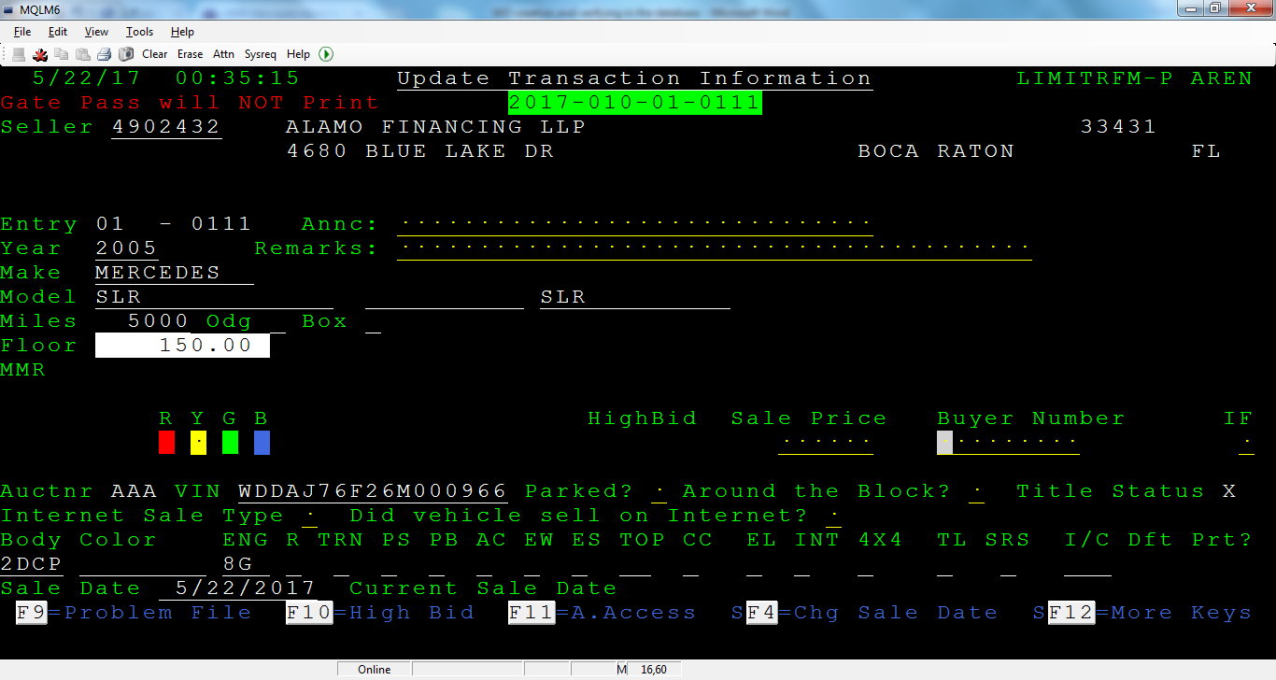

Step 10: Enter Sale Price and Buyer Number

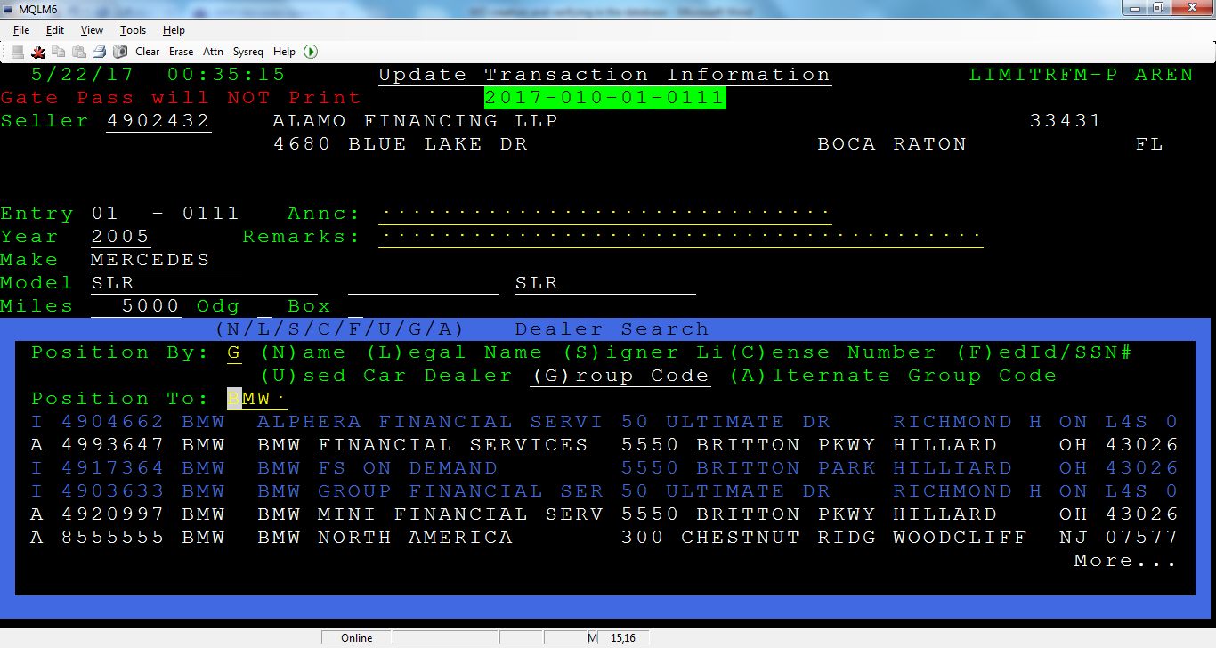

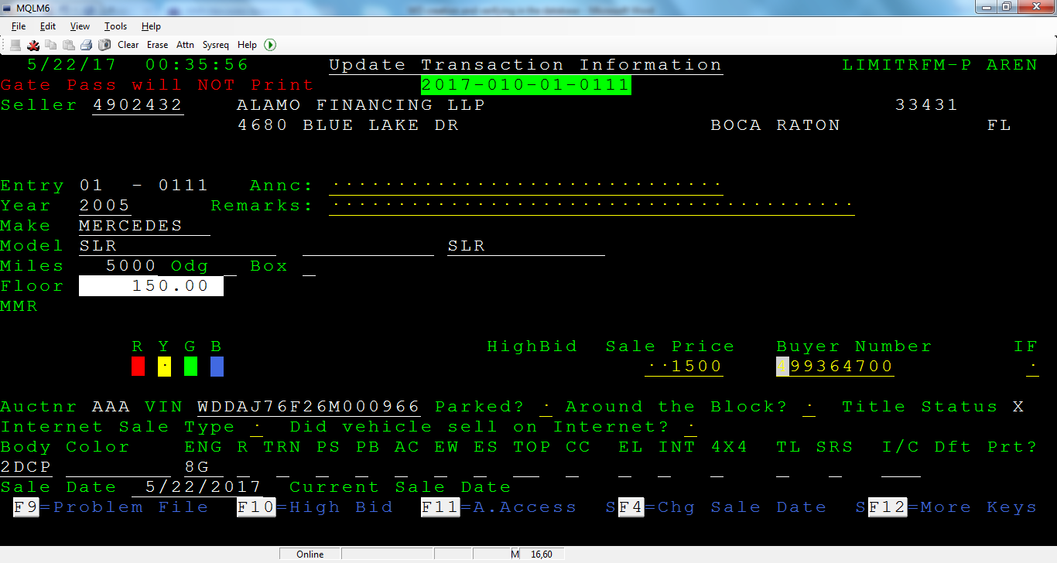

Step 11: SS- KEYED FROM BLK

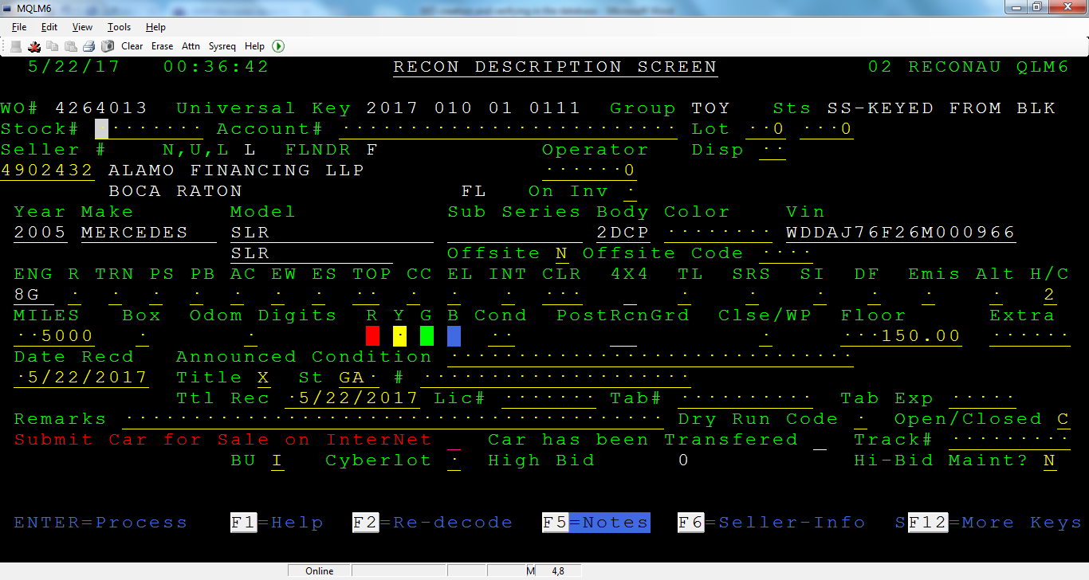

Step 12: Sale 01

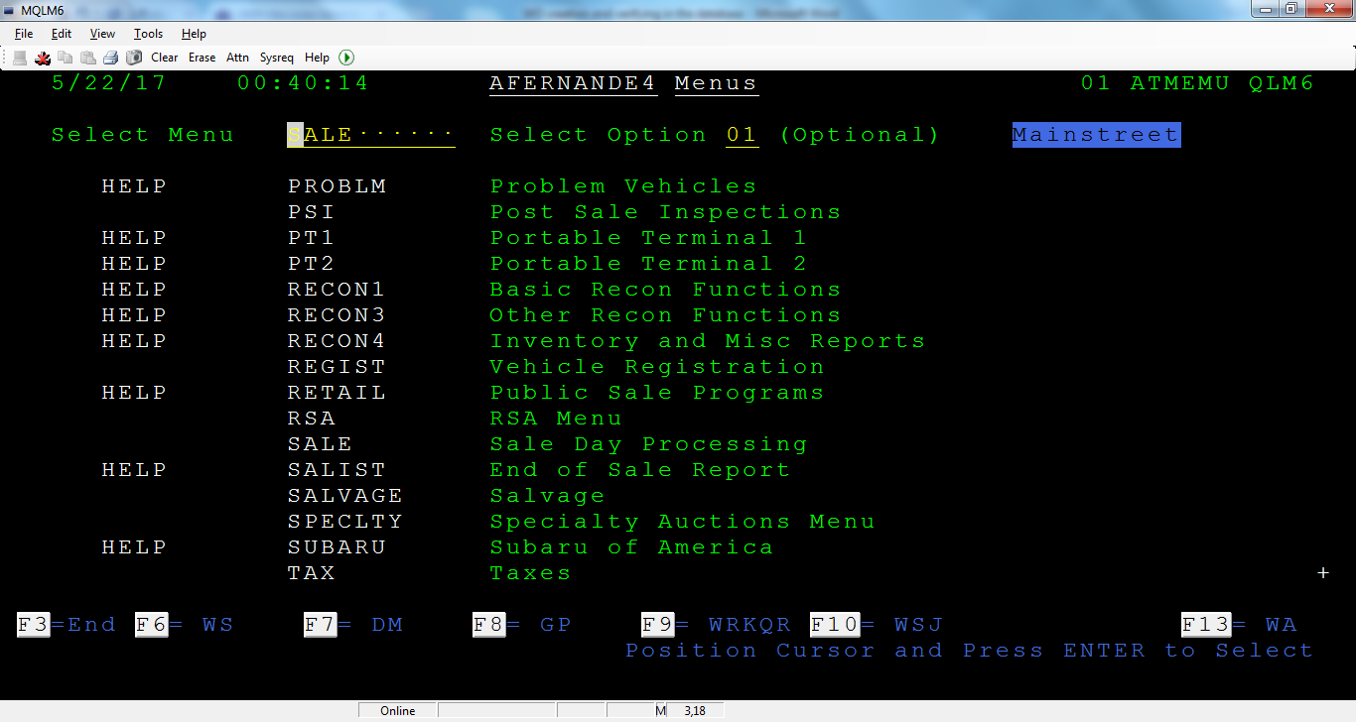

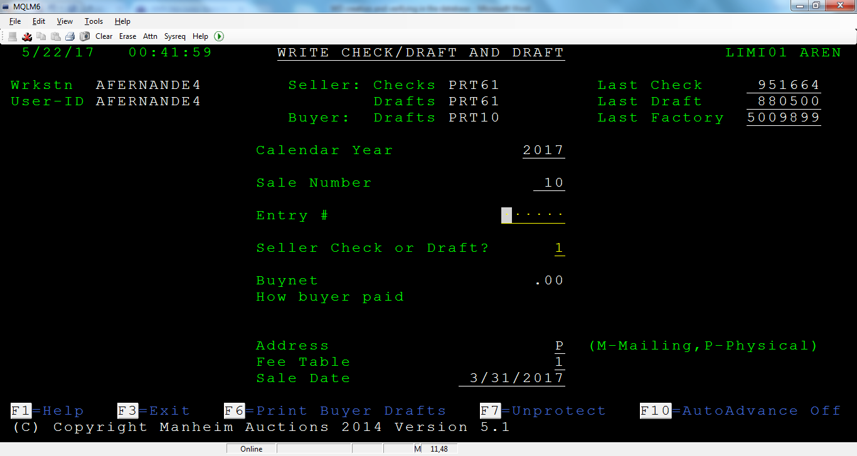

F7

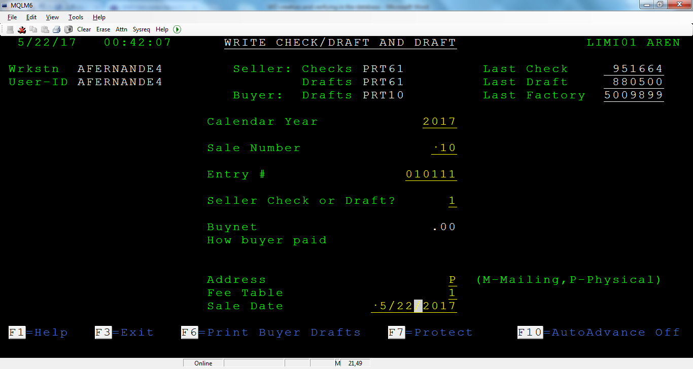

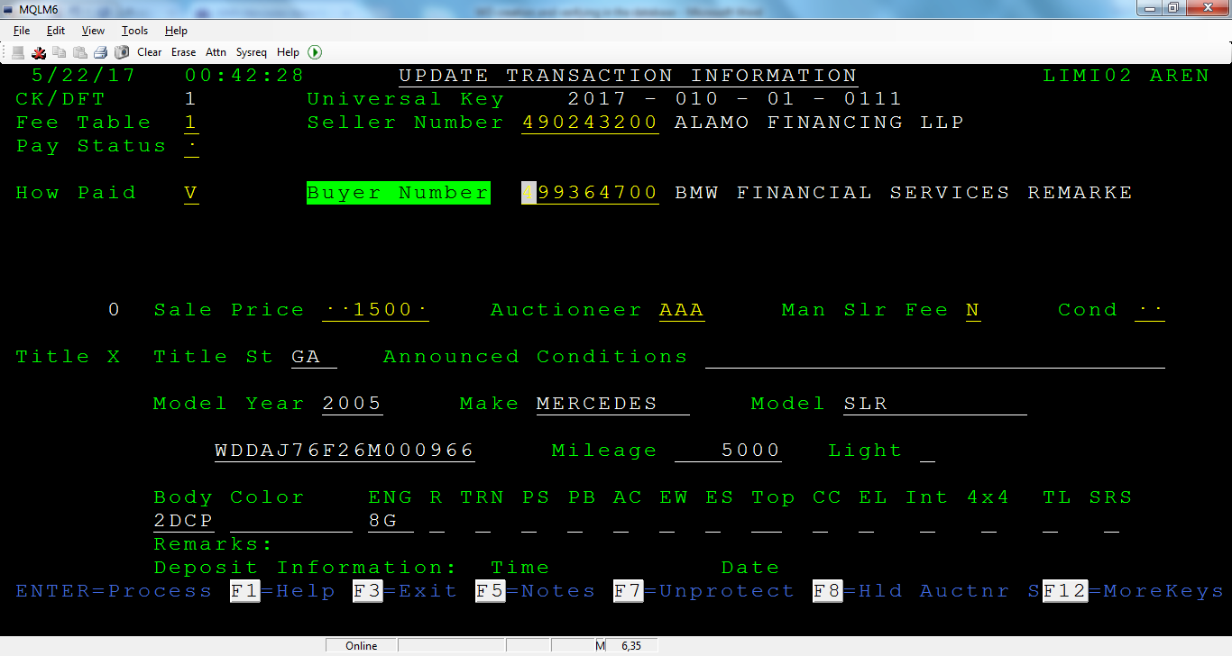

Step 13: SF- SOLD

**4.3.10 Benefits**

* Automation of Work order creation for Consignor using UiPath was successful.
* The automation efficiency is 40% better than the current manual testing.

**4.3.11 Conclusion**

PoC completed successfully.

**Chapter 5**

**References**

**5.1 References**

UiPath: <https://www.uipath.com/>

Academy: <https://academy.uipath.com/lms/>

Studio: <https://studio.uipath.com/>

Orchestrator: <https://orchestrator.uipath.com/>

Robot: <https://robot.uipath.com/>

Activities: <https://activities.uipath.com/>

Swagger: [https://demo.uipath.com/swagger/ui/index](%20https:/demo.uipath.com/swagger/ui/index)